

See discussions, stats, and author profiles for this publication at: [https://www.researchgate.net/publication/278064928](https://www.researchgate.net/publication/278064928_Mathematical_modeling_of_a_PCM_storage_tank_in_a_solar_cooling_plant?enrichId=rgreq-4cfd6c7de6219aa2dfbab6372541d21f-XXX&amp;enrichSource=Y292ZXJQYWdlOzI3ODA2NDkyODtBUzo2MzQ5NDcyMDMyNDgxMjlAMTUyODM5NDYxODk4Ng%3D%3D&amp;el=1_x_2&amp;_esc=publicationCoverPdf)

## [Mathematical modeling of a PCM storage tank in a solar cooling plant](https://www.researchgate.net/publication/278064928_Mathematical_modeling_of_a_PCM_storage_tank_in_a_solar_cooling_plant?enrichId=rgreq-4cfd6c7de6219aa2dfbab6372541d21f-XXX&amp;enrichSource=Y292ZXJQYWdlOzI3ODA2NDkyODtBUzo2MzQ5NDcyMDMyNDgxMjlAMTUyODM5NDYxODk4Ng%3D%3D&amp;el=1_x_3&amp;_esc=publicationCoverPdf)

**Article** *in* Solar Energy · July 2013

DOI: 10.1016/j.solener.2013.03.026

CITATIONS

21

READS

511

**8 authors**, including:

[Antonio J. Gallego Len](https://www.researchgate.net/profile/Antonio_J_Len?enrichId=rgreq-4cfd6c7de6219aa2dfbab6372541d21f-XXX&amp;enrichSource=Y292ZXJQYWdlOzI3ODA2NDkyODtBUzo2MzQ5NDcyMDMyNDgxMjlAMTUyODM5NDYxODk4Ng%3D%3D&amp;el=1_x_5&amp;_esc=publicationCoverPdf) [Universidad de Sevilla](https://www.researchgate.net/institution/Universidad_de_Sevilla?enrichId=rgreq-4cfd6c7de6219aa2dfbab6372541d21f-XXX&amp;enrichSource=Y292ZXJQYWdlOzI3ODA2NDkyODtBUzo2MzQ5NDcyMDMyNDgxMjlAMTUyODM5NDYxODk4Ng%3D%3D&amp;el=1_x_6&amp;_esc=publicationCoverPdf)

**34** PUBLICATIONS **202** CITATIONS

[Álvaro Ruiz-Pardo](https://www.researchgate.net/profile/Alvaro_Ruiz-Pardo?enrichId=rgreq-4cfd6c7de6219aa2dfbab6372541d21f-XXX&amp;enrichSource=Y292ZXJQYWdlOzI3ODA2NDkyODtBUzo2MzQ5NDcyMDMyNDgxMjlAMTUyODM5NDYxODk4Ng%3D%3D&amp;el=1_x_5&amp;_esc=publicationCoverPdf) [Universidad de Cádiz](https://www.researchgate.net/institution/Universidad_de_Cadiz?enrichId=rgreq-4cfd6c7de6219aa2dfbab6372541d21f-XXX&amp;enrichSource=Y292ZXJQYWdlOzI3ODA2NDkyODtBUzo2MzQ5NDcyMDMyNDgxMjlAMTUyODM5NDYxODk4Ng%3D%3D&amp;el=1_x_6&amp;_esc=publicationCoverPdf)

**17** PUBLICATIONS **342** CITATIONS

[SEE PROFILE](https://www.researchgate.net/profile/Antonio_J_Len?enrichId=rgreq-4cfd6c7de6219aa2dfbab6372541d21f-XXX&amp;enrichSource=Y292ZXJQYWdlOzI3ODA2NDkyODtBUzo2MzQ5NDcyMDMyNDgxMjlAMTUyODM5NDYxODk4Ng%3D%3D&amp;el=1_x_7&amp;_esc=publicationCoverPdf)

[SEE PROFILE](https://www.researchgate.net/profile/Alvaro_Ruiz-Pardo?enrichId=rgreq-4cfd6c7de6219aa2dfbab6372541d21f-XXX&amp;enrichSource=Y292ZXJQYWdlOzI3ODA2NDkyODtBUzo2MzQ5NDcyMDMyNDgxMjlAMTUyODM5NDYxODk4Ng%3D%3D&amp;el=1_x_7&amp;_esc=publicationCoverPdf)

[Jose sanchez ramos](https://www.researchgate.net/profile/Jose_Sanchez_Ramos?enrichId=rgreq-4cfd6c7de6219aa2dfbab6372541d21f-XXX&amp;enrichSource=Y292ZXJQYWdlOzI3ODA2NDkyODtBUzo2MzQ5NDcyMDMyNDgxMjlAMTUyODM5NDYxODk4Ng%3D%3D&amp;el=1_x_5&amp;_esc=publicationCoverPdf) [Universidad de Cádiz](https://www.researchgate.net/institution/Universidad_de_Cadiz?enrichId=rgreq-4cfd6c7de6219aa2dfbab6372541d21f-XXX&amp;enrichSource=Y292ZXJQYWdlOzI3ODA2NDkyODtBUzo2MzQ5NDcyMDMyNDgxMjlAMTUyODM5NDYxODk4Ng%3D%3D&amp;el=1_x_6&amp;_esc=publicationCoverPdf)

**37** PUBLICATIONS **286** CITATIONS

[Luisa F. Cabeza](https://www.researchgate.net/profile/Luisa_F_Cabeza?enrichId=rgreq-4cfd6c7de6219aa2dfbab6372541d21f-XXX&amp;enrichSource=Y292ZXJQYWdlOzI3ODA2NDkyODtBUzo2MzQ5NDcyMDMyNDgxMjlAMTUyODM5NDYxODk4Ng%3D%3D&amp;el=1_x_5&amp;_esc=publicationCoverPdf) [Universitat de Lleida](https://www.researchgate.net/institution/Universitat_de_Lleida?enrichId=rgreq-4cfd6c7de6219aa2dfbab6372541d21f-XXX&amp;enrichSource=Y292ZXJQYWdlOzI3ODA2NDkyODtBUzo2MzQ5NDcyMDMyNDgxMjlAMTUyODM5NDYxODk4Ng%3D%3D&amp;el=1_x_6&amp;_esc=publicationCoverPdf)

**543** PUBLICATIONS **18,769** CITATIONS

[SEE PROFILE](https://www.researchgate.net/profile/Jose_Sanchez_Ramos?enrichId=rgreq-4cfd6c7de6219aa2dfbab6372541d21f-XXX&amp;enrichSource=Y292ZXJQYWdlOzI3ODA2NDkyODtBUzo2MzQ5NDcyMDMyNDgxMjlAMTUyODM5NDYxODk4Ng%3D%3D&amp;el=1_x_7&amp;_esc=publicationCoverPdf)

[SEE PROFILE](https://www.researchgate.net/profile/Luisa_F_Cabeza?enrichId=rgreq-4cfd6c7de6219aa2dfbab6372541d21f-XXX&amp;enrichSource=Y292ZXJQYWdlOzI3ODA2NDkyODtBUzo2MzQ5NDcyMDMyNDgxMjlAMTUyODM5NDYxODk4Ng%3D%3D&amp;el=1_x_7&amp;_esc=publicationCoverPdf)

**Some of the authors of this publication are also working on these related projects:**

MERITS [View project](https://www.researchgate.net/project/MERITS?enrichId=rgreq-4cfd6c7de6219aa2dfbab6372541d21f-XXX&amp;enrichSource=Y292ZXJQYWdlOzI3ODA2NDkyODtBUzo2MzQ5NDcyMDMyNDgxMjlAMTUyODM5NDYxODk4Ng%3D%3D&amp;el=1_x_9&amp;_esc=publicationCoverPdf)



ENERGY EFFICIENCY - AUDIT METHODOLOGY [View project](https://www.researchgate.net/project/ENERGY-EFFICIENCY-AUDIT-METHODOLOGY?enrichId=rgreq-4cfd6c7de6219aa2dfbab6372541d21f-XXX&amp;enrichSource=Y292ZXJQYWdlOzI3ODA2NDkyODtBUzo2MzQ5NDcyMDMyNDgxMjlAMTUyODM5NDYxODk4Ng%3D%3D&amp;el=1_x_9&amp;_esc=publicationCoverPdf)

All content following this page was uploaded by [Jose sanchez ramos](https://www.researchgate.net/profile/Jose_Sanchez_Ramos?enrichId=rgreq-4cfd6c7de6219aa2dfbab6372541d21f-XXX&amp;enrichSource=Y292ZXJQYWdlOzI3ODA2NDkyODtBUzo2MzQ5NDcyMDMyNDgxMjlAMTUyODM5NDYxODk4Ng%3D%3D&amp;el=1_x_10&amp;_esc=publicationCoverPdf) on 07 June 2018.

The user has requested enhancement of the downloaded file.





### This article appeared in a journal published by Elsevier. The attached copy is furnished to the author for internal non-commercial research and education use, including for instruction at the authors institution and sharing with colleagues.

**Other uses, including reproduction and distribution, or selling or licensing copies, or posting to personal, institutional or third party websites are prohibited.**

**In most cases authors are permitted to post their version of the article (e.g. in Word or Tex form) to their personal website or institutional repository. Authors requiring further information regarding Elsevier’s archiving and manuscript policies are encouraged to visit:**

[**http://www.elsevier.com/authorsrights**](http://www.elsevier.com/authorsrights)

Available online at [www.sciencedirect.com](http://www.sciencedirect.com/)





Solar Energy 93 (2013) 1–10



[www.elsevier.com/locate/solener](http://www.elsevier.com/locate/solener)

Mathematical modeling of a PCM storage tank in a solar cooling plant

## A.J. Gallego a,⇑, A. Ru´ız-Pardo b, A. Cerezuela-Parish b, J. Sa´nchez b, C. Mart´ın-Macareno a,

L.F. Cabeza c, E.F. Camacho a, E. Oro´ c

a *Systems Engineering and Automatic Department, Engineering College of the University of Seville, Av. Camino de los Descubrimientos s/n, 41092 Seville, Spain*

b *Group of Termote´cnia, Engineering College of the University of Seville, Av. Camino de los Descubrimientos s/n, 41092 Seville, Spain*

c *GREA Innovacio´ Concurrent, Universitat de Lleida, Ediﬁci CREA, Pere de Cabrera s/n, 25001 Lleida, Spain*

Received 27 June 2012; received in revised form 25 March 2013; accepted 26 March 2013

Communicated by: Associate Editor D. Laing

Abstract

Solar cooling plants can work in multiple operation modes. A numerical model of the whole plant can be used to choose the adequate operation mode and optimizing the energy production by using hierarchical control strategies. Simpliﬁed models are required for solving the control problem in a suitable time-window using systems such as Programmable Logic Controllers (PLCs) or microcontrollers.

The storage system is an important component of a solar cooling plant. They are useful in solar systems for helping to satisfy the energy demand when solar energy is not available. Those based on phase change materials (PCMs) have the advantage of high storage density at a small temperature range.

This paper presents a simpliﬁed model of a PCM storage tank placed at the solar cooling plant of the Escuela Superior de Ingenieros (ESI) in Seville, focusing on the parameter estimation algorithm.

© 2013 Elsevier Ltd. All rights reserved.

*Keywords:* Solar energy; Storage systems; Solar cooling plant; Phase change material; Fresnel collector

1. Introduction

Currently, solar energy covers only a small fraction of the global energy demand. However, the use of solar energy is considerably increasing driving by the need of reducing the environmental impact of fossil fuels (Cama- cho et al., 2012).

According to the IEA (2012), the solar heating and cool- ing (SHC) could “supply almost one sixth (16.5 EJ) of the

⇑ Corresponding author. Tel.: +34 954 487 347, +34 954 487 259; fax:

+34 954 463 153.

*E-mail addresses:* [antgallen@gmail.com](mailto:antgallen@gmail.com) (A.J. Gallego), [jsr@us.es](mailto:jsr@us.es) (A. Ru´ız-Pardo), [jsr@us.es](mailto:jsr@us.es) (A. Cerezuela-Parish), [jsr@us.es](mailto:jsr@us.es) (J. Sa´nchez), [cristinamm@us.es](mailto:cristinamm@us.es) (C. Mart´ın-Macareno), [lcabeza@diei.udl.cat](mailto:lcabeza@diei.udl.cat) (L.F. Cabeza), [eduardo@esi.us.es](mailto:eduardo@esi.us.es) (E.F. Camacho), [lcabeza@diei.udl.cat](mailto:lcabeza@diei.udl.cat) (E. Oro´).

world’s total energy use for both heating and cooling by 2050”. However, solar energy is not available when it is needed. It may produce that a mismatch between energy

supplied by the sun and the electrical or thermal demand appears (Moens et al., 2003). Storage systems are useful to shift the energy delivery when it is required.

Researches in this topic are considered of high priority by the Europe’s Energy Portal (EUREC, 2009), because energy storage is necessary to make feasible the use of renewable energy and, in particular, for the solar heating and cooling. The use of phase change materials (PCMs) is one of the most promising techniques for thermal energy storage, since high storage density at small temperature changes can be obtained (Zalba et al., 2003).

The project “Almacenamiento te´rmico en caliente para refrigeracio´n solar por absorcio´n” (hot thermal storage

0038-092X/$ - see front matter © 2013 Elsevier Ltd. All rights reserved. <http://dx.doi.org/10.1016/j.solener.2013.03.026>

2 *A.J. Gallego et al. / Solar Energy 93 (2013) 1–10*

for solar absorption cooling) was conducted. The main objective was developing thermal storage system using phase change material (PCM) for the solar absorption cooling plant placed at the ESI of Seville (Spain) (Bermejo et al., 2010). The solar cooling plant consists of a double eﬀect water absorption chiller powered by a pressurized hot water ﬂow delivered by means of a 352 m2 linear Fres- nel collector, a direct-ﬁrer gas natural burner and a PCM storage tank. The PCM tank is in the hot water circuit where the working temperature is approximately 170 °C, close to the hydroquinone fusion temperature (the selected PCM).

Solar cooling plants may work in diﬀerent operation modes as is pointed out in Zambrano et al. (2006) and Zambrano (2007). In order to ensure an optimal operation of the plant and minimizing the natural gas consumption, a model of the plant for control purposes is needed. The resulting control problem is an optimization problem com- bining discrete and continuous variables, which is diﬃcult to solve it in real-time applications (Sonntag et al., 2008). Simpliﬁed models of each subsystem with an adequate trade-oﬀ between complexity and computational burden are required.

Simulation models for PCM tanks have been done pre- viously by several authors. In Jokisalo et al. (2000), a model to be suitable in TRNSYS is developed. Hed and Bellander (2006) developed a mathematical model for a PCM air heat exchanger. This model considers the exchanger as a duct with airﬂow where the PCM has a

constant temperature. They use a “ﬁctive heat transfer coeﬃcient” to take in consideration “aspects of the geom- etry and the airﬂow in the heat exchanger as well as the material properties of the PCM”. Esen and Ayhan (1996) performed a numerical model of a PCM tank,

where the PCM was contained in cylinders and the heat transfer ﬂuid (HTF) ﬂowed parallel to it. This model was based in the enthalpy method and the equations solved using an iterative method. Bony and Citherlet (2007) describes a numerical model to simulate heat trans- fer in (PCM) plunged in water tank storage. The model is an extension of the existing TRNSYS Type 60 (Klein, 2007), where a discretization in segments or nodes is per- formed. The heat transfer equations are solved using the explicit method.

Some of the above-mentioned simulation models are computationally expensive. In this paper, a simpliﬁed model of the storage tank and the procedure for obtaining the model parameters are presented. The model described here is similar but simpler than the one described in Ru´ız-

Pardo et al. (2012). The diﬀerence relies on that this model

does not record the amount of the PCM mass which has changed its phase. The main drawback is that less accu- racy is achieved when the phase change is not performed completely. The advantage is that less computational resources are needed and the model computation is faster. Nevertheless, an adequate trade-oﬀ between errors pro- duced and the computational burden is obtained.

The paper is organized as follows: in Section 2 a general description of the solar cooling plant is presented. In Sec- tion 3, the mathematical model of the PCM storage tank is described. In Section 4, the parameter estimation prob- lem is exposed. In Section 5, results and comparisons with real data are discussed. Finally, the paper draws to a close with concluding remarks.

1. Plant description

The solar cooling system with gas boiler backup installed consists of three subsystems: the double-eﬀect LiBr+ water absorption chiller of 174 kW nominal cooling capacity. The solar Fresnel collector ﬁeld heats the pressurized water and delivers it to the water absorption chiller. The PCM storage tank helps supplying energy to the water in order to reach the required water temperature, whenever the solar ﬁeld is not able to reach it. Fig. 1 shows the scheme of the whole plant.

* 1. *Water absorption chiller*

It is a double-eﬀect cycle LiBr+ absorption machine which transforms the thermal energy (hot water at 140– 180 °C) coming from the Fresnel solar ﬁeld or the PCM stor- age tank, in cold water to be used by the ESI of Seville. It has a cooling power of 174 kW and a cold theoretical COP of

1.34. Apart from the hot water, a cooling ﬂuid is needed for the condenser and the absorber as well. It is obtained from the water catchment of the river Guadalquivir.

* 1. *Solar collector*

The solar system is composed of a set of Fresnel solar collectors (Fig. 2), supplied by Industrial Solar (I.S.F.C, 2012) which concentrate solar radiation onto an absorption tube through which a heat transfer ﬂuid circulates (in our case, pressurized water). The Fresnel collector is used in small plants due to the cost reduction and the minimization of the plant maintenance (Grena and Tarquini, 2011; Rob- ledo et al., 2010).

* 1. *PCM storage tank*

The PMC storage is a tank of 18 m long and 1.31 m of diameter (Fig. 3). The storage tank of the ESI of Sevilla is a shell-tube heat exchanger with a theoretical thermal stor- age capacity of 275.5 kW h (145–180 °C) and 150 kW. It consists of a series of tubes containing a heat transfer ﬂuid and the PCM ﬁlls up the space between tubes and the shell. The theoretical thermal storage is computed by using the properties of the hydroquinone, showed in Table 1, and taking into account the total mass of the PCM, which

is of 3294 kg.

Thermal energy is stored nearly isothermally as the latent heat of phase change solid–liquid transition, that

*A.J. Gallego et al. / Solar Energy 93 (2013) 1–10* 3

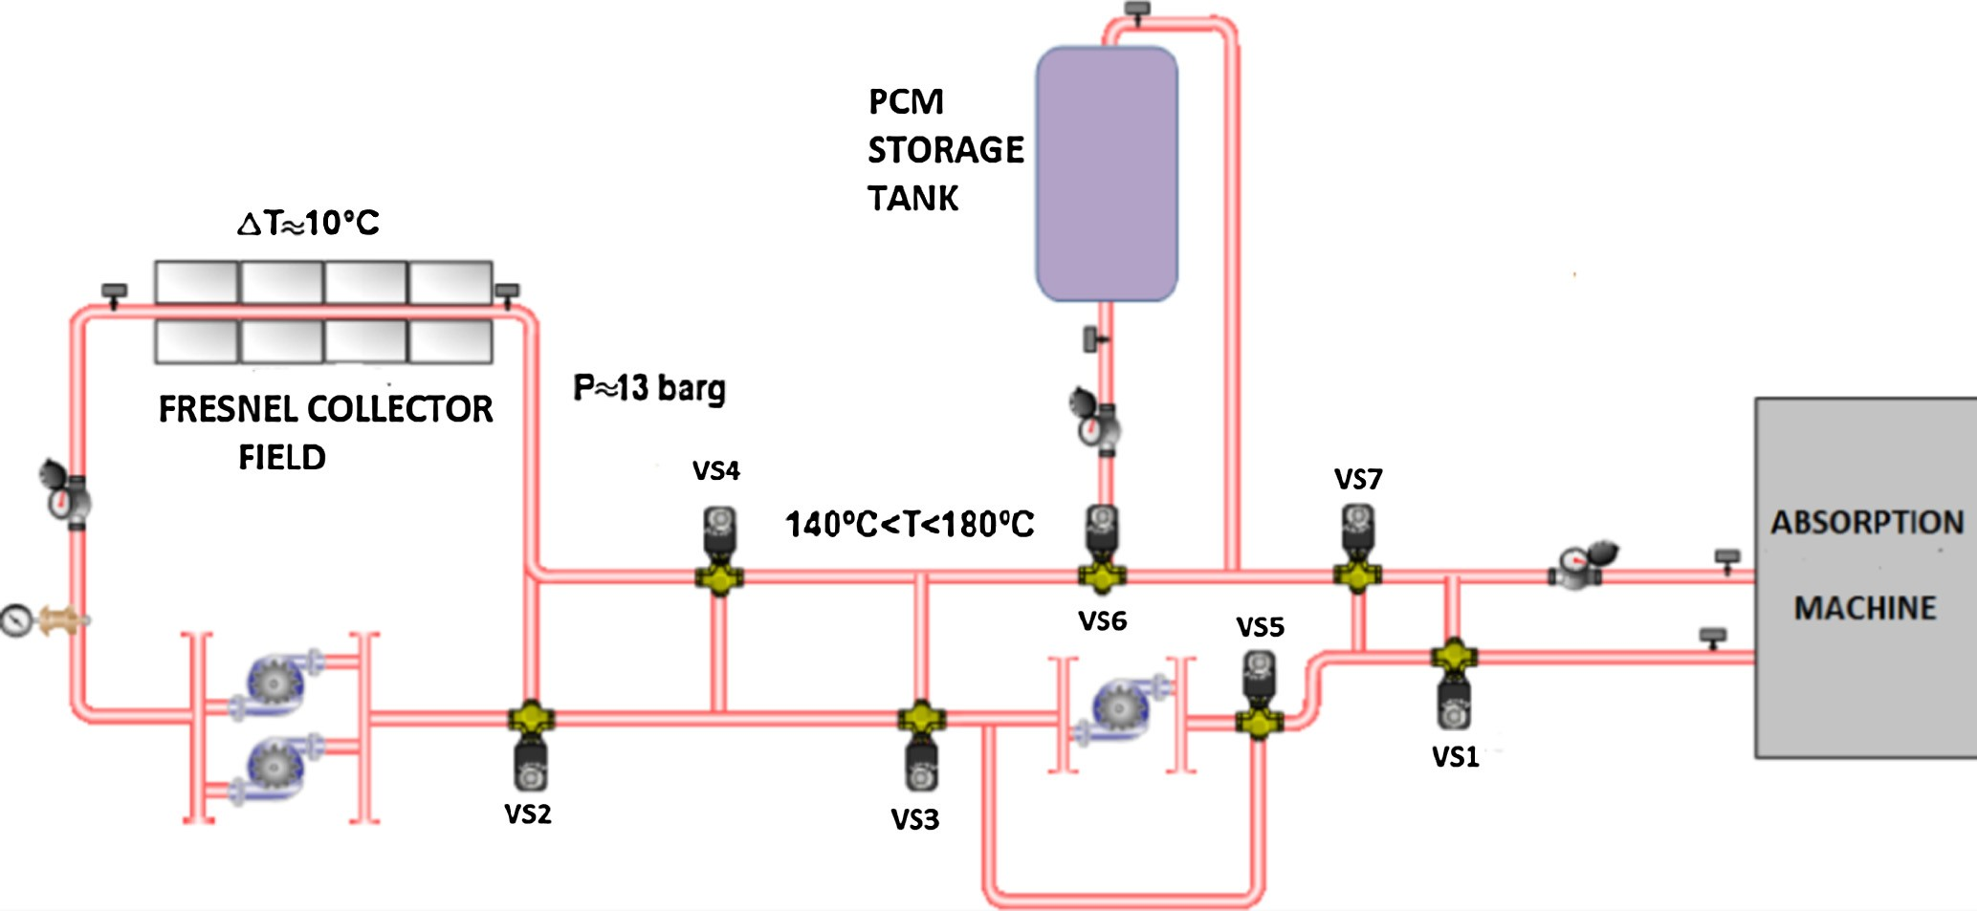

Fig. 1. Plant general scheme.

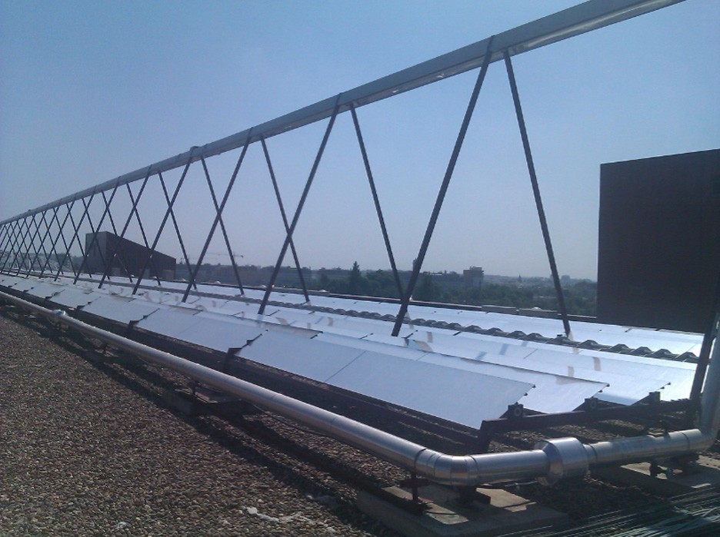

|  |  |  |
| --- | --- | --- |
| Table 1  Properties of the PCM (hydroquinone). |  | |
|  | Solid | Liquid |
| Density (kg/m3) | 1358 | 1155 |
| Speciﬁc heat (J K—1 kg—1) | 2310 | 2670 |

Fig. 2. Fresnel collector ﬁeld.

Fig. 3. PCM storage tank.

is, as heat of fusion. Substances with these characteristics are called phase change materials (PCMs).

The latent heat of fusion between the liquid and solid states of materials is rather high compared to the sensible heat (Herrmann and Kearney, 2002; Lunardini, 1981). In the case of this PCM is two order of magnitude higher. The storage tank uses a hydroquinone as a PCM because the fusion temperature is about 170 °C, which is suitable for the water absorption chiller operational range. (145– 170 °C).

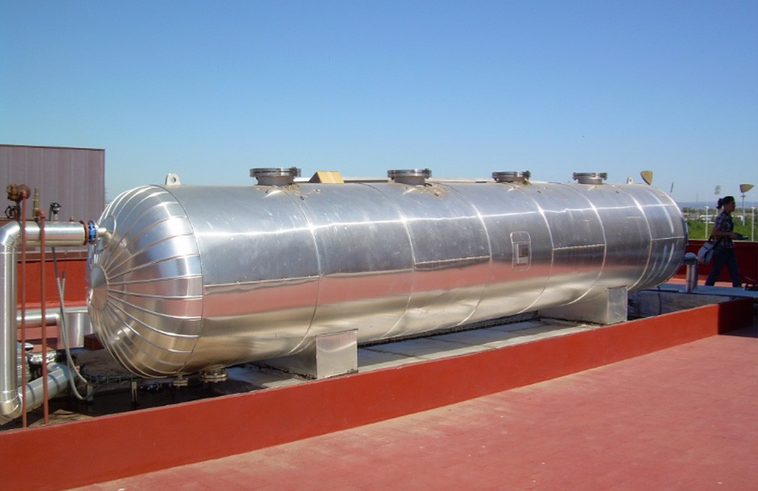

1. Mathematical model of the PCM storage tank

In this section, a mathematical model of the PCM stor- age tank is developed. Since the purpose of the model is to be used in hierarchical control strategies, a simple model which has an adequate trade-oﬀ between precision and complexity is required. More complexity implies higher computational burden, and this is not a desirable property in order to solve a nonlinear optimization problem derived

from hierarchical control strategies. In (Ru´ız-Pardo et al.,

2012), a more complex numerical model of the PCM stor- age tank is presented.

The mathematical model is based on the Stefan solution for the phase change stage (Kreith et al., 2011). For the sake of clarity, some remarks about the model implementa- tion are needed:

# Author's personal copy

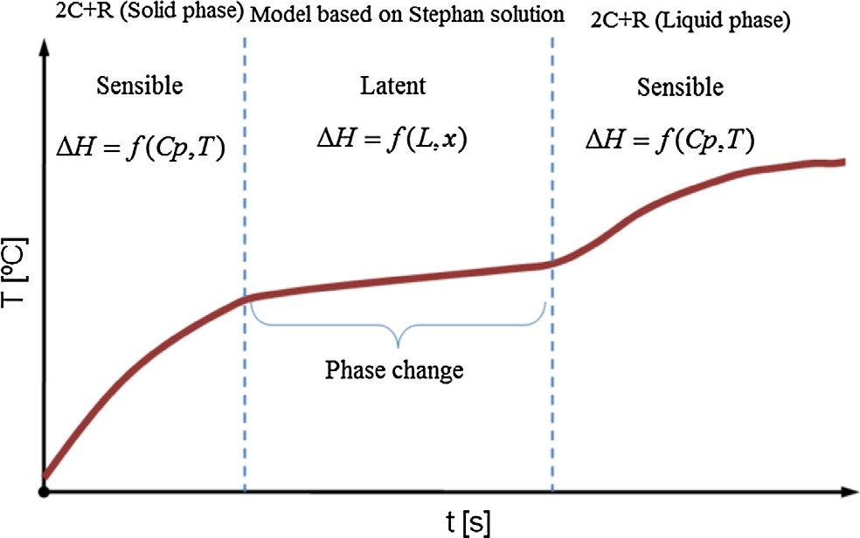

1. *A.J. Gallego et al. / Solar Energy 93 (2013) 1–10*

Since the PCM is a continuous medium, in order to model the heat transmission in a very precise way a com- putational ﬂuid dynamics model with many zones for each tube would be adequate, increasing the computa- tional eﬀort. In this paper, a simpliﬁed model is used for simulation purposes. The PCM tank is broken down into 18 segment of 1 m length in axial direction. Each segment is considered to be a cylinder which have the same thermal behavior, varying its temperature along the radial direction. The simpliﬁed model is composed of two submodels: one describing the PCM behavior in the sensible heat stage and another which describes the PCM dynamics in the phase change stage. When

●

the PCM is in the sensible heat transmission a double capacity model is employed. In the phase change stage, a model based on the Stefan solution is employed.Exper- imentally was found that, from a thermal point of view, there are two types of tube: tubes placed in the central zone, and those placed in the peripheral zone. The behavior of the central tubes is considered the same. Only a study of a central tube is carried out, because the percentage of the tubes placed in the peripheral zone is very low compared to those placed in the central zone (see Fig. 4).

In each segment, the temperature is computed using a two stage algorithm. Firstly each one is corrected in function of losses produced by the energy transport of the water ﬂow and secondly, they are updated using heat transfer equations, depending on if they are in the sensi- ble heat transmission stage or the phase change stage. To compute the temperature evolution in the sensible heat transfer stage, two energy balance equations are used for both liquid and solid state. The diﬀerences between both states are that the density, speciﬁc heat and conductivity of hydroquinone may have diﬀerent values. This model is called double capacity model (see

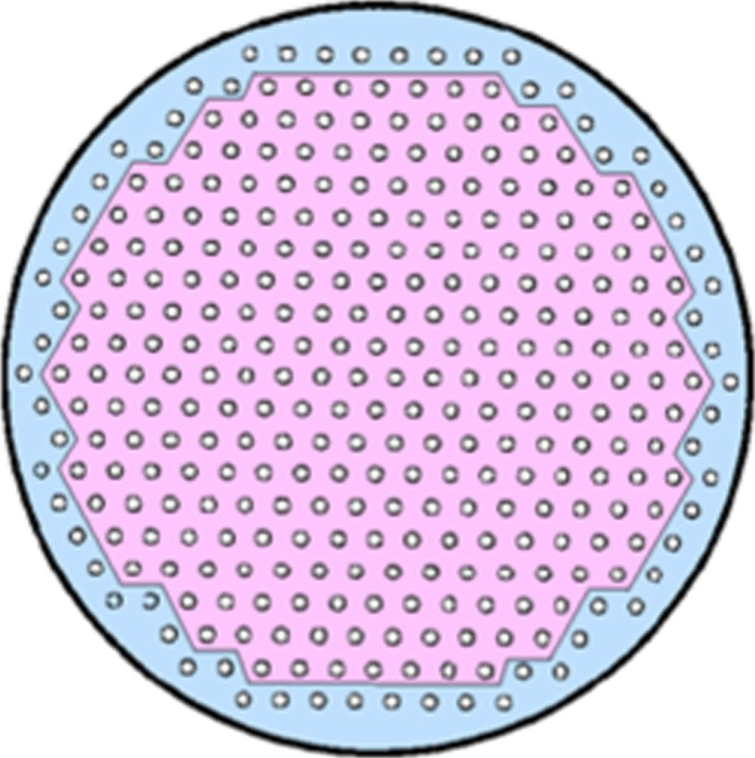

●

●

Fig. 5. Phases in the PCM evolution.

Fig. 6). The resistance and capacity of each zone depend on *rm*. The higher is rm the higher is the thermal resis- tance and viceversa.

In the phase change stage, a system composed of two equations based on the Stefan solution are used to com- pute the PCM temperature evolution.

●

In Table 1, parameters and their units are shown.

The PCM behavior is represented in Fig. 5. Initially the PCM is in solid phase. When it reaches the melting temper- ature, the phase change starts and the PCM temperature evolves at an almost constant temperature. Stefan’s solu- tion considers that, at the initial instant, the whole PCM is at the phase change temperature. As the interface evolves, the temperature of the material which has changed its phase, does not remain constant. Finally, the PCM is melted, reaching the liquid phase.

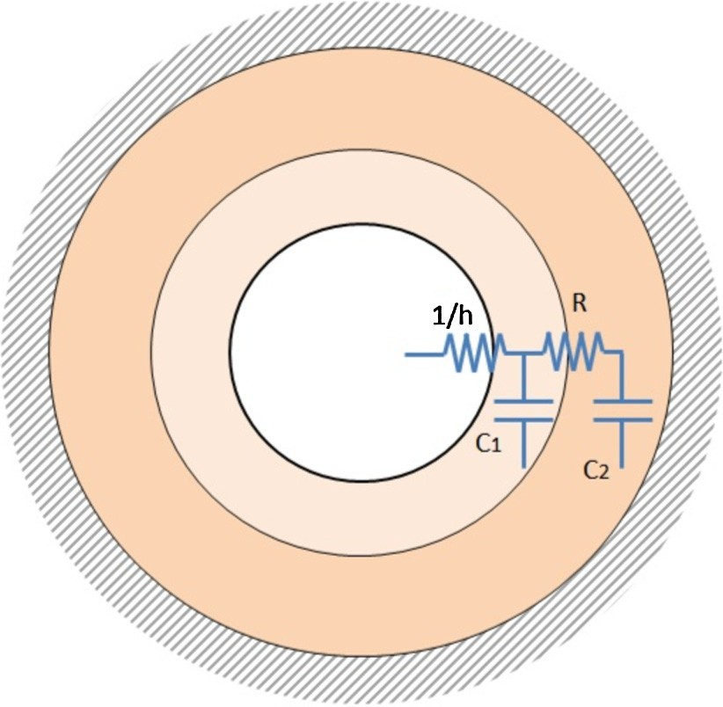

The two heat transmission models are described in the following subsections.

Fig. 4. Tube distribution in the PCM tank. Fig. 6. 2C + R model.

*A.J. Gallego et al. / Solar Energy 93 (2013) 1–10* 5

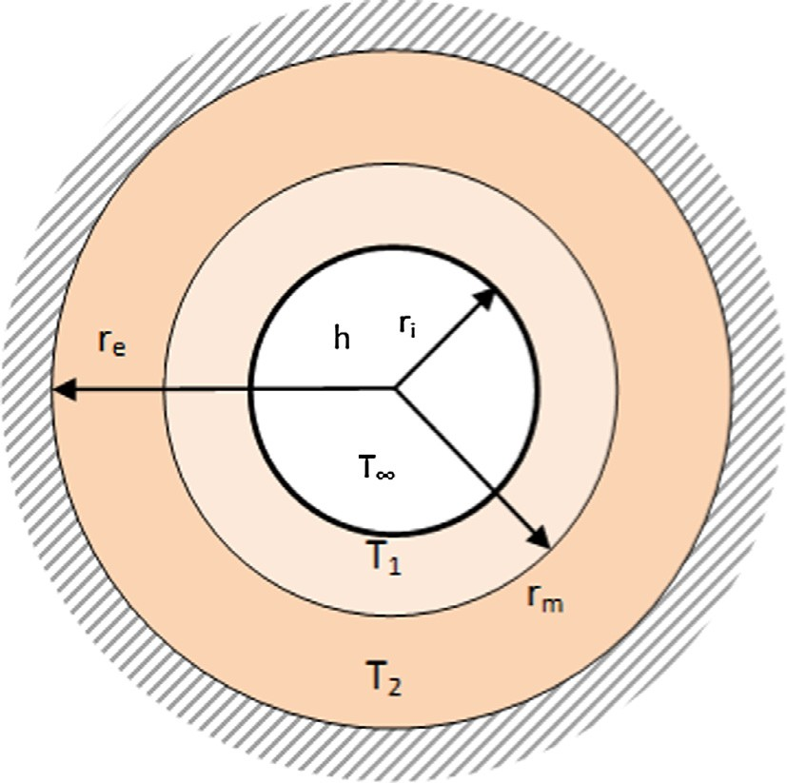

Table 2

Parameters description.

Fig. 7. PCM geometry.

* 1. *Double capacity model for the sensible heat stage*

In order to develop this part of the model, it is necessary to take into account that the PCM geometry is an annulus as it is shown in Fig. 7. Adiabatic boundary conditions have been imposed to *re* due to the symmetric conﬁguration of the storage tank.

The model consists of two diﬀerent capacitive zones, with a thermal resistance between both of them. The *re* and *ri* radius denote exterior and interior radius respec-

|  |  |  |
| --- | --- | --- |
| Symbol | Description | Units |
| *t* | Time | s |
| *k* | Space | m |
| *At* | Tube area | m |
| *tst* | Stefan time | s |
| *ql* | Density of liquid state | kg m—3 |
| *qs* | Density of solid state | kg m—3 |

*Cpsolid* Speciﬁc heat capacity of solid hydroquinone J K—1 kg—1 *Cpliquid* Speciﬁc heat capacity of liquid hydroquinone J K—1 kg—1 *Cpwater* Speciﬁc heat capacity of water J K—1 kg—1 *h* Coeﬃcient of convection water-hydroquinone W m—2 K—1 *K* Coeﬃcient of conductivity W m—1 K—1 *Kl* Coeﬃcient of liquid hydroquinone conductivity W m—1 K—1 *Ks* Coeﬃcient of solid hydroquinone conductivity W m—1 K—1 *T*1 Water temperature K, °C

*T*(*r*) Superﬁcial temperature of each segment K, ° C

*Tseg*(*t*, *k*) Segment temperature K, ° C

*qmass*(*t*) Water ﬂow rate kg s—1

*re* Exterior radius m

*ri* Interior radius m

*rm* Separation radius m

*R*(*t*) Interface position m

*L* Latent heat of hydroquinone J/g

or solid phases (that is, sensible storage), is neglected. The Stefan problem establishes an inferior limit of stored energy in a phase change phenomenon as well as a velocity limit for its evolution. For the adequate application of this solution, the use of the Stefan number is needed:

*Cp* m ð*T f* — *T* ð*ri*Þ

tively, *rm* is the separation radius dividing the two capaci- ties zones and it is a parameter which has to be

*ST* ¼

*L* ð3Þ

identiﬁed. *T*1 and *T*2 represent temperatures of zones 1 and 2, and *T*1 stands for the hot water temperature (see Table 2).

The model has two diﬀerential equations, one per zone:

*Zone*1:

*q* m *C* m *p* m .*r*2 — *r*2Σ *dT* 1

If the Stefan number is very close to 0 (as occurs in this

case), the sensible heat can be neglected in comparison with the latent heat. Due to the sensible heat is very small com- pared to the latent heat, it is possible a solution supposing a semi-inﬁnite medium and all the PCM is initially at the phase change temperature (Lunardini, 1981; Naterer, 2002). Only the ﬁnal equations are given, because the pro-

*p*

¼ *h* m 2*p* m *ri*

Þ—

*m i*

m ð*T* 1

*dt*

— *T* 1

2*p* m *K* m ð*T* 1 — *T* 2Þ

lnð*re*=*ri*Þ

ð1Þ

cess of obtaining the solution is out of the scope of this paper.

*h* m *ri T f* — *T* 1 m *h* m *ri* m lnð*ri*=*R*Þ !

*K* 1 — *K*m *i* m lnð*ri*=*R*Þ

*Zone*2:

*T* ð*r*Þ¼ *T f* þ

m

*h r*

*K*

— *T* 1

m lnð*r*=*R*Þ

m lnð*ri*=*R*Þþ

—

. Σ

¼ m

2

2

2*p* m *K* m ð*T* 1 — *T* 2Þ *q C*

lnð*re*=*ri*Þ

m *p* m *re* — *r*

*dT* 2

*dt*

*tst* ¼ *C* m *ri* m

*i*

— 2

— *R*

*p*

*m*

. Σ*r* m *h* Σ

ð2Þ

*K*

.2 m *h*

*K*

*h* 2ΣΣ ð4Þ

*K*

*ri*

Equations are the same for both states, but as it has been aforementioned, conductivity *K* and density *q* may

*C q* m *L*m

4 m *h* m ð*T* 1 — *T f* Þ

¼

ð5Þ

have diﬀerent values for solid and liquid states.

* 1. *Model based on Stefan solution for phase change*

When the PCM reaches a temperature of 170 °C, the phase change stage starts. In this stage, the dynamic is chieﬂy dictated by the phase change assuming that the liquid and solid phases are in the stable state. The heat storage which stems from the temperature change of liquid

where *R* = *R*(*tst*) is the interface position which depends on *tst* (Stefan time) time, *Tf* is the melting temperature, *T*(*r*) is the PCM temperature which depends on the position in ra- dial direction and *L*\* is the corrected latent heat of hydro- quinone. This solution is valid while *R* < *re*, because the case *R* = *re* implies that the whole mass has changed its phase.

Since one of the assumptions of the Stefan solution is that the whole mass is at the melting temperature, the

6 *A.J. Gallego et al. / Solar Energy 93 (2013) 1–10*

latent heat must be corrected by adding the needed heat to make the whole mass is at melting temperature. Let *Tlast* be the temperature of the last PCM segment. The corrected latent heat is computed as follows:

Although the parameters to be estimated have a physical meaning, their values do not necessarily correspond to the actual values. The values obtained by the identiﬁcation algorithm, are those making the model captures the real

*L*0 *p r*2 *r*2 *q*

*e*

*i*

*solid*

¼ m . — Σ m

*m* ¼ *p* m .*r*2 — *r*2Σ m *qsolid*

*e*

*i*

m *C* m j*T*

— *T* j

ð6Þ

*p*

*last*

*f*

PCM dynamics.

* 1. *Parameters to be estimated*

*L*m *L* m *m* þ *L*0

¼

*m*

where *L* is the latent heat of hydroquinone whose value is 230 J/g.

* 1. *Computation of model*

Once the two heat transfer processes have been exposed, the model computation is as follows: Make *Tseg*(1) equal to the inlet temperature of the storage tank. For each PMC segment (2 to *N*):

* + 1. If *q* = 0, the energy transmission between segments is negligible compared to the thermal losses to the ambient. A simple model which takes into account the thermal losses is used.

*Tseg*ð*t*; *k*Þ¼ *Tseg*ð*t* — 1; *k*Þ— *Hl*

where *Hl* is the thermal losses coeﬃcient obtained from real data, and *Tamb* is the ambient temperature. *Hl* is given by the Eq. (7):

*Hl* ¼ 8:94*e* — 4 m ð*Tseg*ð*t* — 1; *k*Þ— *T amb*Þ

þ 0:0188 ð○CÞ ð7Þ

* + 1. If *q* is not 0, correct the segment temperature with the energy transported by mass ﬂow *q*(*mass*):

*Tseg t*;*k Tseg t*;*k* 1 *At* m *h* m ð*Tseg*ð*t*; *k*Þ— *T*ð*ri*ÞÞ

ð Þ¼ ð — Þþ

*qmass* m *Cpwater*

— *Hl*

ð8Þ

* + 1. If *T*(*ri*)> *Tf* and *Rsegment* = *ri*, the segment is in liquid state and Eqs. (1) and (2) are employed, making *q* = *ql*, *Cp* = *Cpliquid* and *K* = *Kl*.
    2. If *T*(*ri*) < *Tf* and *Rsegment* = *ri*, the segment is in solid state and Eqs. (1) and (2) are employed, making *q* = *qs*, *Cp* = *Cpsolid* and *K* = *Ks*.
    3. If *ri* 6 *Rseg* 6 *re*, the segment is in the phase change stage and the system of Eqs. (4) and (5) must be solved.

1. Parameter estimation problem

In this section the identiﬁcation algorithm is presented. In the ﬁrst place, the parameters to be estimated and their ranges are exposed. Secondly, the nonlinear optimization algorithm for parameter estimation is described.

In this subsection, the set of parameters to be estimated

and their ranges are discussed. As it has been stated in Sec- tion 3, there are four unknown parameters: hydroquinone conductivity in solid state, hydroquinone conductivity in liquid state, coeﬃcient of convection *h* and *rm*. The main problem is establishing their values range in order to be estimated by the optimization algorithm.

* + 1. *Conductivity coeﬃcient*

The energy ﬂow by conduction heat transference of the hydroquinone is modulated by this coeﬃcient. Actually, there are two diﬀerent coeﬃcients one for the solid state and another for liquid state, which may be diﬀerent. As it is described in (Velrag et al., 1999), most of the phase change materials have a low thermal conductivity and tech- niques of heat transfer enhancement are required in some cases. Because of this fact, the searching ranges for both coeﬃcients are 0 6 *Ks* 6 1.2 and 0 6 *Kl* 6 1.2 W m—1 K—1.

* + 1. *Convection coeﬃcient*

In general, the detailed modeling of convection pro- cesses is a diﬃcult task because there are many factors that may inﬂuence in heat transfer processes. In PCM based storage systems, this coeﬃcient usually takes a value much higher than the conductivity coeﬃcient. Although *h* depends on the oil ﬂow and the temperature, in this case a constant value is searched. This assumption is based on two facts:

The water ﬂow variation in an operation day is low. The inﬂuence of the *h* coeﬃcient in the PCM dynamics is much lower than the conductivity coeﬃcients, because its value is much higher. The thermal resistance due to the convection heat transmission is much lower than that is produced by the conduction heat transmission.

●

●

In this paper, a searching range of 0 6

*h* 6 1400 W m—2 K—1 is considered.

* + 1. *Separation radius rm*

This parameter separates the two considered zones which are used in the sensible heat transfer equations. In this case, the establishing of the searching range is easier, because it has to be bounded by *ri* and *re*, thus *ri* 6 *rm* 6 *re*.

*4.2. Estimation algorithm*

In this subsection the parameter estimation algorithm is presented. Basically, the estimation algorithm computes a

*A.J. Gallego et al. / Solar Energy 93 (2013) 1–10* 7

set of parameter values and the model evolution, compar- ing the outcome with the supplied data. To perform the computation of parameter values, the minimization of a cost function is performed.

There are many estimation methods for both linear and nonlinear systems such as minimum least squares for linear and nonlinear systems, and constrained estimation (Ikko- nen and Najim, 2002). In this case, parameter values are subject to constraints leading to a nonlinear optimization problem posed as follows:

operational conditions, a substantial amount of data over the whole operating range is needed. This will also avoid that over parameterization problems may appear which may ﬁt parameters to work properly only in a small range of temperatures.

There are many algorithms dealing with nonlinear opti- mization problems: Gradient methods, interior-points methods, etc. (Bertsekas, 2003). In this case an interior-point algorithm has been used to solve the parameters estimation.

min

*h*

*J* ð*y*; *h*Þ

ð9Þ

1. Results

s:t: *hmin* 6 *h* 6 *hmax*

where *h* represents the vector parameter. The cost function *J* is chosen as a quadratic form. Let *ysal* the real data taken from the real PCM storage tank, *ymodel* the model output, *f*(*t*, *T*, *Kl*, *Ks*, *h*, *rm*) the model equations, the optimization problem is as follows:

*T*

This section shows the results and comparison between the real and model data. The model was validated in an ample range of temperatures.

Two experiments have been carried out at the ESI of Seville to validate the model behavior in a low-medium tem- perature range between 70 and 150 °C. The last simulation is performed using data provided by the GREA Innovacio´

min

*Kl* ;*Ks* ;*h*;*rm*

ð*ysal* — *ymodel*Þ ð*ysal* — *ymodel*Þ

Concurrent for a tank located at Lleida (Catalun˜a (Spain)).

s:t: *ymodel* ¼ *f* ð*t*; *T* ; *Kl*; *Ks*; *h*; *rm*Þ

0 6 *Kl* 6 1:2

0 6 *Ks* 6 1:2

ð10Þ

The input of the model are the inlet temperature which

comes from the Fresnel solar ﬁeld, and the mass ﬂow. Since the ﬂow-meter measures water ﬂow *q* in m3/h, the water density is needed to calculate the mass ﬂow in kg/s:

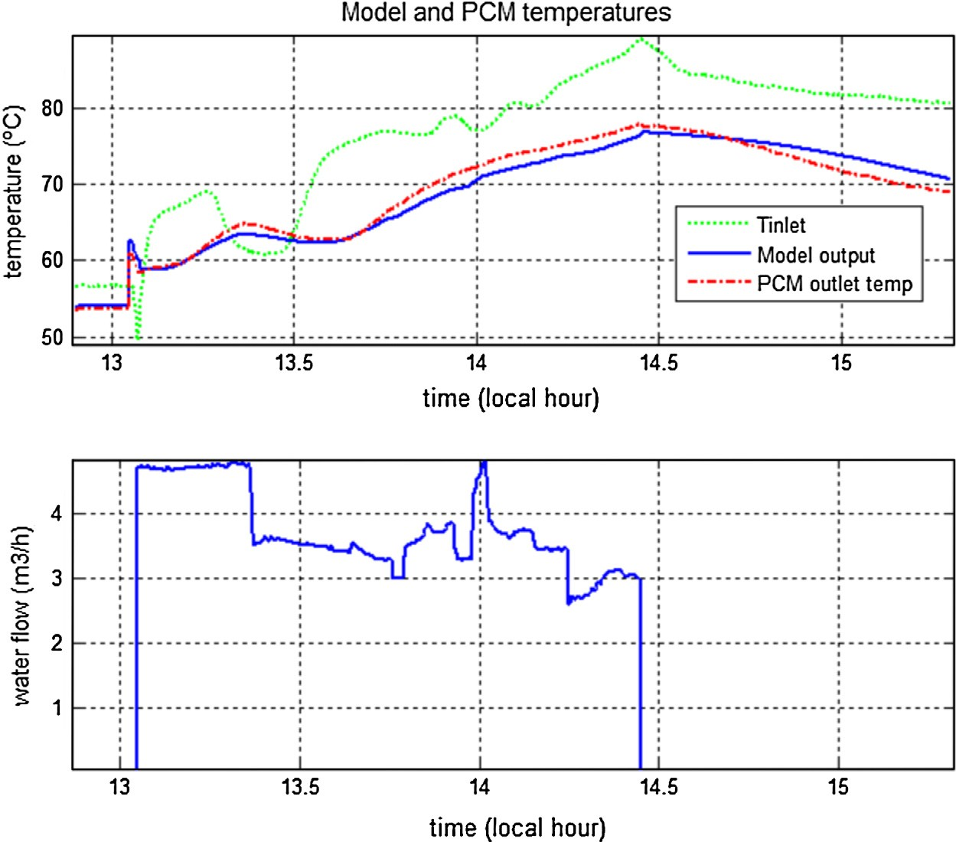

0 6 *h* 6 1400

*ri* 6 *rm* 6 *re*

*qmass*

*q* m *qwater*

3600

¼

ð11Þ

In general the solution of a nonlinear (perhaps non-convex) optimization problem may be diﬃcult. Furthermore, a glo- bal solution is not guaranteed. In order to reach a solution which makes the model work properly in the whole plant

The density and the speciﬁc heat of pressurized water have been obtained as a polynomial functions of the water temperature, using a least square algorithm. The expres- sions are as follows:

Fig. 8. Test carried out in October 2011.

8 *A.J. Gallego et al. / Solar Energy 93 (2013) 1–10*

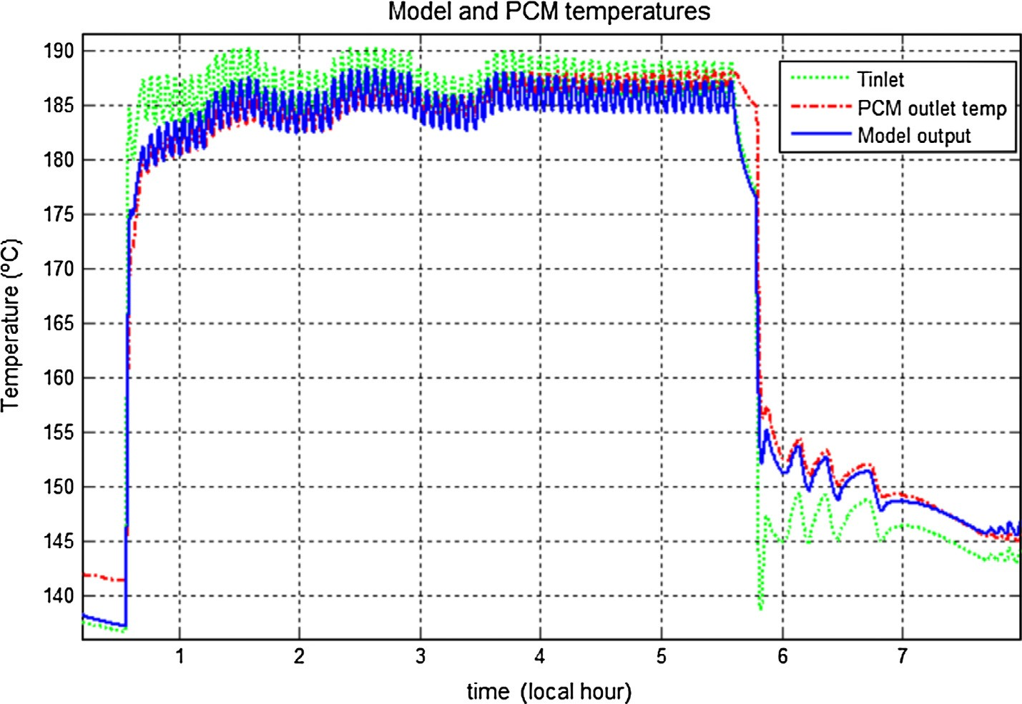

Fig. 9. Test carried out in September 2011.

Fig. 10. Test where the PCM was melted.

*qwater* ¼ —2:55*e* — 4 m *T* 2 — 0:20 m *T* þ 1003:92 ðkg=m3Þ

4 3 2

*Ks* ¼ 0:45 W=ðm KÞ

*Cpwater*

¼ 5:16*e* — 7 m *T* — 1:56*e* — 4 m *T* þ 2:76*e* — 2 m *T*

*Kl* ¼ 0:612 W=ðm KÞ

*h* ¼ 510 W=ðm KÞ

— 1:62 m *T* þ 4207:40 ðJ=ðkg KÞÞ

ð12Þ

*rm* ¼ 0:01471 m

Fig. 8 shows a test performed in October 2011. The

As far as the parameters estimation is concerned, the outcome of the optimization algorithm is as follows:

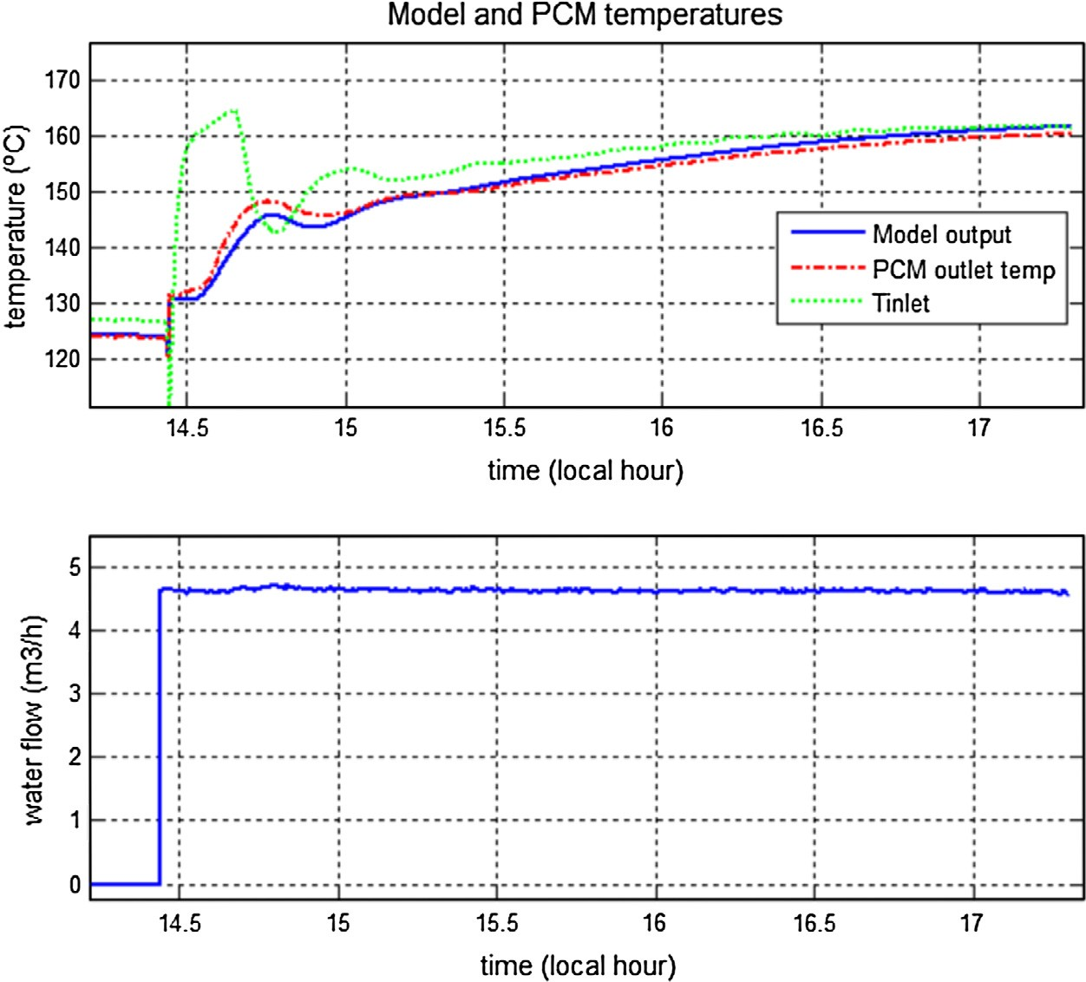

PCM temperature was about 55 °C. At 13.05 h, the valve which allows the water ﬂow to enter to the storage tank

*A.J. Gallego et al. / Solar Energy 93 (2013) 1–10* 9

is opened, and the temperature of the PCM starts to evolve. The sudden diminishing of the inlet temperature is pro- duced by the cold stagnant water at the storage tank input. Throughout the test, the model and the real PCM temper- atures are close and with a maximum error of 2.5 °C. At

14.45 h the test ﬁnishes when the tank storage input valve

is closed.

Fig. 9 shows a test carried out in September 2011. In this test, the PCM works in a medium temperature range between 125 and 160 °C. At 14.45 h, the input valve is opened and PCM starts its evolution. As can be observed, the model evolution is very similar to the real PCM, tending to be very close at the ﬁnal of the experiment. A maximum

error of 2.5 °C in the transitory phase is observed, decreas- ing at the ﬁnal of experiment up to be less than 1.3 °C, which constitutes a very good result.

Finally, Fig. 10 shows a test where the PCM was melted. The data was supplied by the GREA Innovacio´ Concur- rent for a diﬀerent tank from the one that is located at Sevilla with the same PCM (Gil et al., 2012), which can be used to obtain the conductivity *Kl*.

The initial PCM temperature is about 146 °C. Half an

hour after the beginning of the experiment, the inlet temper- ature is increased up to 185 °C, and the temperature of the PCM surpasses the melting point at 170.3 °C. In the melting part of the experiment, the inlet temperature has an oscilla- tory behavior. After 6 h, the PCM temperature drops to a value between 140 and 150 °C. As can be seen, the model evolution is very close to the PCM evolution throughout the experiment. The water ﬂow was 3 m3/h throughout the test.

As a ﬁnal remark, all tests carried out show a good model behavior in an ample range of temperatures, in spite of its simplicity. The ﬁnal outcome can be considered satisfactory.

1. Concluding remarks

This work has presented a mathematical model and the parameters estimation procedure of a PCM storage tank to be used it in hierarchical control strategies. In the ﬁrst part, process dynamic equations have been described and assumptions which simplify the model in order to reduce the computational burden are given. A study of the param- eters to be estimated, their values range and the optimiza- tion procedure have been described.

The model has been validated in an ample range of tem- peratures, working properly throughout the PCM opera- tional range, producing an adequate trade-oﬀ between complexity and modeling accuracy.

Acknowledgments

The authors want to thank to the Corporacio´n Tec- nolo´gica de Andaluc´ıa and the European Union DPI2008-05818 for supporting this work and the GREA Innovacio´ Concurrent, Universitat de Lleida for providing

data. Likewise, the author want to thank to the professor Servando A´ lvarez Dom´ınguez for his constructive remarks and useful guidelines.

References

Bermejo, P., Pino, F.J., Rosa, F., 2010. Solar absorption cooling plant in Seville. Solar Energy 84, 1503–1512.

Bertsekas, D.P., 2003. Convex Analysis and Optimization. ﬁrst ed. Athena Scientiﬁc.

Bony, J., Citherlet, S., 2007. Numerical model and experimental validation of heat storage with phase change materials. Energy and Buildings 39 (10), 1065–1072.

Camacho, E.F.C., Berenguel, M., Rubio, F.R., Martnez, D., 2012.

Control of Solar Energy Systems. Springer-Verlag.

Esen, M., Ayhan, T., 1996. Development of a model compatible with solar assisted cylindrical energy storage tank and variation of stored energy with time for diﬀerent phase change materials. Energy Conversion and Management 37 (12), 1775–1785.

EUREC, 2009. Research Priorities for Renewable Energy Technology by 2020 and Beyond. <<http://www.energy.eu/publications/a06.pdf>>.

Gil, A., Oro´, E., Salmero´n, J., Alvarez, S., Cabeza, L., 2012. Experimental analysis of the eﬀective thermal conductivity enhancement of pcm using ﬁnned tubes in high temperature bulk tanks. In: The 12th International Conference on Energy Storage, Innostock 2012, LLeida, 16th–18th May.

Grena, R., Tarquini, P., 2011. Solar linear Fresnel collector using molten nitrates as heat transfer ﬂuid. Energy 36, 1048–1056.

Hed, G., Bellander, R., 2006. Mathematical modelling of pcm air heat exchanger. Energy and Buildings 38 (2), 82–89.

Herrmann, U., Kearney, D.W., 2002. Survey of thermal energy storage for parabolic trough power plants. Journal of Solar Energy Engineering 124, 145–152.

IEA, 2012. Technology Roadmap: Solar Heating and Cooling – Foldout.

<<http://www.iea.org/publications/freepublications/publication/> name,28284,en.html>.

Ikkonen, E., Najim, K., 2002. Advanced Process in Identiﬁcation and Control. Marcel Dekker.

I.S.F.C, 2012. Industrial Solar Fresnel Collector. <http://www.industrial- solar.de/cms/>.

Jokisalo, J., Lamberg, P., Siren, K., 2000. J. jokisalo et al. thermal simulation of pcm structures with trnsys. terrastock 2000. In: Eighth International Conference on Thermal Energy Storage, Stuttgart, Germany.

Klein, S.A., 2007. TRNSYS Reference Manual.

Kreith, F., Manglik, R.M., Bohn, M.S., 2011. Principles of Heat Transfer. seventh ed.. Cengage Learning.

Lunardini, V.J., 1981. Heat Transfer in Cold Climates. Van Nostrand Reinhold Company.

Moens, L., Blake, D.M., Rudnicki, D.L., Hale, M.J., 2003. Advanced thermal storage ﬂuids for solar parabolic trough systems. Transactions of the ASME 125, 112–116.

Naterer, G.F., 2002. Heat Transfer in Single and Multiphase Systems, 978-0-8493-1032-4.

Robledo, M., Escano, J.M., Nu´nez, A., Bordons, C., Camacho, E.F., 2010. Development and experimental validation of a dynamic model for a Fresnel solar collector. In: 18th IFAC World Congress, October 2010.

Ru´ız-Pardo, A., Salmero´n, J.M., Cerezuela-Parish, A., Gil, A., A´ lvarez,

S., Cabeza, L., 2012. Numerical simulation of a thermal energy storage system with pcm in a shell and tube tank. In: The 12th International Conference on Energy Storage, Innostock 2012, LLeida, 16th–18th May.

Velrag, R., Seenirag, R., Hafner, B., Faber, C., Schwarzer, K., 1999. Heat transfer enhancement in a latent heat storage system. Solar Energy 65, 171–180.

10 *A.J. Gallego et al. / Solar Energy 93 (2013) 1–10*

Sonntag, C., Ding, H., Engell, S., 2008. Supervisory control of a solar air conditioning plant with hybrid dynamics. European Journal of Control 6, 451463.

Zalba, B., Mar´ıa, J.M., Cabeza, L.F., Melhing, H., 2003. Review on thermal energy storage with phase change: materials, heat transfer analysis and applications. Applied Thermal Engineering 23 (3), 251–283.

Zambrano, D., 2007. Modelado y Control Predictivo H´ıbrido de una Planta de Refrigeracio´n Solar. Ph.D. Thesis, Escuela Superior de Ingenieros de Sevilla.

Zambrano, D., Bordons, C., Gab´ın, W.M.G., Camacho, E.F., 2006. A

solar cooling plant; a benchmark for hybrid systems control. In: Adhs’ 06 2nd IFAC Conference on Analysis and Design of Hybrid Systems, pp. 199–204.

[View publication stats](https://www.researchgate.net/publication/278064928)