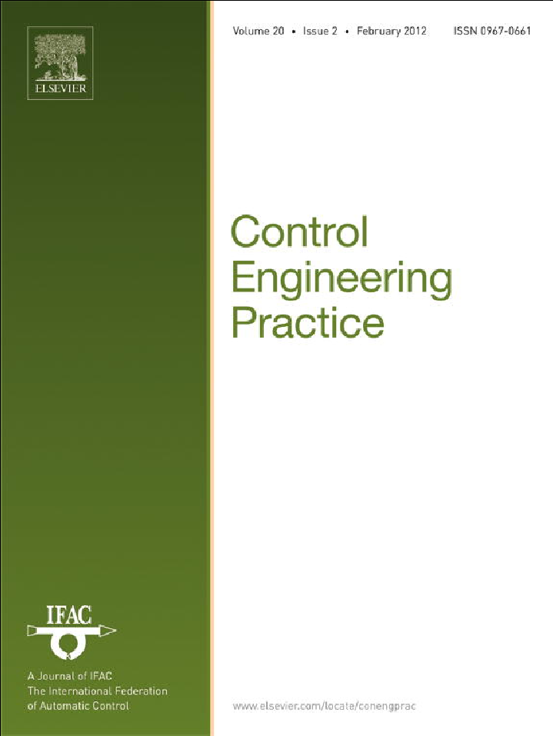

This article appeared in a journal published by Elsevier. The attached copy is furnished to the author for internal non-commercial research and education use, including for instruction at the authors institution and sharing with colleagues.
Other uses, including reproduction and distribution, or selling or licensing copies, or posting to personal, institutional or third party websites are prohibited.
In most cases authors are permitted to post their version of the article (e.g. in Word or Tex form) to their personal website or institutional repository. Authors requiring further information regarding Elsevier’s archiving and manuscript policies are encouraged to visit:
http://www.elsevier.com/copyright

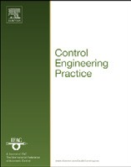
Control Engineering Practice 20 (2012) 111–122
Contents lists available at SciVerse ScienceDirect

Control Engineering Practice

journal homepage: www.elsevier.com/locate/conengprac

Chance-constrained model predictive control for spacecraft rendezvous with disturbance estimation
Francisco Gavilan ª, Rafael Vazquez ^{a,}n, Eduardo F. Camacho ^{b}
a Departamento de Ingenier´ıa Aeroespacial, Escuela Superior de Ingenieros, Universidad de Sevilla, Camino de los Descubrimientos s/n, 41092 Sevilla, Spain
b Departamento de Ingenier´ıa de Sistemas y Automa´tica, Escuela Superior de Ingenieros, Universidad de Sevilla, Camino de los Descubrimientos s/n, 41092 Sevilla, Spain

a r t i c l e i n f o

Article history:
Received 17 December 2010
Accepted 23 September 2011
Available online 29 October 2011

Keywords:
Predictive control Robust control Bounded disturbances
Constraint satisfaction problems Spacecraft autonomy
Space vehicles

a b s t r a c t

A robust Model Predictive Controller (MPC) is used to solve the problem of spacecraft rendezvous, using the Hill–Clohessy–Wiltshire model with additive disturbances and line-of-sight constraints. Since a standard (non-robust) MPC is not able to cope with disturbances, a robust MPC is designed using a chance-constrained approach for robust satisfaction of constraints in a probabilistic sense. Disturbances are modeled as Gaussian allowing for an explicit transformation of the probabilistic constraints into simple algebraic constraints. To estimate the distribution parameters a predictor of disturbances is proposed. Both robust and non-robust MPC control laws are compared using the Monte Carlo method, which shows the superiority of the robust MPC.
& 2011 Elsevier Ltd. All rights reserved.

- Introduction

Technology enabling simple autonomous spacecraft rendezvous and docking is becoming a growing ﬁeld as access to space continues to increase. After decades of development, many approaches have been proposed and there have been many experi- ences, positive and negative; see Wofﬁnden and Geller (2008) for an historical account or Fehse (2003) for the basics. For instance, one of the most recent developments in the ﬁeld is ESA’s Automated Transfer Vehicle (ATV), mainly developed by EADS Astrium, an expendable unmanned spacecraft designed to resupply the Interna- tional Space Station. ATV has automatic rendezvous capabilities, as demonstrated in its ﬁrst successful ﬂight in 2008.
The ﬁeld has become very active in recent years, with an
increasingly growing literature; for instance, among many, one can cite Richards, Schouwenaars, How, and Feron (2002), where fuel-optimal trajectories with avoidance constraints are designed using mixed-integer linear programming, Wang, Mokuno, and Hadaegh (2003), which includes autonomous rendezvous and docking capabilities into formation ﬂying satellites, Geller (2006), which uses a linear covariance analysis method to design impulsive maneuvers, or Breger and How (2008), where safe, fail- tolerant rendezvous trajectories are planned.
This work approaches the problem of rendezvous of spacecraft using a chance-constrained Model Predictive Control (MPC) with on-line prediction of disturbance statistical properties.

n Corresponding author. Fax: þ34 954486041.
E-mail addresses: fgavilan@us.es (F. Gavilan), rvazquez1@us.es (R. Vazquez), eduardo@esi.us.es (E.F. Camacho).

MPC (Camacho & Bordons, 2004) originated in the late seven- ties and has developed considerably since then. There are many applications of predictive control successfully in use at the current time, not only in the process industry but also in other applications ranging from solar technology (Camacho, Berenguel, & Bordons, 1994) to ﬂight control (Breger & How, 2006). Model Predictive Control is considered to be a mature technique for linear and rather slow systems like the ones usually encountered in the process industry.
The term Model Predictive Control does not designate a speciﬁc control strategy but rather an ample range of control methods which make explicit use of a model of the process to obtain the control signal by minimizing an objective function over a ﬁnite receding horizon. In MPC the process model is used to predict the future plant outputs, based on past and current values and on the proposed optimal future control actions. These actions are calculated by the optimizer taking into account the cost function (where the fuel cost and the future tracking error are considered) as well as the constraints.
One of the advantages of MPC is that robust control methods can be easily incorporated. In space vehicles, one can ﬁnd multiple sources of disturbances, such as position or velocity measuring errors, thruster misalignments, or even atmospheric drag; so there is a need to design robust control schemes to deal with these disturbances.
Thus, MPC is very suitable to deal with the problem of space- craft rendezvous, which is inherently slow and can be very precisely modeled by linear equations (shown in Section 2). The use of robust MPC for rendezvous of spacecraft is not new; for instance Richards and How (2003) analyzes the advantages of robust and non-robust MPC for rendezvous compared with other

0967-0661/$ - see front matter & 2011 Elsevier Ltd. All rights reserved. doi:10.1016/j.conengprac.2011.09.006

112 F. Gavilan et al. / Control Engineering Practice 20 (2012) 111–122

methods. In the work of How and Tillerson (2001) the effect of velocity measurements error during formation ﬂight is taken into
account. Sensor errors are modeled, and a robust MPC scheme is
y€ 2nx_ n²y m y
½ðR þ xÞ2 þ y2 þz2 ]3=2
¼ — þ —
þu_{y},

proposed that satisﬁes the constraints for the worst case dis- turbance, recalculating the trajectory only when the spacecraft
z€ m z
½ðR þ xÞ2 þy2 þ z2 ]3=2
¼ —
þu_{z}, ð1Þ

get out of a desired error box.
In these works, the key idea is to explicitly take into account system disturbances and uncertainties and to optimize the objective function for the worst case scenario (Camacho & Bordons, 2004). However, for these methods it is necessary to obtain an estimate on the bound of the disturbances. In Richards (2004), several methods for estimation of uncertainty properties are proposed.
This work proposes the use of the so called chance-constrained model predictive control as an alternative to design robust control- lers for spacecraft. In this approach, disturbances are incorporated into the problem constraints using a probabilistic formulation. A procedure to transform these probabilistic constraints into algebraic equations is given, and control signals are computed so the con- straints are satisﬁed with a desired probability. Chance-constrained MPC can be found in previous works (mainly for chemical engineer- ing applications), for instance, in Li, Wendt, and Wozny (2000) and Schwarm and Nikolaou (1999) where methods are proposed to deal with linear systems in which uncertainties are present in the step response coefﬁcients of the systems. These authors consider that statistical properties of unknown parameters are acquired off-line.
This work employs an on-line estimator of statistical properties
of disturbances together with the chance-constrained formulation of the problem. The advantage of the chance-constrained formulation is that it does not need to know a priori bounds on the size of the disturbances. However, it needs a distribution model for them; a Gaussian model is used which allows for an explicit solution of the probabilistic constraints into algebraic constraints, thus allowing for fast computation of a solution. The parameters of the Gaussian model are inferred from past disturbances using the on-line estimator. To the best of our knowledge, these methods have not been proposed before to solve the problem of spacecraft rendezvous.
The structure of this work is as follows. Section 2 describes the mathematical model for rendezvous spacecraft used for MPC and the constraints of the rendezvous problem. Next, Section 3 follows with a formulation of standard (non-robust) Model Predictive Control suitable for the rendezvous maneuver with continuous thrust. Then the robust chance-constrained MPC is formulated with estimation of disturbance properties. Section 4 shows a Monte Carlo comparison of the robust and non-robust methods. The comparison is also shown for elliptical target orbits, with the discrepancies due to eccentricity considered as a disturbance. Section 5 closes the work with some ﬁnal remarks.

- Model of spacecraft rendezvous

There are numerous mathematical models for spacecraft rendezvous; which one should be used depends on the para- meters of the scenario. In Carter (1998) a survey of numerous mathematical models for spacecraft rendezvous can be found.
For instance, if the target is orbiting in a circular Keplerian orbit, the general equations of the relative movement between an active chaser spacecraft and a passive target vehicle are (see Wie, 1998)
x€ ¼ 2ny_ þ n²ðR þ xÞ—m R þx þ u ,
x
where x, y, and z denote the position of the chaser in a local- vertical/local-horizontal (LVLH) frame of reference ﬁxed on the center of gravity of the target vehicle (see Fig. 1), in which x refers to the radial position, y to the in-track position, and z to the cross- track position. The velocity of the chaser in the LVLH frame is given by x_ , y_ , and z_ ; and the variables u_{x}, u_{y}, and u_{z} are the inputs (thrust actuation) acting on the chaser vehicle. R is the target orbit
radius and n ¼ m=R³ is the angular speed of the target through its orbit (where m is the gravitation parameter of the Earth, m ¼ 398600:4 km³=s2 ).
qﬃﬃﬃﬃﬃﬃﬃﬃﬃﬃﬃ
Moreover, if the approaching vehicle is close to the target,
Eq. (1) can be linearized around the rendezvous position, leading to the linear Hill–Clohessy–Wiltshire (HCW) equations (intro- duced in Hill, 1878 and Clohessy & Wiltshire, 1960) which describe with adequate precision the relative position of the spacecraft. The HCW model is the one used throughout this paper, including the possibility of disturbances to allow for unmodeled effects, and the rotation of the target vehicle.
It must be noted that, in many situations, the HCW equations are not accurate. For instance, if the target vehicle is moving in a Keplerian eccentric orbit (see Inalhan, Tillerson, & How, 2002) or if some orbital perturbations are taken into account (see for example Humi & Carter, 2008). Section 4 considers simulations with the target orbiting in an eccentric Keplerian trajectory and shows that the control design (based on the HCW equations) still works.
Considering that the control inputs are constant for each sample time interval of duration T, it is possible to derive the following discrete time version of the HCW equations:
x_{k} _{þ1} ¼ Ax_{k} þBu_{k} þd_{k}, ð2Þ
where an unknown vector d_{k} has been added to take into account possible additive disturbances.
In (2), x_{k}, u_{k} and d_{k} denote, respectively, the state, input, and disturbance at time k, where
x ¼ ½x y z x_ y_ z_]T , u ¼ ½u_{x} u_{y} u_{z}]T , ð3Þ
d ¼ ½dx dy dz dx_ dy_ dz_ ]T , ð4Þ
where d_{x}, d_{y}, d_{z}, d_{x_} , d_{y_} , and d_{z_} represent the disturbances entering the system. Both are referred to the LVLH axes as indicated by their respective subscripts.
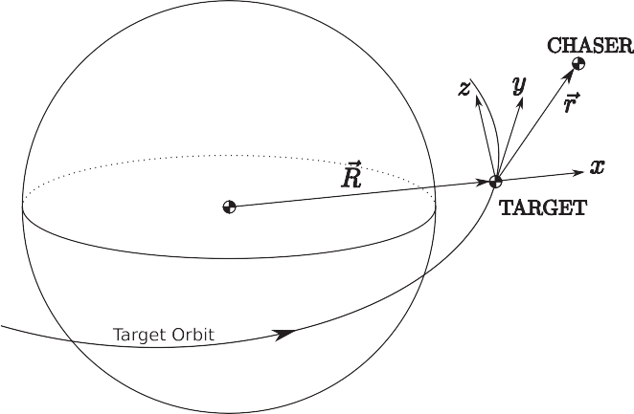

½ðR þxÞ2 þ y2 þ z2 ]3=2
Fig. 1. LVLH frame.

F. Gavilan et al. / Control Engineering Practice 20 (2012) 111–122 113

The system (2) will be used for predicting the spacecraft position in the predictive controller formulation (Section 3).
The matrices A and B appearing in (2) are given by
chaser vehicle remains inside a line of sight (LOS) area from the docking point; and second, the amount of thrust that can produce the actuators is bounded.

S
2
4—3C | 0 | 0
6ðS—nTÞ | 1 | 0
0 | 0 | C
3nS | 0 | 0

n
6 — 2ð1—CÞ
n
6
0 0

¼
2ð1—CÞ 0
4S 3nT
n
—
0
3
n 7

The LOS area is a region deﬁned to guarantee that the chaser spacecraft is all time visible from the docking point. Thus this area must be deﬁned using a new body ﬁxed frame, since the target

S
7
7 ð Þ
- n , 5
6
C 2S 0
64 75
—6nð1—CÞ 0 0 —2S 4C—3 0
0 0 —nS 0 0 C
2 n
can rotate respect to the LVLH axes used in (2), which are ﬁxed to
the orbit. Then, once the LOS region is formulated in body axes, a
transformation must be used to include these constraints into the rendezvous problem, which is formulated in the LVLH frame.
The target body ﬁxed reference frame is shown in Fig. 2. In this

1 C 2nT—2 2S
—
2
6
n

0 37
reference system, one can deﬁne the LOS region by the equations
y Zc ðx —x Þ, y Z—c ðx þx Þ, y Zc ðz —z Þ, y Z—c ðz þ z Þ

6 2ðS—nTÞ
3T²
1—C 7
B x B 0 B
x B 0
- z B 0 B
z B 0

n2 — 2 þ4 n2 0
7
6 0 0 1—C 7

n

S
and yB Z0 (where x_{B}, y_{B} and z_{B} denote the coordinates in the
body ﬁxed frame); as shown in Fig. 2.

n2
B ¼ 6 7, ð6Þ

S 2 1—nC 0
6 7
6

0 0 S
The LOS constraint is formulated as A_{L}x_{Bk} rb_{L}, where

2ðC—1Þ
n
—3T þ4 0 7 2 3

4 n n 5
c
75
6
x
—1 0 0 0 0 7
4 0 —1 c_{z} 0 0 0
0 —1 0 0 0 0

where S ¼ sin nT and C ¼ cos nT. The disturbances are unknown, so
A_{L} ¼ 6 —c_{x} —1 0 0 0 0 7, ð7Þ

it is assumed that d_{k} is a random vector, with known distribution
but unknown distribution parameters mean d and covariance R,
respectively. These disturbances might arise from errors in the input
signals (as thrusters are typically subject to command uncertainties
and are never perfectly aligned), or they could also be thought of as
unmodeled dynamics (in this case they are not random; however,
the randomness assumption is kept for convenience). In Section 4.3 the disturbance model used in simulations is described.
Even though the disturbances are modeled as additive, in Section 4.3 it is shown that the control scheme works for other kind of disturbances such as multiplicative disturbance or mod- eling errors.
  - Constraints on the problem
Two set of constraints are considered in this paper. First, for sensing purposes (see Breger & How, 2008) it is required that the
6 0 —1 —c_{z} 0 0 0
b_{L} ¼ ½0 c_{x}x₀ c_{x}x₀ c_{z}z₀ c_{z}z₀]T ð8Þ
and x_{Bk} denotes the state in the body ﬁxed reference frame.
Since these constraints are not deﬁned using the same refer- ence frame than the equation of motion used by the controller (2), a transformation of LOS constraints from body axes to LVLH frame must be done. The transformation of these matrices can be easily computed using projective geometry (see Hartley & Zisserman, 2003).
Using homogeneous coordinates, one can write the equations of a set of n planes as
pðn~4Þ x~ ¼ 0, ð9Þ

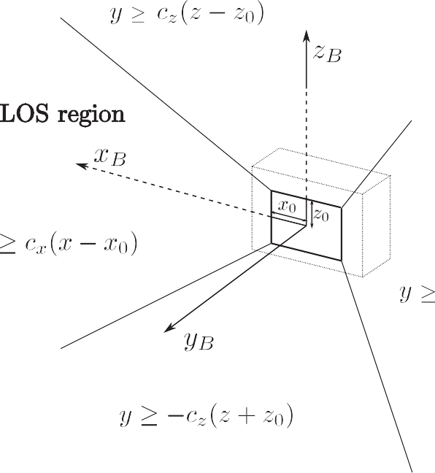Fig. 2. Line of sight region.

114 F. Gavilan et al. / Control Engineering Practice 20 (2012) 111–122

where each row of p, namely pi, deﬁnes one plane; and x~ is the vector of homogeneous coordinates, that is
x~ ¼ ½x y z 1]T : ð10Þ
It can be proven that under a projective transformation
x~ ¼ Hx~ ⁰, a plane transforms as
p0i ¼ pi H, ð11Þ
where H is a transformation matrix in homogeneous coordinates.
In this case, the LOS planes in body axes introduced in (7) and
(8) can be deﬁned as:
Dealing with the control inputs constraints, it is assumed that they are bounded above and below
u_{min} r u_{k} r u_{max}, ð19Þ
and that u_{k} can take any value in the interval, i.e., it is assumed that thruster valves can be opened partially to produce the exact amount of force.

- Robust MPC formulation

Next a robust MPC scheme is formulated; ﬁrst some notation

2 0 —1 0 0

x
32 x 3

y
is developed to formulate the general problem, and afterwards it

6 c_{x} —1 0 —c_{x}x₀ 7
B
is explained how to tackle the disturbances appearing in (2).

6 —c —1 0 —c x 76 B 7 ¼ 0: ð12Þ
6 x 0 764 z 75

64 0 —1 c_{z} —c_{z}z₀ 75 B
  - Prediction of the state

0 —1 —c_{z} —c_{z}z₀
1
|ﬄﬄ{zﬄﬄ}
The state at time k þ j, given the state at time k, and the input

|ﬄﬄﬄﬄﬄﬄﬄﬄﬄﬄﬄﬄﬄﬄﬄﬄﬄﬄﬄﬄﬄﬄﬄﬄﬄ{pzB ﬄﬄﬄﬄﬄﬄﬄﬄﬄﬄﬄﬄﬄﬄﬄﬄﬄﬄﬄﬄﬄﬄﬄﬄﬄ}
x~ _{B}
signals and disturbances from time k to time k þ j—1, is computed

The projective transformation between body axes and LVLH
j—1
¼
|ﬄﬄﬄﬄﬄﬄﬄﬄﬄﬄﬄﬄﬄ{zﬄﬄﬄﬄﬄﬄﬄﬄﬄﬄﬄﬄﬄ}
by applying recursively Eq. (2):

frame can be deﬁned as
2 C
0 0 3
!
xk j ¼ Ajxk þ X Aj—i—1Buk
i þ X Aj—i—1 dk
i: ð20Þ

x~ _{B}
R3~3 t3~1
01~3 1
x~ LVLH
þ
, ð13Þ
6 6 77 y—c C —S c S —C 0 —c x ¼ 0, ð16Þ_{O} _{O} _{O} _{O}
75
where now x, y and z are the coordinates of the chaser spacecraft
7
64
75
i ¼ 0
þ þ
i ¼ 0
j—1
,
1
2
3
^
i—j i—j

H
75
6
46
where R is a rotation matrix from LVLH frame to body axes, and t
is a translation vector which contains the coordinates of center of
Deﬁne now x_{S}ðkÞ, u_{S}ðkÞ, d_{S}ðkÞ as a stack of N_{p} · n_{x} states, N_{p} · n_{u}
input signals, and N_{p} · n_{x} disturbances beginning at time k, where
x
6
X
^
S
64
^
75
S
N_{p} is the prediction horizon, n_{x} is the number of state variables
and n_{u} is the number of control inputs:

the LVLH frame respect to the center of the body axes.
Thus, the set of constraint planes in the LVLH frame can be
2 xk þ 1 3
6 k þ 2 7
u_{k}
6 uk þ 1 7

computed as:
x_{S}ðkÞ¼ 64 ^ 75, u_{S}ðkÞ¼ 64 ^ 7

pLVLH ¼ pBH ð14Þ
For instance, if the target spacecraft is rotating around the
S_{O}
z_{LVLH} axis with angular velocity O, the transformation matrix H is
xk þ N_{p}
2 dk 3
uk þ N_{p} —1 5

deﬁned as
O
d ðkÞ¼ 6
dk þ 1
7: ð21Þ

6 —S_{O} C_{O} 0 0 7
dk þ N_{p} —1

H ¼ 64
0 0 1 0 , ð15Þ
0 0 0 1
Then,
2
Ax_{k} þBu_{k} þd_{k} 3

where C_{O} ¼ cos ðOtÞ and S_{O} ¼ sin ðOtÞ. Thus, the transformed LOS
6 2 X
1—i. Σ 7

lines are computed as follows:
2 3
A x_{k} þ
x ðkÞ¼ 6
A
i ¼ 0
Buk þ i þdk þ i
7, ð22Þ

—S_{O} —C_{O} 0 0
2 x 3 6 7

c_{x}C_{O}—S_{O} —c_{x}S_{O}—C_{O} 0 —c_{x}x₀
6 x x x 0 764 z 75
64 AN_{p}
x_{k} þ
N_{p} —1
AN_{p} —1—i
ðBuk þ idk þ i Þ 75

—S_{O} —C_{O} c_{x} —c_{x}z₀ 1
—S_{O} —C_{O} c_{z} —c_{z}z₀
|ﬄﬄﬄﬄﬄﬄﬄﬄﬄﬄﬄﬄﬄﬄﬄﬄﬄﬄﬄﬄﬄﬄﬄﬄﬄﬄﬄﬄﬄﬄﬄﬄﬄﬄﬄﬄﬄpﬄﬄ{LVzLHﬄﬄﬄﬄﬄﬄﬄﬄﬄﬄﬄﬄﬄﬄﬄﬄﬄﬄﬄﬄﬄﬄﬄﬄﬄﬄﬄﬄﬄﬄﬄﬄﬄﬄﬄﬄﬄﬄﬄ}
in the LVLH frame.
Using these terms, the LOS constraint matrices become:
i ¼ 0
which can be written as
x_{S}ðkÞ¼ Fx_{k} þ G_{u}u_{S}ðkÞþ G_{d}d_{S}, ð23Þ
where G_{u} and G_{d} are block lower triangular matrix with its non-
null elements deﬁned by ðG_{u}Þ_{ij} ¼ A B and ðG_{d}Þ_{ij} ¼ A (with i Z j),
and the matrix F is deﬁned as:

2 —S_{O} —C_{O} 0 3
2 A 3

6 c_{x}C_{O}—S_{O} —c_{x}S_{O}—C_{O} 0 7
6 A2 7

A⁰ ¼ 6 —c C —S c S —C 0 7,
H
F ¼ 6 ^ 7: ð24Þ

L x O O
x O O
5~3 4 5

—S_{O} —C_{O} c_{z}
—S_{O} —C_{O} c_{z}
AN_{p}
Note that it is assumed that the control logic has perfect knowledge of the state vector x_{k}.

b⁰L ¼ ½0 c_{x}x₀ c_{x}x₀ c_{z}z₀ c_{z}z₀]T , ð17Þ
where H_{5~3} is a matrix full of zeros, with dimensions 5 ~ 3. Notice that in this situation A0L and b0L become time dependent.
Then the LOS constraint in the LVLH frame can be rewritten as:
  - Objective function
Taking mathematical expectation, deﬁne x^
k þ j9k
¼ E½x_{k}
þ j], the

A⁰Lx rb⁰L : ð18Þ
expected value of x_{k} _{þj} given x_{k}. Similarly deﬁne x_{S}ðk þ j9kÞ¼
E½x_{S}ðk þjÞ]. For the MPC formulation the following cost function

F. Gavilan et al. / Control Engineering Practice 20 (2012) 111–122 115

is used:
N_{p}
XJðkÞ¼ ½x
^ T
k þ i9k
i ¼ 1

Rðk þ iÞx^

k þ i9k

N_{p}
uT
X]þ ½
k þ i—1
i ¼ 1

Id_{3~3}u

k þ i—1

], ð25Þ

set to the ﬁrst three components of u_{S}, and the computation is repeated for every time step.
However, if the disturbances are not known but rather their mean and variance are known, it is necessary to modify (33), as it

where the matrix RðkÞ is deﬁned as
RðkÞ¼ ghðk—k Þ" Id3~3 H3~3 #: ð26Þ
is explained next.

3.4. Robust satisfaction of constraints

a H3 3 H3 3
~
~

In (26), h is the step function, k_{a} is the desired arrival time for
To eliminate the disturbances from (31), a bound of the term

docking, g a large positive number, and Id
3~3
, H3~3
are, respec-
—A_{c}G_{d}d_{S} must be found to enforce the satisfaction of constraints
in presence of disturbances. Two procedures are given, depending

tively, the identity matrix and a matrix full of zeros, both of
order 3 by 3.
on which disturbance properties are available.
Assume ﬁrst that some bounds for the disturbances are known,

The reason for choosing (26) is that it is desired to arrive at
the origin at time k_{a} (and remain there) and at the same time
i.e., d has the property that ðd_{x}Þ_{min}
rd_{x} rðd_{x}Þ

max
and similarly for

minimize the control effort.

Remark 1. The relative position during the maneuver is not impor- tant as long as constraints are satisﬁed and docking is reached on time.

Using (23), and since E½dðk þ iÞ] ¼ d, Eq. (25) can be rewritten as:

JðkÞ¼ ðG_{u}u_{S}ðkÞþ Fx_{k} þG_{d}d_{S}ÞT R_{S}ðG_{u}u_{S}ðkÞþ Fx_{k} þ G_{d}d_{S}Þþu^{T} Q S u_{S},
ð27Þ
S

where d_{S} is a stack vector with d repeated N_{p} times, Q S ¼ Id_{3N}p ~3Np
and R_{S} is a block diagonal matrix deﬁned by:
the rest of the components of d. Those bounds are summarized as
A_{d}d_{S} rc_{d}. Hence, it is assumed that the region deﬁned by this constraint is enclosed by a polytope. Then, it is possible to eliminate
the disturbances from (31) by bounding the term —A_{c}G_{d}d_{S}. This would give
A_{c}G_{u}u_{S} r b_{c}—A_{c}Fx_{k}—A_{c}G_{d}d_{S} r b_{c}—A_{c}Fx_{k} þ b_{d}ðkÞ, ð34Þ where b_{d}ðkÞ is column vector, whose i-th term ðb_{d}ðkÞÞ_{i} is given by ðb_{d}ðkÞÞ_{i} ¼ min a_{i}d_{S},
d_{S}
s:t: A_{d}d_{S} rc_{d}, ð35Þ

Rðk
2
R_{S} ¼ 64
þ1Þ
&

Rðk þ N_{p}Þ
37: ð28Þ
where a_{i} is the i-th row of the matrix —A_{c}G_{d}. Since the function
to minimize is linear and the feasible region is enclosed by a polytope, this minimization can be rapidly solved.
Eq. (34) represents the constraints computed for the worst- case disturbances. Hence, enforcing (34) the constraints (29) are

Using the notation above developed with the LOS constraints
formulated in Section 2.1, the constraints equations for the state can be rewritten as:
A_{c}x_{S} rb_{c}, ð29Þ
where A_{c} and b_{c} are given by:
robustly satisﬁed, i.e., satisﬁed for any possible disturbance.
However, if the disturbance bounds are not precisely known, but the disturbance is modeled as a random vector, the inequality b_{d}ðkÞr—A_{c}G_{d}d_{S} is made to be satisﬁed with a certain probability. This probability should be near one, thus guaranteeing that the inequality is satisﬁed for almost all disturbances.
5

A0L ðk þ 1Þ
2
A_{c} ¼ 64

&
A0L ðk þN_{p}Þ
37,
Assuming that the disturbances are normally distributed (d ~ N₆ðd,RÞ), and that their mean (d) and covariance matrix (R ¼ R^{T} 4 0) are known, it is possible to write (see Rencher, 1998)

d ~ N₆ðd,RÞ ) ðd—dÞT R^{—1}ðd—dÞ~ w2 ð6Þ, ð36Þ

b_{c} ¼ ½b⁰L ðk þ 1Þ · · · b⁰L ðk þN_{p}Þ]T : ð30Þ
5
Using Eq. (23), one can reformulate the LOS constraints as constraints for the control signals in the following way:
A_{c}G_{u}u_{S} rb_{c}—A_{c}Fx_{k}—A_{c}G_{d}d_{S}, ð31Þ
and similarly it is possible to write (19) as:

where w2 ð6Þ is a chi-square probability distribution with six degrees of freedom.
Assuming that the statistical properties of the disturbances are time-invariant, Eq. (36) is valid for the disturbances at all times k þ j for j ¼ 0, ... ,N_{p}—1:
2

u~ min
r u_{S} ru~
max,
ð32Þ
ðd_{k}
j—dÞT R—1 ðdk
þ j—dÞ~ w ð6Þ,

being u~
þ

min
and u~

max
stacks of N_{p}
~ n_{u}
minimum and maximum
j ¼ 0, ... ,N_{p}—1: ð37Þ

bounds of the control input.

3.3. Computation of control input
Hence, ﬁnding a from the equation:
Pðw2 ð6ÞraÞ¼ p, ð38Þ
it is guaranteed with probability p that

To compute the control input at time k, one seeks the control signal that minimizes the cost function over the prediction
ðd_{k}
j—dÞT R—1 ðdk
þ j—dÞra: ð39Þ

horizon, satisfying at the same time the constraints:
þ

min J x_{k},u_{S},d_{S} ,
u_{S}
ð Þ
Thus, p is a parameter of the control design and should be close to unity.
Then, dividing the inequality by a, b_{d}ðkÞ can be found by solving

s:t: A_{c}G_{u}u_{S} r b_{c}—A_{c}Fx_{k}—A_{c}G_{d}d_{S} 8d_{S},
u~ min r u_{S} ru~ max: ð33Þ
the following minimization problem for each row i of A_{c}G_{d}.
ðb_{d}ðkÞÞ_{i} ¼ min a_{i}d_{S},
d_{S}

Since the cost function is quadratic and the constraints are linear, if the future disturbance d is perfectly known (for example,
s:t: ðd_{k} _{þj}
—dÞT ðaRÞ—1 ðdk þ j

—dÞr 1,

in the undisturbed case) then (33) can be solved; the control u_{k} is
j ¼ 0, ... ,N_{p}—1, ð40Þ

116 F. Gavilan et al. / Control Engineering Practice 20 (2012) 111–122

where a_{i} and ðb_{d}ðkÞÞ_{i} are the i-th row of the matrix —A_{c}G_{d} and the
Pk—1 e—lðk—iÞðdi —d^ kÞðdi —d^ kÞT

vector b_{d}ðkÞ, respectively.
Now, breaking down the stack vector d_{S} into each of its
R^ k ¼
i ¼ 0
Pk—1 e—lðk—iÞ
, ð49Þ

components d_{k} up to d_{k} _{þN}p —1 , it is possible to write a_{i}d_{S} ¼
i ¼ 0
where l4 0 isa forgetting factor. Even though it has been assumed

PN_{p} —1 a d
. Thus, the minimization problem can be written as:
that the disturbances are just a random variable, this would help

j ¼ 0
ij k þ j

N_{p} —1
accommodate the case in which they are a random process, i.e.,
their statistical properties change with time.
i ¼ 0

b_{d} k i min a_{ij}d_{k} _{j},
Xð ð ÞÞ ¼ _{þ}
dk þ ^{j} j ¼ 0
Deﬁne gk
gression,
¼ Pk—1 e—lðk—iÞ. Using the sum of a geometric pro-

s:t: ðd_{k} _{þj}—dÞT ðaRÞ—1 ðd_{k} _{þj}—dÞr 1,
e—l 1 e—lk

j ¼ 0, ... ,N_{p}—1: ð41Þ
1

gk ¼
ð —
1—e—l
Þ : ð50Þ

Deﬁning zðjÞ¼ H2 ðd_{kþj}—dÞ, where H ¼ ðaRÞ—1 (being
H ¼ H^{T} 40), it is possible to write (41) as:
N_{p} —1
d i
ij
ij

Then, it is possible to deﬁne recursive formulas for (48) and (49)
as follows:
e—l
gk

ðb Þ ¼ min X ða H^{—1=2}zðjÞþa dÞ,
d^ k ¼ ðgk—1 d^ k—1 þd_{k—1}Þ, ð51Þ

s:t: zðjÞT zðjÞr 1, j ¼ 0, ... ,N_{p}—1, ð42Þ
zðjÞ
j ¼ 0
which can be rewritten as
e—l
k ¼ g ð k—1 k—1 þð k—1 — kÞð k—1 — kÞ Þ ð Þ
T
k
R^ g R^ d d^ d d^ , 52

ðb_{d}Þ_{i} ¼
N_{p} —1
minða_{ij}H^{—1=2}zðjÞÞþa_{ij}d ,
X . Σ
with d^ 0 ¼ 0, R^ 0 ¼ 0.
These formulas allow to save memory, only needing to store

j ¼ 0
zðjÞ
the last estimate of the mean and covariance.

s:t: zðjÞT zðjÞr 1,
j ¼ 0, ... ,N_{p}—1: ð43Þ
Problem (43) can be explicitly solved independently for each j
via the Lagrange formalism, yielding the minimum at
H—1=2 aT
z^{n}ðjÞ¼ — qﬃﬃﬃﬃﬃﬃﬃﬃﬃﬃﬃﬃﬃiﬃjﬃﬃﬃﬃ : ð44Þ
a_{ij}H^{—1}aT

ij
Substituting into (43) the rows of the vector b_{d}ðkÞ are
Once the mean and covariance are estimated, the procedure outlined in Section 3.4 can be used.

- Simulation results

  - Rendezvous model

It is important to remark that although the controller shown in Section 3 is designed using the linear HCW model (2), in simula-
tions the general nonlinear model of spacecraft rendezvous (1)

NXp —1 . qﬃﬃﬃﬃﬃﬃﬃﬃﬃﬃﬃﬃﬃﬃﬃﬃﬃﬃ Σ
ij

ðb_{d}ðkÞÞ_{i} ¼
j ¼ 0
— aij H—1 aT þ aijd
: ð45Þ
has been considered.
Dealing with the model parameters, it has been considered that
the case of a target spacecraft ﬂying in a circular orbit at 500 km

Once the vector b_{d}ðkÞ is calculated (using Eq. (35) or (45)), the
control input at time k is now computed from

min J x_{k},u_{S},d_{S} ,
u_{S}
ð Þ
s:t: A_{c}G_{u}u_{S} rb_{c}—A_{c}Fx_{k} þ b_{d}ðkÞ,
u~ min r u_{S} ru~ max, ð46Þ
where now everything is known except for the control inputs to be computed.
In simulations, the probabilistic method is used to compute the robust MPC control.

3.5. Disturbance estimation algorithm

The robust satisfaction of constraints presented in Section 3.4 requires knowledge of disturbance statistical properties. How- ever, it is often the case that such properties are completely unknown and have to be obtained on-line.
To do so, it is assumed that the disturbances are normally distributed with mean d and covariance matrix R, i.e., d ~ N₆ðd,RÞ.
At each time k, d and R are estimated taking into account all
past disturbances, which can be computed a posteriori as
d_{i} ¼ x_{i} _{þ1}—Ax_{i}—Bu_{i}, ð47Þ
for i 1, ... ,k 1.
¼ —
Then d^ k and R^ k, the estimates of d and variance R at time k, based on disturbances up to time k—1, are given by
Pk—1 e—lðk—iÞdi

of altitude, which means that R₀ ¼ 6878 km and n ¼ 1:1068~
10 rad=s.
—3
Concerning the constraints, the maximum and minimum amount of acceleration that can provide the chaser’s actuators are u_{max} ¼ 10^{—3} m=s2 and u_{min} ¼ —10^{—3} m=s2, respectively (all the actuators have the same values). The LOS area is estated with the parameters: x₀ ¼ z₀ ¼ 1:5 m and c_{x} ¼ c_{z} ¼ 1 (see Fig. 2).
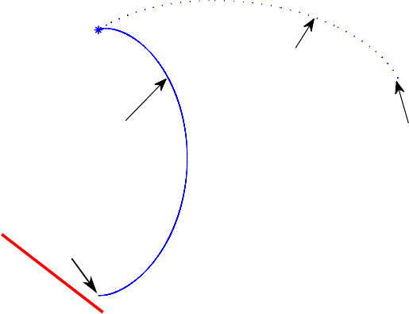XY plane trajectory
Docking
ea

Forbidden ar

on

onstraint violati
C

PC,
se

Non−robust M undisturbed ca

C,
e

Non−robust MP disturbed cas

Starting point

20

15
y [m]

10

5

0
−5 0 5 10 15 20
x [m]

d^ i ¼ 0
¼ Pk
k—1 e—lðk—iÞ
i ¼ 0
, ð48Þ
Fig. 3. Non-robust MPC without disturbances (solid line) and with disturbances
(dashed line). For clarity, only the XY plane is shown.

F. Gavilan et al. / Control Engineering Practice 20 (2012) 111–122 117

In addition, in some simulations it has been considered that the target vehicle has an eccentric orbit. In these cases, the motion of each vehicle is simulated separately using the general equation for a Keplerian orbit (which can be found in Wie, 1998), and then differentiating both trajectories to obtain the relative position.

  - Disturbances model

When designing the control laws, it was considered that the commanded forces were equal to u_{real} ¼ ½u_{x} u_{y} u_{z}]T , which are the real forces applied to the spacecraft. To include disturbances, u_{real} is modeled not as being the exact control signal commanded by

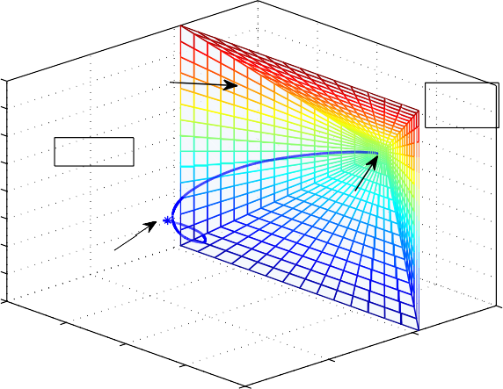3D chaser path
LOS constraints
F
Docking
Starting point
10
0
x [m]
−10
40
20
y [m]
−20
60
zone
Safe
orbidden area

20
15
10
5
z [m]
0
−5
−10
−15
−20
20 0

Fig. 4. Path followed by the chaser spacecraft (d₁ : d ¼ ½0:2592 0:8065 —0:0533]~ 10— , S_{ii} ¼ 1 ~ 10— ; dh : d_{i} ¼ 0:0436, S_{ii} ¼ 0:0436). Controller parameters are N_{p} ¼ 60, g ¼ 1000, k_{a} ¼ 60, p ¼ 0.95, l ¼ 0:23.

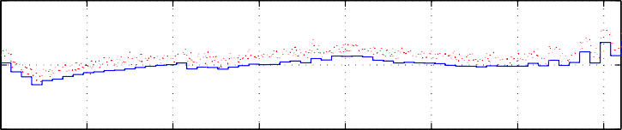
0.2
pﬃﬃﬃﬃﬃﬃ pﬃﬃﬃﬃﬃﬃ₄ ₅

the controller, but rather as
u_{real} ¼ TðdhÞðu þd₁Þ, ð53Þ
where u is the commanded output computed by the control laws, d₁ is a random variables, and TðdhÞ is a rotation matrix where dh is a vector of small, random angles modeling imperfect alignment.
Hence in this case the disturbance d ¼ BððTðdhÞ—IdÞu þ TðdhÞd₁Þ, which is not strictly an additive disturbance. The matrix B is deﬁned in Eq. (6).
These disturbances model several physical aspects. First, the attitude control of the chaser is not perfect, so one can expect some alignment errors; those are modeled by TðdhÞ. It can be noted that the disturbance attitude angles may not have zero mean value, since some bias in the sensors or actuators can exist and lead to a steady state error. On the other hand, with d₁ one can model thrust disturbances. Notice that it might have nonzero mean value, introducing some bias in the thrust level.
Finally, it must be noted that in several simulations, an eccentric orbit of the target spacecraft have been considered, so equations (1) are no longer valid. The new equations of move- ment are given in reference Inalhan et al. (2002). Since the circular equations (1) are similar to the eccentric equations (at least for moderate values of eccentricity) the difference between the models can be thought of as unmodeled dynamics.

  - Simulation results

    - Robust vs non-robust controller
Next the results obtained by the non-robust controller (33) are shown, where the disturbances are just ignored. In Fig. 3, two scenarios are considered: one ideal case in which disturbances do not exist (solid line) and another more realistic situation in which thrusters disturbances and misalignments errors are present. The non-robust controller achieves perfect rendezvous for the nom- inal case satisfying the constraints, whereas in the perturbed case the controller violates the constraints and is not able to reach the target.

Thrust

0
ux/umax

−0.2
0 500 1000 1500 2000 2500 3000 3500
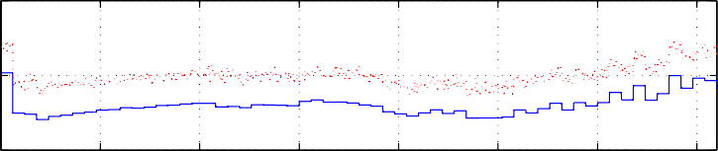
0.2

0
uy/umax

−0.2
0
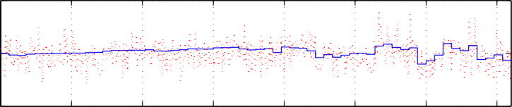
0.05

500 1000

1500

2000

2500 3000 3500

0
uz/umax

−0.05
0

500 1000 1500

2000
Time [s]
pﬃﬃﬃﬃﬃﬃ pﬃﬃﬃﬃﬃﬃ

2500 3000

3500

Fig. 5. Control signals (d₁ : d ¼ ½0:2592 0:8065 —0:0533]~ 10^{—4}, S_{ii} ¼ 1 ~ 10^{—5} ; dh : d_{i} ¼ 0:0436, S_{ii} ¼ 0:0436). Controller parameters are N_{p} ¼ 60, g ¼ 1000, k_{a} ¼ 60, p ¼ 0.95, l ¼ 0:23. The solid and dotted lines represent the commanded control signals (u) and the real control applied (u_{real}), respectively. Notice that u_{max} for all the actuators was deﬁned as u_{max} ¼ 10—3 m=s².

118 F. Gavilan et al. / Control Engineering Practice 20 (2012) 111–122

Introducing now the robust MPC controller designed in Section 3.4, a rendezvous maneuver in a disturbed environment is shown in Fig. 4, where, it can be seen that now the chaser spacecraft’s path is maintained inside the safe zone. In Fig. 5, the control signals computed by the robust MPC controller (solid lines) and the real forces applied to the spacecraft (dotted lines) are presented. Notice the disturbances in the real control signals applied, which have severe bias and large typical deviation.
The trajectory followed by the chaser spacecraft is also shown in Fig. 6. It can be seen that the controller is not only able to make the spacecraft follow a safe path, but also guarantees that the target is reached on time.
Since the disturbances introduced in the model are random variables with normal distribution of probability (see Section 4.2), a Monte Carlo analysis is conducted to get more conﬁdence on the controller design. A number of 1220 simulations have been done for both robust and non-robust controllers, using same
properties of the misalignment disturbance vector dh were set to the same values as shown in Fig. 5.
The result of the analysis is summarized in Table 1, where the advantages of the robust MPC can be seen. In 100% of the scenarios simulated, the robust controller was able to achieve rendezvous, guiding the chaser spacecraft to a docking position less than 20 cm (d denotes the distance to the target at the arrival time). The non-robust controller only could achieve the rendez- vous in the 40.9% of the cases, reaching docking positions farther than the robust one.
In addition, it can be seen that the robust controller is not only able to achieve the rendezvous with more guarantees but it also can do the maneuver with less cost. Fig. 7 plots the mission cost

Table 1
Results of a simulation batch of 1220 cases for both robust and non-robust controllers. d is the distance the relative distance at the desired arrival time.

the parameters and disturbance distribution for both cases. The
Performance indicator Non-robust
MPC (%)
Robust
MPC (%)

selected parameters were N_{p} ¼ 60, g ¼ 1000, k_{a} ¼ 60, p ¼ 0.975,

l ¼ 0:1 and T ¼ 40 s. Regarding the disturbances, since the mean of the bias in the thrust force (d₁) has a strong inﬂuence in the simulation result, its value was selected for each simulation in the
interval d A½—0:05u , 0:05u ] m=s, with constant probability.
max
max
i
Constraint violations 59 0
d r 0:2m 19 100
0:2 m r d r 0:5m 22 0
0:5 m r d 0 0

Mean cost (m/s) of successful missions 0.2444 0.2039

The standard deviation for d₁ was pSﬃﬃﬃﬃiﬃiﬃ ¼ 0:01u_{max}. The statistical

5
0
x
−5

50
0
y
−50

5

0
z

0 500 1000 1500 2000 2500 3000 3500

0 500 1000 1500 2000 2500 3000 3500
e to arrive

e to arrive
← Tim
← Tim

e to arrive
← Tim

−5
0 500 1000 1500 2000 2500 3000 3500

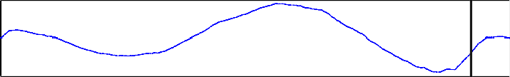0.01
← Tim
dx/dt
0
−0.01

e to arrive

0.04
0.02
dy/dt
0
−0.02
−0.04
0 500 1000 1500 2000 2500 3000 3500

0 500 1000 1500 2000 2500 3000 3500
← Ti

me to arrive

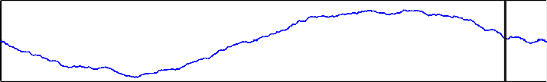
5 x 10−3
dz/dt
← Ti

0

−5
0 500 1000 1500 2000 2500 3000 3500
t [s]

me to arrive

Fig. 6. Time evolution of the system states (d₁ : d ¼ ½0:2592 0:8065 —0:0533]~ 10^{—4} , S_{ii} ¼ 0:5 ~ 10^{—5}; dh : d_{i} ¼ 0:0436, S_{ii} ¼ 0:0436). Controller parameters are
N_{p} ¼ 60, g ¼ 1000, k_{a} ¼ 60, p ¼ 0.95, l ¼ 0:23.
pﬃﬃﬃﬃﬃﬃ pﬃﬃﬃﬃﬃﬃ

F. Gavilan et al. / Control Engineering Practice 20 (2012) 111–122 119

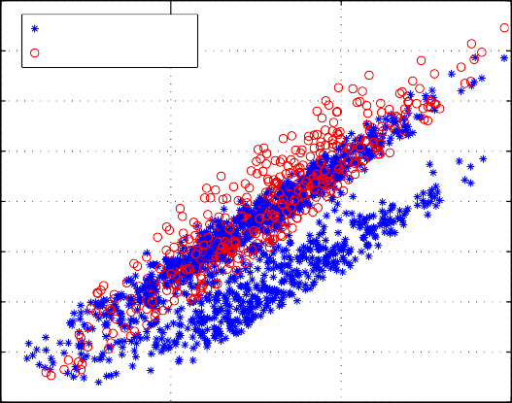0.45
Robust MPC Non−robust MPC

0.4

0.35
Mission cost [m/s]

0.3

0.25

0.2

0.15

0.1

0.05
0

0.5 1 1.5

obtained for each simulation, against the L₁-norm of the mean disturbance vector d₁. Notice that only successful missions are depicted in the ﬁgure and that the number of points corresponding to the non-robust MPC is signiﬁcantly smaller than the number corresponding to the robust MPC, where all missions were success- ful. For both controllers, the cost seems to increase with 9d₁91 , but in
most cases, the robust controller can achieve the rendezvous with
less cost than the non-robust one.
This fact is appreciated in Fig. 8 where is plotted the increment in the mission cost of the non-robust controller respect to the robust one, in the cases when both controllers can achieve rendezvous without constraints violations. It can be found that using the non- robust controller implies a 15% of cost increment.

    - Eccentric orbit
Unmodeled dynamics due by eccentricity (e) in the target orbit

|δ1| x 10−4
Fig. 7. Mission cost plotted against the L₁-norm of the mean of the disturbance vector d₁.

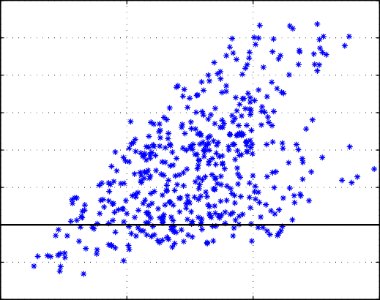
0.12

0.1

0.08
Mission cost difference [m/s]

0.06

0.04

0.02

0

−0.02

−0.04
0 0.5 1 1.5
are considered next. Several values of the target eccentricity are tested for both robust and non-robust controllers, without con- sidering thruster and misalignments disturbances.
The controller parameters are set to the same values as in the Monte Carlo analysis. The results obtained can be seen in Figs. 9 and 10 (notice that only the XY-plane is represented for more simplicity). It is shown that even in the absence of thruster or misalignments disturbances, the presence of an eccentric orbit causes the non-robust controller to violate the constraints (see Fig. 9), while the robust controller is able to achieve the rendezvous without constraint violations (Fig. 10).

    - Rotating target
In the previous simulations, the target spacecraft has a ﬁxed attitude in the LVLH frame (this means that the target spacecraft has a rotation respect to an inertial reference system with orbital frequency n), however, it might be possible to ﬁnd situations in which the target spacecrafts is not ﬁxed to this frame.
For instance, let consider the case in which it is desired that the target spacecraft is pointing to a ﬁxed direction (for example, to a ﬁxed star). Then it must have some angular velocity respect

|δ1|1
[m/s]
x 10−4
to the LVLH frame, since these axes are rotating with angular
velocity O_{LVLH} ¼ nk_{LVLH} respect to an inertial reference frame.

Fig. 8. Increment of the non-robust controller mission cost with respect to the robust one (in m/s), plotted against the L₁-norm of the mean of the disturbance vector d₁. Only successful missions are compared.
Then, to maintain the target attitude ﬁxed to an inertial frame, it must have an angular velocity O_{target} ¼ —nk_{LVLH}. Thus, the LOS constraint (which are deﬁned in a body ﬁxed reference frame)

XY plane chaser path
Starti |  | ng point
0.1
0.08
0.06
0.04  0.02  0 |  |  |  |  |  |  |  |  |  |  |  |  | e = 0.05  e = 0.1
 |  |  |  |  |  |  | Co |  | nstrain | t
−0.02  −0.04  −0.06 |  |  |  |  |  |  |  |  |  |  |  |  |  |  | e  e = 0.2
0. |  | 2 0.3 0. |  | 4 0.5 0 |  | .6 0.7 |  | 0.8 0.9
Docki |  | ng |  |  |  |  |  |  |  |  |  |  |  | e = | 0.15

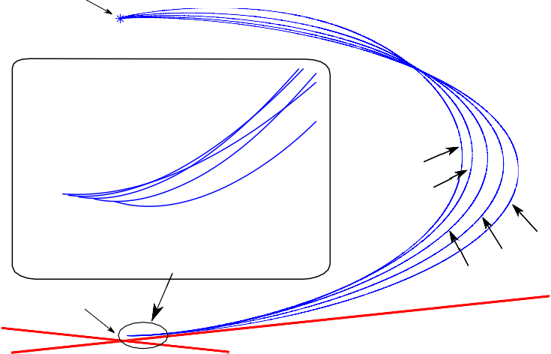
50

40

30
y [m]

20
= 0.25

10

0
−2 0 2 4 6 8 10 12 14
x [m]
Fig. 9. Non-robust MPC with unmodeled dynamics. Controller parameters are N_{p} ¼ 60, g ¼ 1000, k_{a} ¼ 60 and T ¼ 45 s.

120 F. Gavilan et al. / Control Engineering Practice 20 (2012) 111–122

XY plane chaser path

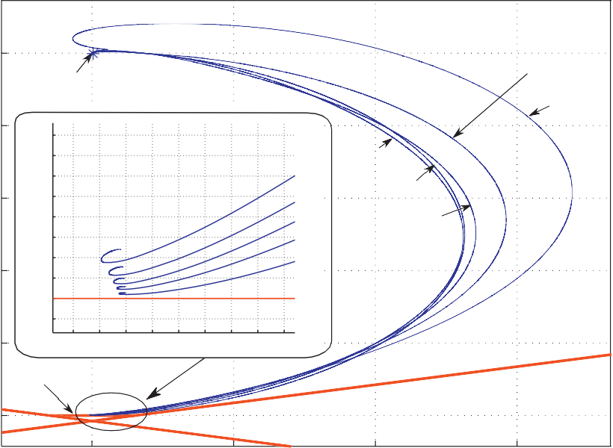50
Starting point

0.4
0.35
0.3
0.25
0.2
0.15
0.1
0.05
0
−0.05
0.25
0.2
0.15
0.1
e =
0.05
−0.2 −0.1 0 0.1 0.2 0.3 0.4 0.5 0.6
Docking

e = 0.15

0.05
e = 0.1
e = 0.2

e = 0.25

40

30
y [m]

20

10

0

0 5 10 15
x [m]
Fig. 10. Robust MPC with unmodeled dynamics. Controller parameters are N_{p} ¼ 60, g ¼ 1000, k_{a} ¼ 60, p ¼ 0.99, l ¼ 0:23 and T ¼ 45 s.

20
15
10
5
z_{B} [m]
0
−5
−10
−15
−20
20
3D chaser path
that the chaser is able to follow the LOS-zone movement, and as shown in Fig. 13 (which depicts the time evolution of the system states) it achieves rendezvous at the desired time. Additionally, the applied control signals during the maneuver are shown in Fig. 12.

- 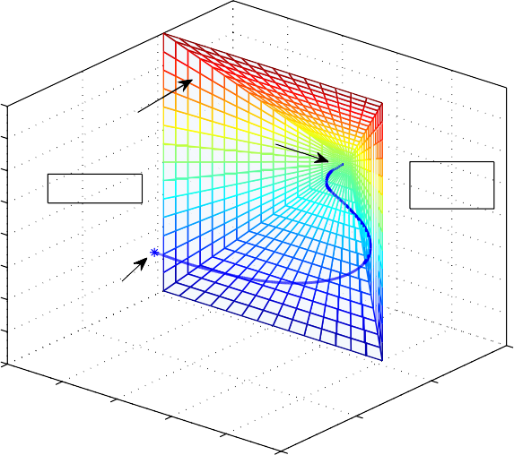Concluding remarks
LOS constraints
Docking
Starting point
10
20
0
x_{B} [m]
−10
40
−20
y [m]
B
−30 60
e zone
Saf
dden ea
Forbi ar

Autonomous rendezvous and proximity operations are a vital element to enable a more operationally responsive space. These procedures are rather complex and technologically demanding; in particular, increasing autonomy presents a serious challenge from the point of view of control theory. Thus, there is an emerging necessity to develop easy-to-implement rendezvous control laws
0 able to comply with severe safety restrictions and cope with disturbances and unmodeled dynamics, while at the same time optimizing fuel consumption. This work described a robust Model Predictive Controller that solves the rendezvous problem using the Hill–Clohessy–Wiltshire model with disturbances and line-of- sight constraints. The performance of the controller is demon-

Fig. 11. Path followed by the chaser spacecraft when the target has an angular velocity
O_{target} ¼ —nk_{LVLH} (d₁ : d ¼½0:2592 0:8065 —0:0533]~ 10^{—4}, pﬃSﬃﬃﬃiﬃiﬃ ¼ 1 ~ 10^{—5} ; dh :
pﬃﬃﬃﬃﬃﬃd ¼ 0:0436, S ¼ 0:0436). Controller parameters are N ¼ 60, g ¼ 1000, k ¼ 60,_{p} _{ai} _{ii}
p¼ 0.95, l ¼ 0:23. The axis displayed in the ﬁgure are ﬁxed on the rotating target spacecraft.

must be transformed into the LVLH frame using the procedure given in Section 2.1, being the transformation matrix:

cosðntÞ —sinðntÞ 0 0
2 3
H sinðntÞ cosðntÞ 0 0 : 54
5
4
¼ 6 7 ð Þ
0 0 1 0
0 0 0 1

Notice that these constraints are time dependent.
In Fig. 11 is shown the rendezvous maneuver with the target spacecraft rotating at O_{target} ¼ —1:1068 ~ 10^{—3}k_{LVLH}. It can be seen
strated in simulations. It is ﬁrst shown that standard Model Predictive Control is not able to cope with disturbances, justifying the necessity to formulate a robust controller. It is shown that using a Gaussian probabilistic model for the disturbances and a disturbance estimator to compute the estimated disturbance mean and covariance, it is possible to formulate a robust Model Predictive Control that robustly satisﬁes the problem constraint without signiﬁcantly increasing the control law computation time. Even though simple models (Hill–Clohessy–Wiltshire ren- dezvous model, additive Gaussian disturbances, thrusters capable of a continuous range of thrust) were used in the control law formulation, simulation results demonstrate the controller effec- tiveness for more complex situations, such as multiplicative disturbances or unmodeled dynamics (due to eccentricity of the orbit of the target spacecraft). In conclusion, the robust model predictive controller described provides an implementable, fuel- efﬁcient, and computationally feasible control algorithm for

F. Gavilan et al. / Control Engineering Practice 20 (2012) 111–122 121

0.1
Thrust

0
ux/umax

−0.1 0 500
0.2

1000

1500

2000 2500 3000 3500

0
uy/umax

−0.2 0
0.05

500

1000 1500

2000

2500 3000 3500

0
uz/umax

−0.05 0

500

1000

1500

2000

2500

3000 3500

Time [s]
pﬃﬃﬃﬃﬃﬃ pﬃﬃﬃﬃﬃﬃ

Fig. 12. Control signals (d₁ : d ¼ ½0:2592 0:8065 —0:0533]~ 10^{—4}, S_{ii} ¼ 1 ~ 10^{—5} ; dh : d_{i} ¼ 0:0436, S_{ii} ¼ 0:0436). Controller parameters are N_{p} ¼ 60, g ¼ 1000, k_{a} ¼ 60, p ¼ 0.95, l ¼ 0:23. The solid and dotted lines represent the commanded control signals (u) and the real control applied (u_{real}), respectively. Notice that u_{max} for all the actuators was deﬁned as u_{max} ¼ 10—3 m=s².

10
0
x
−10

50
0
y
−50

2
0
z
−2

0.02
0
dx/dt
−0.02

0.04
0.02
dy/dt
0
−0.02
−0.04

2
dz/dt
0
−2

0 500 1000 1500 2000 2500 3000 3500

0 500 1000 1500 2000 2500 3000 3500

0 500 1000 1500 2000 2500 3000 3500

0 500 1000 1500 2000 2500 3000 3500

0 500 1000 1500 2000 2500 3000 3500
x 10−3

0 500 1000 1500 2000 2500 3000 3500
t [s]
e to arrive

e to arrive
← Tim
← Tim

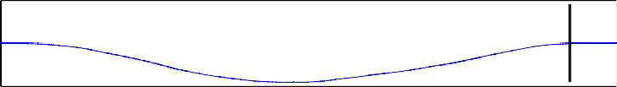e to arrive
← Tim

e to arrive
← Tim

e to arrive
← Tim

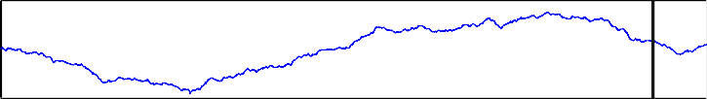e to arrive
← Tim

Fig. 13. Time evolution of the system states (d₁ : d ¼ ½0:2592 0:8065 —0:0533]~ 10^{—4} , S_{ii} ¼ 1 ~ 10^{—5}; dh : d_{i} ¼ 0:0436, S_{ii} ¼ 0:0436). Controller parameters are
N_{p} ¼ 60, g ¼ 1000, k_{a} ¼ 60, p ¼ 0.95, l ¼ 0:23.
pﬃﬃﬃﬃﬃﬃ pﬃﬃﬃﬃﬃﬃ

122 F. Gavilan et al. / Control Engineering Practice 20 (2012) 111–122

spacecraft rendezvous procedures in the presence of model uncer- tainties and disturbances.

Acknowledgments

The authors thank Teodoro Alamo for pointing out the prob- abilistic method of Section 3.4.
The authors would also like to gratefully acknowledge MICINN and Junta de Andalucia for funding part of this work under grants DPI2008-05818 and P07-TEP-02720.

References

Breger, L., & How, J. P. (2006). Nonlinear model predictive control technique for unmanned air vehicles. Journal of Guidance, Control and Dynamics, 29(5), 1179–1188.
Breger, L., & How, J. P. (2008). Safe trajectories for autonomous rendezvous of spacecraft. Journal of Guidance, Control and Dynamics, 31(5), 1478–1489.
Camacho, E., Berenguel, M., & Bordons, C. (1994). Adaptive generalized predictive control of a distributed collector ﬁeld. IEEE Transactions on Control Systems Technology, 2, 462–468.
Camacho, E. F., & Bordons, C. (2004). Model predictive control (2nd ed.). Springer- Verlag (pp. 131–205).
Carter, T. E. (1998). State transition matrices for terminal rendezvous studies: Brief survey and new example. Journal of Guidance, Control and Dynamics, 21(1), 148–155.
Clohessy, W. H., & Wiltshire, R. S. (1960). Terminal guidance systems for satellite rendezvous. Journal of the Aerospace Sciences, 27(9), 653–658.
Fehse, W. (2003). Automated rendezvous and docking of spacecraft (1st ed.).
Cambridge, UK: Cambridge University Press (pp. 171–215).
Geller, D. (2006). Linear covariance techniques for orbital rendezvous analysis and autonomous onboard mission planning. Journal of Guidance, Control and Dynamics, 29(6), 1404–1414.
Hartley, R., & Zisserman, A. (2003). Multiple view geometry in computer vision (2nd ed.).
Cambridge, UK: Cambridge University Press (pp. 26–36).
Hill, G. (1878). Researches in lunar theory. American Journal of Mathematics, 1(3), 5–26. 129–147, 245–260.
How, J., & Tillerson, M. (2001). Analysis of the impact of sensor noise on formation ﬂying control. in: American Control Conference, vol. 5.
Humi, M., & Carter, T. (2008). Orbits and relative motion in the gravitational ﬁeld of an oblate body. Journal of Guidance, Control and Dynamics, 31(3), 522–532. Inalhan, G., Tillerson, M., & How, J. P. (2002). Relative dynamics and control of spacecraft formations in eccentric orbits. Journal of Guidance, Control and
Dynamics, 25(1), 48–59.
Li, P., Wendt, M., & Wozny, G. (2000). Robust model predictive control under chance constraints. Computers and Chemical Engineering, 24(2–7), 829–834.
Rencher, A. C. (1998). Multivariate statistical inference and applications (1st ed.).
New York: Wiley (pp. 40–42).
Richards, A., Schouwenaars, T., How, J. P., & Feron, E. (2002). Spacecraft trajectory planning with avoidance constraints using mixed-integer linear programming. Journal of Guidance, Control, and Dynamics, 25(4), 755–764.
Richards, A. G. (2004). Robust constrained model predictive control. Ph.D. Thesis.
Cambridge, MA: Massachusetts Institute of Technology, (pp. 27–77).
Richards, A. G., & How, J. (2003). Performance evaluation of rendezvous using model predictive control. AIAA Paper 2003-5507.
Schwarm, A., & Nikolaou, M. (1999). Chance-constrained model predictive control.
AIChE Journal, 45(8), 1743–1752.
Wang, P., Mokuno, M., & Hadaegh, F. (2003). Formation ﬂying of multiple spacecraft with automatic rendezvous and docking capability. AIAA Paper 2003-5363.
Wie, B. (1998). Space vehicle dynamics and control. AIAA Education Series.
Wofﬁnden, D. C., & Geller, D. K. (2008). Navigating the road to autonomous orbital rendezvous. Journal of Spacecraft and Rockets, 44(4), 898–909.

