This article appeared in a journal published by Elsevier. The attached copy is furnished to the author for internal non-commercial research and education use, including for instruction at the authors institution and sharing with colleagues.
Other uses, including reproduction and distribution, or selling or licensing copies, or posting to personal, institutional or third party websites are prohibited.
In most cases authors are permitted to post their version of the article (e.g. in Word or Tex form) to their personal website or institutional repository. Authors requiring further information regarding Elsevier’s archiving and manuscript policies are encouraged to visit:
http://www.elsevier.com/copyright

Automatica 47 (2011) 1473–1481
Contents lists available at ScienceDirect

Automatica
journal homepage: www.elsevier.com/locate/automatica

Brief paper
Ultimate bounded stability and stabilization of linear systems interconnected with generalized saturated functions✩
S. Tarbouriech a,b,∗, I. Queinnec a,b, T. Alamo c, M. Fiacchini a,b, E.F. Camacho c
a CNRS; LAAS; 7 avenue du Colonel Roche F-31077, Toulouse, France
b Université de Toulouse, UPS, INSA, INP, ISAE, LAAS, F-31077, Toulouse, France
c Dept. Ingeniería de Sistemas y Automática, Universidad de Sevilla, Camino de los Descubrimientos s/n, 41092 Sevilla, Spain

a r t i c l e i n f o
Article history:
Received 2 June 2009 Received in revised form 2 November 2010
Accepted 17 January 2011
Available online 9 March 2011
Keywords:
Stability analysis Stabilization
Convex differential inclusion

a b s t r a c t

This paper proposes some ultimate bounded stability analysis and stabilization conditions for systems involving actuators with different nonlinear elements, like for instance both saturation and dead-zone or both saturation and stick–slip. Results are based on the use of a convex differential inclusion approach. Indeed, an adequate property allowing to upper-bound some product terms related to the nonlinearity is provided. Thus, constructive conditions associated to convex optimization schemes are developed to determine suitable regions of the state space in which the closed-loop trajectories can be captured.
© 2011 Elsevier Ltd. All rights reserved.

Introduction
Many industrial processes exhibit non-smooth nonlinearities, generally due to physical, technological or safety constraints, as in the cases of hydraulic servo valves or electric servo motors. The interest for this kind of system mainly comes from the fact that neglecting these nonlinearities, during the stability analysis or the control design, can be a source of undesirable and even catastrophic behaviors (see, for example, Nordin, Ma, & Gutman, 2002; Tarbouriech, Garcia, & Glattfelder, 2007; Taware & Tao, 2003). For all these reasons, the specific case of nonlinear actuators involving saturation elements (position and/or higher dynamics) has been extensively studied in the last ten years Hu and Lin (2001), Kapila and Grigoriadis (2002) and Tarbouriech and Garcia (1997). In particular, several results have been provided in a local context for stability analysis and synthesis purposes, in which the key point is to determine an estimate of the basin of attraction of the closed-loop nonlinear system: see Tarbouriech et al. (2007) for recent advances on this topic. On the other hand, practical actuators often involve more complex nonlinearities, such as friction terms for example, which may generally be represented by hysteresis, backlash, dead-zone or stick–slip elements Gomes,

✩ This paper was not presented at any IFAC meeting. This paper was recommended for publication in revised form by Associate Editor Tong Zhou under the direction of Editor Roberto Tempo.
∗ Corresponding author at: CNRS; LAAS; 7 avenue du Colonel Roche F-31077,
Toulouse, France. Tel.: +33 561336928; fax: +33 561336936.
E-mail addresses: tarbour@laas.fr (S. Tarbouriech), queinnec@laas.fr
(I. Queinnec), alamo@cartuja.us.es (T. Alamo), fiacchini@laas.fr (M. Fiacchini), eduardo@cartuja.us.es (E.F. Camacho).
0005-1098/$ – see front matter © 2011 Elsevier Ltd. All rights reserved. doi:10.1016/j.automatica.2011.02.020
da Rosa, and Albertini (2006), Olsson and Åström (1989) and Shoukat Choudhury, Thornhill, and Shah (2005). However, such nonlinear actuators have been rarely studied, and in many cases only practical solutions without a priori guarantees of stability have been derived. One reason is certainly that such nonlinearities are generally poorly known and that mathematical descriptions are often not very well adapted for stability analysis or synthesis purposes Thiery, Kunze, Karimi, Curnier, and Longchamp (2006). Nevertheless, different solutions can be investigated to guarantee the closed-loop stability requiring some knowledge about the nonlinearities (see for example Corradini, Orlando, & Parlangeli, 2004; Tarbouriech, Prieur, & Queinnec, 2010, and references therein).
The current paper is concerned with the study of nonlinear actuators involving different nonlinear characteristics like both dead-zone and saturation elements. Literature on this subject is very limited. One can however cite preliminary results concerning semi-global stabilization of linear systems interconnected with such nonlinear elements Lin (1997), but with the main drawback that open-loop stability hypothesis has to be satisfied. More recently, attention was paid to bifurcation analysis of such nonlinear systems Ortega, Aracil, Gordillo, and Rubio (2000). The state feedback stabilization problem was addressed in Fong and Hsu (2000), but for the particular case of single input systems. In Gomes da Silva, Robaski, and Reginatto (2002), stability analysis conditions are proposed by considering a hybrid modeling for the closed-loop discrete-time system. Fliegner, Logemann, and Ryan (2003) reported some recent results on integral control, but for single-input single-output open-loop stable systems only.
In this paper, the notion of a generalized saturated function is presented, which is directly related to the notion of convex

1474 S. Tarbouriech et al. / Automatica 47 (2011) 1473–1481

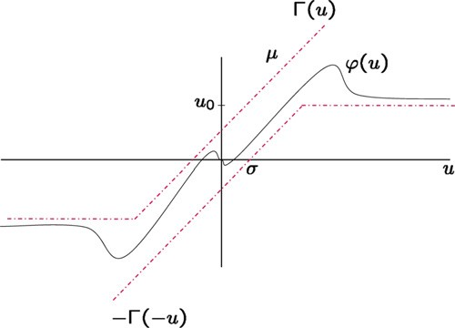
differential inclusion Alamo, Cepeda, Fiacchini, and Camacho (2009) and Fiacchini (2010). Such a tool allows us to address the problem of computing estimates of the domain of attraction for a broad class of actuator nonlinearities. Based on this, an adequate property allowing to upper-bound some pertinent product terms related to the nonlinearity is provided. Then, using quadratic Lyapunov functions, constructive conditions are proposed in a quasi-LMI form, in the sense that the nonlinearity only appears through the product of a matrix by a scalar variable. The proposed approach allows us to characterize both an inner and an outer set. The closed-loop trajectories starting in the outer set are ultimately bounded in the inner set. The outer set is a positively invariant and contractive set for the closed-loop system. The objective of

the related optimization problem is then to maximize a measure of the size of the outer set, whereas the inner set is minimized. It is important to point out that the technique proposed does not require the open-loop system to be stable. The main contribution resides in the fact that the results developed encompass those in Alamo, Cepeda, and Limon (2005), Fong and Hsu (2000), Gomes da Silva et al. (2002) and Hsu and Fong (2003). Furthermore, the proposed conditions can be considered as complementary to that ones provided in Dai, Hu, Teel, and Zaccarian (2009) and Hu, Thibodeau, and Teel (2009).
Notation. 1 and 0 denote respectively the identity matrix and the null matrix of appropriate dimensions. Furthermore, 1_{m} denotes
a vector of dimension m with all components equal to 1. The elements of a matrix A m×n are denoted by A(i,j), i 1, . . . , m, j 1, . . . , n. A(i) and A_{i} denote the ith row and ith column of matrix A, respectively. A′ denotes the transpose of A. He A A A′. A is the matrix given by the absolute value of each element of
≥
| |
[ ] = +
=
∈ ℜ =
A. For two symmetric matrices, A and B, A > B (resp. A B) means
−
that A B is positive definite (resp. positive semi-definite). For two vectors x, y n, the notation x y means that x(i) y(i)
∀ = ∈ ℜ ∈ ℜ
∈ ℜ ≥ − ≥
0, i 1, . . . , n. For any vector u m and u₀ m, with
=
u₀ > 0, one defines each component of sat_{u}0 (u) by sat_{u}0 (u(i)) sign(u(i)) min(u₀(i), u(i) ), i 1, . . . , m. Given an integer m, the set V_{m} is defined as the set of all the subsets of T_{m} 1, 2, . . . , m , that is, V_{m} S S T_{m} . S^{c} denotes the complement of S in T_{m} (see Alamo et al., 2005, for more details). Given a set E , ∂E denotes its boundary. Given a symmetric and positive definite matrix P , an ellipsoid E (P, 1) is defined by E (P, 1) = {x ∈ ℜn; x′Px ≤ 1}.
= { ; ⊆ }
= { }
| | =

Generalized saturated functions
In this section, the notion of generalized saturated functions is introduced. As it will be shown, this class of functions encompasses many common nonlinearities which appear in real control processes. The following definition introduces this notion for scalar (possibly time-varying) nonlinearities.
Definition 1 (Scalar Case). The scalar function ϕ is said to be a generalized saturated function with saturation level u₀ ∈ ℜ, u₀ > 0, dead-zone σ ∈ ℜ, σ ≥ 0, and linear slope
: ℜ × ℜ → ℜ
µ ∈ ℜ,µ > 0, if
−Γ (−u) ≤ ϕ(u, t) ≤ Γ (u), ∀u, ∀t
where Γ (u) = max{µ(u + σ ), −u₀}.
See Fig. 1 for an example of a scalar generalized saturated function. Any nonlinear function involving a combination of dead- zone, stick–slip and saturation elements can be shown to be an element of the class of generalized saturated functions (see Figs. 2 and 3). Moreover, it is also worth mentioning that some time- varying nonlinear phenomena like, for example, hysteresis and friction can be easily modeled by means of this class of functions (see Fig. 4).
The notion of (scalar) generalized saturated function is easily extended to the vector case.
Fig. 1. Generalized saturated function (scalar case).
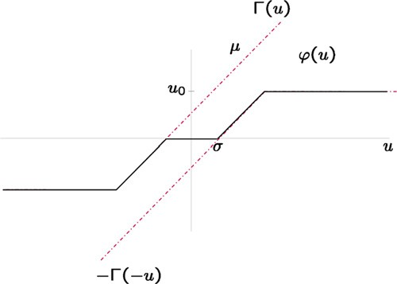

Fig. 2. Input–output characteristics of a nonlinear actuator involving a dead-zone plus a saturation element.
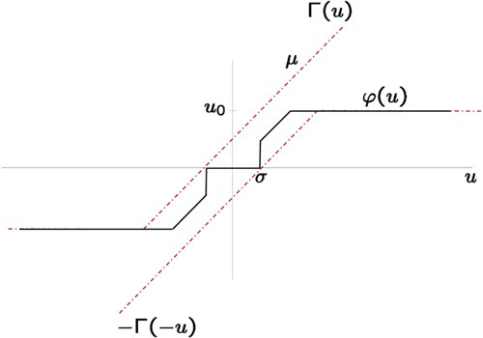

Fig. 3. Input–output characteristics of a nonlinear actuator involving a stick–slip plus a saturation element.
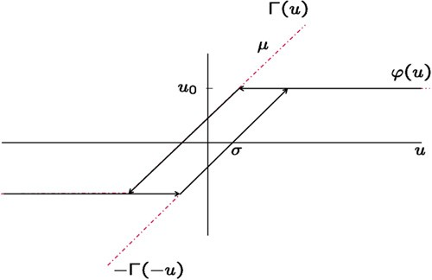

Fig. 4. Input–output characteristics of a nonlinear actuator involving a hysteresis plus a saturation element.

Definition 2 (Vector Case). The function ϕ m m is said to be a generalized saturated function with saturation level u₀ ∈ ℜm, u₀ > 0, dead-zone σ ∈ ℜm, σ ≥ 0, and linear slope
: ℜ × ℜ → ℜ

µ ∈ ℜm,µ > 0, if
−Γ (−u) ≤ ϕ(u, t) ≤ Γ (u), ∀u, ∀t
S. Tarbouriech et al. / Automatica 47 (2011) 1473–1481 1475
On the other hand, according to the saturation level u₀, we face the classical problem of determining admissible initial state sets. In other words, we want to estimate an outer set of safe operation,

where the m components of function Γ (u) are given by
Γ_{(i)}(u) = max{µ₍i)(u(i) + σ₍i)), −u₀(i)}, i = 1, . . . , m.
The main results of the paper are based on the following common properties of the (scalar and vector) generalized saturated function (see the Appendix for a proof).

Property 1 (Scalar Case). Suppose that the scalar function ϕ : ℜ × ℜ → ℜ is a generalized saturated function with saturation level
u
0 ∈ ℜ, u₀ > 0, dead-zone σ ∈ ℜ, σ ≥ 0, and linear slope
µ ∈ ℜ,µ > 0. Then the following inequality is satisfied for every z ∈ ℜ, u ∈ ℜ, and t ∈ ℜ:
zϕ(u, t) ≤ max{zµu + |z|µσ, −|z|u₀}. (1)
By extension, a general property may be stated in the vector case (see the Appendix for a proof).

Property 2 (Vector Case). Suppose that ϕ : ℜm × ℜ → ℜm is a generalized saturated function with saturation level u₀ ∈ ℜm, u₀ > 0, dead-zone σ ∈ ℜm, σ ≥ 0, and linear slope µ ∈ ℜm,µ > 0. Then the following inequality is satisfied for every z ∈ ℜm, u ∈ ℜm, and t ∈ ℜ:
− − |z
such that the associated closed-loop trajectories are contractive, as far as they are captured in the inner set. Hence, the problem we intend to solve by exploiting Property 2 can be summarized as follows:
Problem 1 (Analysis Problem). Given the state feedback K , compute an outer ellipsoidal invariant and contractive set Ω₁, as
•
large as possible, for the closed-loop system (3);
compute an inner set Ω₂, as small as possible, in which the closed-loop trajectories, initiated in the outer ellipsoid Ω₁, are ultimately bounded.
•
Throughout the paper, this problem is addressed by considering quadratic Lyapunov functions. Related to the computation of both ellipsoidal sets Ω₁ and Ω₂, optimization issues are discussed. Moreover, some remarks regarding the control design are also provided.

Stability analysis and stabilization conditions

    - Main result

The following theorem uses Property 2 (and Properties 3 and 4

z′ϕ(u, t) max
≤
S∈Vm
−i∈Sc

(i)
z(i)µ(i)u(i) + |z(i)|µ(i)σ(i)

. (2)

|u
0(i)
given in the Appendix) in order to solve Problem 1.

Theorem 1. If there exist three symmetric positive definite matrices W ∈ ℜn×n, Q ∈ ℜn×n, R ∈ ℜn×n, matrix Y S ∈ ℜm×n for every
S ∈ V_{m}, positive vector β and positive scalar θ satisfying:

i∈S
He AW + − B µ

∈
K W + − B Y S  
i∈S

Relation (2) is enclosed in the convex differential inclusion

− − ≤ ≤
i Sc

−
i (i)


 +
i i
(i)
B B′ 
i (i)




framework. Notice that the component-wise nonlinear inclusion
∈ ℜ

µ(i)σ(i)
β₍i)R + − θ W θ W 

Γ ( u) ϕ(u, t) Γ (u), and the inequality (2) are valid for
ℜ

every u m. This is clearly an advantage with respect to most
of the inclusions (and/or sector conditions) that can be found in
i∈Sc
β(i)
θ W −θ Q

the literature, which are valid only on a bounded region of m
(see Alamo, Cepeda, Limon, & Camacho, 2006; Hu & Lin, 2001; Pittet, Tarbouriech, & Burgat, 1997; Tarbouriech et al., 2007).
< 0, ∀i ∈ V_{m} (4)
W − Q ≥ 0 (5)
[ u
]Y
W Q
≥ 0 (6)
[ R W ]

2
(i)
3. Problem statement
0(i)
S
(i) 0 i
(7)

Consider the following continuous-time system:
∈ ℜ
Y S ′ W > , ∀ ∈ S

x˙(t) = Ax(t) + Bϕ(Kx(t), t) (3)
where x(t) n is the state. Matrices A, B and K are constant
matrices of appropriate dimensions. According to Section 2, the function ϕ : ℜm × ℜ → ℜm is assumed to be a generalized
then the closed-loop trajectories of the nonlinear system (3) initiated
in the outer ellipsoid E (W −1, 1) are ultimately bounded in the set
E (Q −1, 1).
Proof. Consider the quadratic Lyapunov function V (x) = x′Px,

saturated function with saturation level u₀ ∈ ℜm, u₀ > 0, dead-
− −
zone σ ∈ ℜm, σ ≥ 0, and linear slope µ ∈ ℜm,µ > 0.
with P = P ′ > 0 and P = W −1. We want to prove that V˙ (x) < 0

When studying the behavior of such a system (3), any
nonlinear function ϕ(., .) bounded by Γ (.) and Γ ( .) is suitable.
This means that the closed-loop trajectories do not necessarily
converge to the origin. However, under some conditions (see
along the trajectories of the nonlinear system (3) for any x such that
x′Px 1 and x′Ux 1 with U U ′ > 0 and U Q −1.
≤ ≥ = =
If relation (4) is satisfied then one gets, by applying the Schur complement, that
(i)
+ −

Theorem 1), the ultimate boundedness of the trajectories Khalil
(2002) can be obtained. The first problem under consideration
is then to evaluate a domain, as small as possible, where it is
L = He
AW +
−i∈Sc
Biµ(i)K(i)W +
−i∈S
B_{i}Y S 

guaranteed that the trajectories will be ultimately bounded. Such
a domain is called the inner set.
+ −i∈Sc
µ(i)σ(i)
β(i)
R B_{i}B′i
β(i)
θ W +
θ WQ −1W
< 0.

Remark 1. The case of presence of dead-zone is a particular case,
which induces the system to behave in open-loop inside the inner
ellipsoid.
Hence, there exists an ϵ > 0 small enough such that
L < −ϵ1. (8)

1476 S. Tarbouriech et al. / Automatica 47 (2011) 1473–1481
From (7) and Property 3 (see Appendix), one gets is a lower bound of (11) and therefore of the left-hand term of (10).

S S ′
B_{i}B′i

From this, for a proper positive value of α₍i) (note that this value has

BiY(i) + (BiY(i)) ≥ −α(i)u0(i)W − α
(i)
u₀(i), ∀α₍i) > 0, ∀i ∈ S.
not to be expressly obtained) and using Property 4 the satisfaction
of

Hence, it follows from relation (8)


He AW +
− Biµ(i)K(i)W 

∈

x′

PA +
−i∈Sc
PBiµ(i)K(i) +
PA +
−i∈Sc
′
PBiµ(i)K(i)


i Sc

    −
−

+ µ
i∈Sc
(i)
σ(i)
β(i)
R B_{i}B′i
β(i)
+
− −i∈S
α(i)
W B_{i}B′i
α(i)
+
u0(i)
− θ P + θ U
x − 2
i∈S
|x′PB_{i}|u₀(i)

− θ W + θ WQ −1W ≤ L < −ϵ1.
Thus, by pre- and post-multiplying both sides of the previous
+ −i∈Sc
µ(i)σ(i)
β(i)
x′PB_{i}B′i Px
β(i)
< 0 (13)

inequality by x′P and Px, respectively, one obtains
implies the satisfaction of inequality (10). By using the fact that

x′
b
PA +
- PB_{i}µ i K _{i}
+ PA +
′
- PB_{i}µ i K _{i}
+
i∈Sc


∈
2|a| ≤ b + a2 , for all b > 0 and for all a, it follows that

i∈Sc

+ − µ
( ) ( )
σ β
(i)
(i)
(i)
i Sc
PRP + PB_{i}B′i P 
( ) ( )
x′
PA +
- PBiµ(i)K(i) +
PA +
′
- PBiµ(i)K(i)
i∈Sc

i S
− 
+
c
β(i)

∈

 −

− α(i)
−
i∈S
P PB_{i}B′i P u
α(i)
0(i)
− θ P + θ U x
− θ P + θ U
x + 2
i∈Sc
µ(i)σ(i)|x′PBi|

≤ x′P LPx < −ϵx′P 2x. (9)

− 2 |x′PB_{i}|u₀(i) < 0. (14)
i∈S

Clearly one gets ϵx′P 2x ≥ ∑ ϵ x′ P 2 x . Thus, by denoting ϵ¯ =
′ 2
i∈S
m
The inequality is satisfied for every S ∈ V_{m}, and therefore one gets
ϵx P x , it follows from inequality (9) ′ ′

m

 −  − ′
−
x′
PA +
PBiµ(i)K(i) +
PA +
PBiµ(i)K(i)

i∈Sc
i∈Sc
x (A P + PA − θ P + θ U)x

−  
+
2 max
S∈Vm
x′PBiµ(i)K(i)x + |x′PBi|µ(i)σ(i)
i∈Sc

+ µ
i∈Sc

(i)
σ(i)
β(i)
PRP + PBiB′i P  − θ P + θ U x
− − |x′PB_{i}|u₀(i)

< 0. (15)

−  x′PB B′Px ϵ¯ 
β(i)
−
α₍i)x′Px +
i
α(i)
i
−
u0(i)
u0(i)

i∈S
i∈S

Then, by using Property 2 with z = B′Px, one has

≤ x′P LPx + ϵx′P 2x < 0. (10)
Since x′Px ≤ 1 for all x ∈ E (W −1, 1), by definition, it follows that
2x′PAx + 2x′PBϕ(Kx, t) − θx′Px + θx′Ux
≤ x′(A′P + PA − θ P + θ U)x

 −  − ′
+ 2 max− x′PB_{i}µ₍i)K(i)x + |x′PB_{i}|µ₍i)σ₍i)

∈

x′ PA +
i∈Sc
PB_{i}µ
(i)
K(i) +
PA +
i∈Sc
PB_{i}µ
(i)
K(i)
S∈Vm

−
i Sc



+ − µ(i)σ(i)
β₍i)PRP +
PB_{i}B′i P 
− θ P + θ U x
−
i∈S
|x′PB_{i}|u₀(i) < 0

i∈Sc
− −i∈S 

α(i) +
x′PB_{i}B′i Px

α(i)
β(i)
ϵ¯
−
u0(i)
 u₀(i) (11)
along the trajectories of the closed-loop system, for all x E (W −1, 1) and x E (Q −1, 1). Hence, the satisfaction of relations (4), (6) and (7) guarantees, by referring to the S-procedure Boyd,
El Ghaoui, Feron, and Balakrishnan (1994), that V˙ (x) < 0 for any x
̸∈
∈
≤ ≥

is a lower bound of the left-hand term of (10). Furthermore, from relation (6) it follows that x′PRPx x′Ux. Thus, since we are considering the decreasing of V for x such that x′Ux 1, it follows
≥
≥
that
such that x′Px 1 and x′Ux 1. Furthermore, from the definition of the ellipsoids E (W −1, 1) and E (Q −1, 1), the condition (5) means that E (Q −1, 1) is included in E (W −1, 1). Finally, the satisfaction of conditions (4)–(7) means that the ellipsoid E (W −1, 1) is

x′

PA +
− PB_{i}µ

∈

(i)

K(i)
+ PA +
− PB_{i}µ

(i)
′
K(i)
contractive with respect to the trajectories of the nonlinear system
(3) until the state enters the set E (Q −1, 1). In other words, the closed-loop trajectories initiated in the outer ellipsoid E (W −1, 1)

i Sc

 − 
i∈Sc
x′PB B′Px

ϵ¯ 
are ultimately bounded in the inner ellipsoid
E (Q −1,
1). Q

− θ P + θ U
x −
i∈S
−
+
α(i) +
i i
α(i)
− u0(i)
u0(i)
Remark 2. Note that the conditions stated in Theorem 1 do not
impose the asymptotic stability of the origin of the state space,

+ µ
i∈Sc

(i)
σ(i)
β(i)
x′PB_{i}B′i Px (12)
β(i)
and then, do not require any stability condition on the open-loop matrix A.

S. Tarbouriech et al. / Automatica 47 (2011) 1473–1481 1477

Remark 3. Theorem 1 gives a solution to the analysis Problem 1. The conditions can be directly extended to consider the control design case by considering matrix Y instead of terms KW , as further optimization variables.
Remark 4. In Theorem 1, the outer ellipsoid E (W −1, 1) is contrac- tive and invariant contrarily to the inner ellipsoid E (Q −1, 1). Nev- ertheless, we can determine the smallest invariant ellipsoid whose shape is determined by W and containing E (Q −1, 1). For this, it suffices to compute the greatest scalar ρ such that the resulting el-
lipsoid E (W −1, ρ⁻1) is invariant and contains E (Q −1, 1); in other words one has to compute the maximal scalar ρ ≥ 1 such that W − ρQ ≥ 0.
Remark 5. It can be of interest to impose a rate of convergence γ , γ > 0, for the closed-loop system trajectories by adding in the (1, 1) block of matrix in relation (4) the term γ W . Moreover, from the satisfaction of (4) and since according to Remark 4 there
+
≥ ⊂
exists a scalar ρ 1 such that E (Q −1, 1) E (W −1, ρ⁻1), it follows V˙ (x) < θx′Px θx′Q −1x θ(1 ρ)x′Px. The positive scalar
− ≤ −
θ(1 ρ) then represents a rate of convergence for the closed-loop system trajectories.
− −

Remark 6. Consider a (normalized) saturation which is equivalent to the generalized saturated function with µ₍i) 1, σ₍i) 0, u₀(i) 1, i 1, . . . , m. By adapting to this case the conditions
= ∀ =
= =
of Theorem 1, it follows that the variable β does not appear and R is no more affecting (4) but is involved only in (6). This relation admits infinite solutions R provided that Q > 0, as assumed in the statement of the theorem, then (6) does not affect the problem. Moreover, by choosing Q W , (5) holds and hence, in this case, only conditions (4) and (7) of
=
Theorem 1 have to be tackled. With Q = W , relation (4) reads:
AW + ∑i∈Sc BiK(i)W + ∑i∈S BiY S)
He
(i
< 0 and therefore the
LMI conditions, due to vector β, and due to the products θ W and θ Q implying that the optimization problem proposed above is not convex. Note however, that, as pointed out in new Remark 5, θ is a sort of measure of how high the decreasing rate is required to be ensured. Posing θ very close to zero, means that inside E (W −1, 1) and outside E (Q −1, 1) the convergence rate is required to be close to null, that is, we are trying to approximate the basin of attraction (outer set) and the ultimately bounded stability region (inner set). Vice versa, high values of θ would entail the requirement of a high convergence rate, convergence rate that could be not possible to be guaranteed inside any region (in fact, infeasibility can occur). Then, in the following, θ is viewed as a design parameter and fixed as a small value since we are interested in the set optimization problem. On the other hand, the influence of the choice of vector β cannot be neglected. Either an iterative search on the components of this vector or an encapsulation of the LMI optimization step
(16) in some overall nonlinear optimization procedure (such as fminsearch Matlab function) may be considered. In the single-input case (m 1), β is a scalar and the optimal solution of (16) can be obtained from a search over a mere one-dimensional grid. For systems with m 2, a preliminary hypothesis (which has been clearly sufficient in all tested examples) may be to consider a vector β a₁1_{m} with scalar a₁, that is, one yet considers a mere one- dimensional parameter of the problem. Hence, in all these cases an optimal or sub-optimal solution for (16) can be easily obtained from the solution of LMI-based problems. Such a point is illustrated in the numerical examples.
=
≥
=

Numerical examples

    - Single input example

Let us consider the following single-input unstable example
borrowed from Fong and Hsu (2000):

current Theorem 1 is equivalent to Theorem 1 in Alamo et al.
(2005). Then the current result can be viewed as an extension of the results proposed in Alamo et al. (2005), and thus also of those
1
0.5 1
1 0.5
[ ]−
A =
; B =
[0.5] .

in Hu and Lin (2001) and Hu, Lin, and Chen (2002).

4.2. Optimization aspects
Theorem 1 provides a condition on ellipsoids E (W −1, 1) and
The nonlinear element ϕ(Kx, t) is the one described in Fig. 2 (dead- zone + saturation) with u₀ = 4,µ = 1 and σ = 0.4. The S- procedure parameter is set to: θ = 10−6. Let us first consider the controller gain provided in Fong and Hsu (2000): K = K_{a} =

E (Q
⊆
[ − ]
−1, 1) with E (Q −1, 1) E (W
−1
−1, 1), such that E (W
−1, 1) is
  - 3.84 . The optimization of the ellipsoid sizes with respect
to the scalar β has been performed using the Matlab fminsearch

contractive and E (Q , 1) captures the ultimate bounded closed-
function, from an initial guess 0.5, and with η1 = η2 = 1. The

loop trajectories. Finally, an optimization problem may be stated, for the analysis or the synthesis case, to simultaneously evaluate the smallest inner ellipsoid and the largest outer ellipsoid1:
min η1Trace(M) + η2T[race(Q ) ]

1 W
optimal inner and outer ellipsoidal sets solution to (16), plotted in Fig. 5 (dashed lines), have then been obtained for β 0.0125.
The synthesis problem is classically a compromise between several objectives, in the present case, a small activity around the
=

subject to (4)–(7) and M 1 > 0
=
(16)
origin (small inner ellipsoid), a large domain of admissible initial
state (large outer ellipsoid), a not-too-high gain and a convenient
pole placement for the linear closed-loop system (ϕ(Kx, t) = Kx).
−

where ηi, i 1, 2, are weighting parameters. The search for the
largest outer ellipsoidal set mainly corresponds to evaluate the influence of the saturation u₀ on the stability properties of the nonlinear closed-loop system Alamo et al. (2005), Gomes da Silva
and Tarbouriech (2005) and Hu et al. (2002). The determination
In this example, one considers a pole-placement requirement in
a disk of ray 5 and centered in 5 Peaucelle, Arzelier, Bachelier,
and Bernussou (2000), and the optimization problem is solved
with the trade-off objective given by η1 0= η2 = 1. One then
=
obtains the controller gain K = K_{s} =
.6750 −8.1591 and

of the smallest inner ellipsoidal set corresponds to the evaluation
of the smallest domain in which the closed-loop trajectories are
ultimately bounded. The conditions stated in Theorem 1 are not

1 Rigorously speaking, we do not compute the smallest and largest ellipsoids, due to the nonlinearities in the optimization problem. What we denote abusively the smallest and largest ellipsoids are only sub-optimal solutions, which depend also on the measure chosen to evaluate the size of the ellipsoid.
β 0.0035 as the solution to the encapsulation of problem (16)
in fminsearch. The optimal inner and outer ellipsoids associated
to this controller are plotted in Fig. 5 in solid lines. Trajectories starting from several initial states are also plotted in Fig. 5. They illustrate that the outer ellipsoid obtained through Theorem 1 with the optimization procedure (16) remains a good approximation of the domain of attraction.
A zoom of the inner ellipsoids and, by the way, of the trajectories of the system for the controller gains K_{a} (dashed lines) and K_{s} (solid

1478 S. Tarbouriech et al. / Automatica 47 (2011) 1473–1481

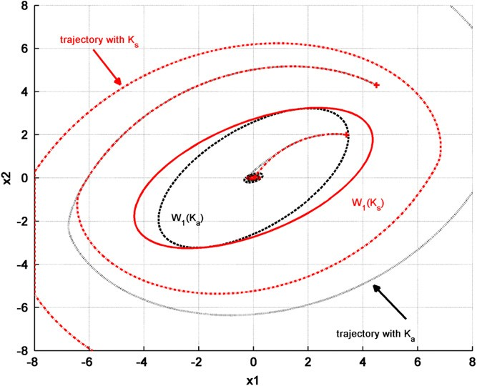
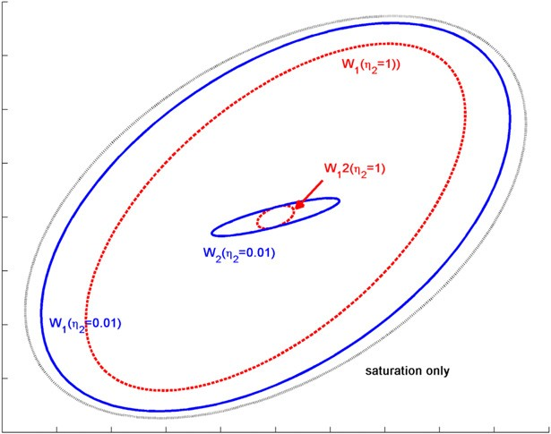
4

3

2

1

0
x2

-1

-2

-3

-4
-5 -4

-3 -2 -1 0 1 2
x1

3 4 5

Fig. 5. Example 1—Inner and outer ellipsoids related to K_{a} (dashed lines) and to K_{s} (solid lines). State space trajectories initiated from various states, related to the controllers K_{a} (dotted line) K_{s} (dashed–dotted line).
Fig. 7. Example 1—Ellipsoidal approximations of the basin of attraction. The dotted ellipsoid refers to the case with saturation only Alamo et al. (2005). The solid line outer (W₁) and inner (W₂) ellipsoids refer to the case with η₂ = 0.01. The dashed
line outer (W₁) and inner (W₂) ellipsoids refer to the case with η₂ = 1.
Table 1
Illustration of the influence of β in the calculus of the optimal inner and outer ellipsoids.

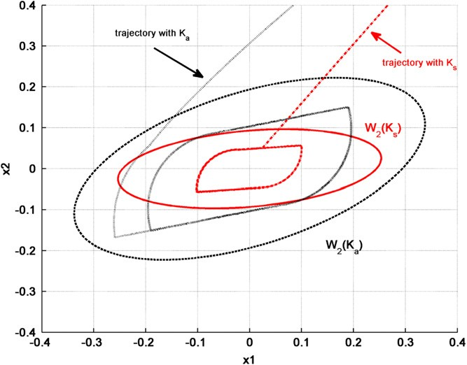
Case 1 Case 2
β [0.7250] [0.1621]

√ 0.7250
0.8142

det(W) 0.0576 0.0283
√
det(Q ) 1.3219 1.5099
nb iteration in fminsearch | 8 | 26
nb execution pb (16) | 16 | 52

data:
−0.5 1.5 4
=

−0.7 −1.3
0

A 4.3 6.0 5.0
3.2 6.8 7.2
; B =
0 −4.3
.8 −1.5
(17)

with nonlinear elements given by:
u₀ = [2] , µ = [1] and σ = [0.2] .

K_{s} (solid lines). State space trajectories related to the controllers K_{a} (dotted lines) K_{s} (dashed–dotted lines).
Fig. 6. Example 1—Zoom on the inner ellipsoids related to K_{a} (dashed lines) and to
2
1
0.2

lines), is shown in Fig. 6. It illustrates that around the origin, the system is not controlled and does not converge to the origin but to a limit cycle. This limit cycle remains however confined inside the inner ellipsoid.
According to Remark 6 focusing on the case of saturation only, the ellipsoidal approximation of the basin of attraction with the controller K_{a} is plotted in Fig. 7 (in black). Note that when the optimization (in Theorem 1 framework) is oriented mainly on the maximal outer set solution (in blue, with η1 1, η2 0.01), it approaches the case with saturation only. However, this is to the detriment of the size of the inner ellipsoid. A compromise is given by the solution issued from Theorem 1 with η1 η2 1
= =
= =
(in red).

5.2. Multivariable example
The second example is a multi-input example, with three states
Note that the open-loop system is unstable, with spectrum given by 13.9600 0.6300 0.7368i . One considers the following control gain:
1.5120 2.5839 5.2308
{ ; − ± }
[ ]− − −K =
2.0067 3.1215 4.3454
for which the linear closed-loop spectrum (ϕ(Kx, t) Kx) is 8.1394 2.4180 1.6404i .
{− ; − ± }
=
Two cases are considered to determine the smallest and largest inner and outer ellipsoids, using fminsearch and problem (16): the first case is with β a1_{m}, and the second case considers that all components of β are independent. The results, presented in Table 1 provide a comparison in terms of computation time and volume2 of ellipsoids. They illustrate that considering only one parameter for β is sufficient to give a good approximation of the ellipsoids with a reasonable computation burden.
=
Finally, Figs. 8 and 9 show the outer and inner ellipsoids, respectively, for the two evaluation cases. State space trajectories

and two inputs derived from Amato, Cosentino, and Merola (2007),

which intends to illustrate the computational burden associated to the nonlinear influence of β. System (3) is defined by the following
2 The expression √det(W) is proportional to the volume of the ellipsoid
E (W −1 , 1).

1.5
1
0.5
x3
0
-0.5
-1
-1.5
2
1.5
S. Tarbouriech et al. / Automatica 47 (2011) 1473–1481 1479

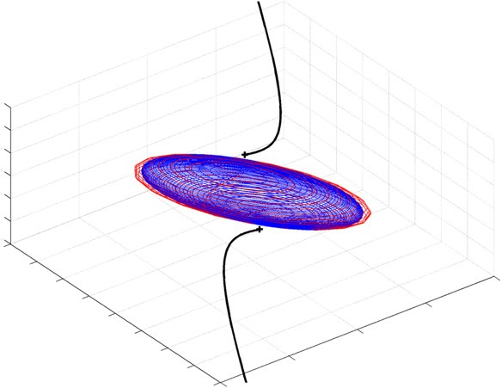
construction of more adequate Lyapunov functions (more complex than the quadratic ones).

Appendix

  - Proof of Property 1
Two cases are considered.
- If z ≥ 0, one obtains from the inequality: ϕ(u, t) ≤ Γ (u), ϕ(u, t) ≤ zΓ (u) = z max{µ(u + σ ), −u₀} = max{zµ(u + σ ), −zu₀} = max{zµu + |z|µσ, −|z|u₀}.
z

1
0.5
x2

0
-0.5

-1
-1.5
4
2
0
-2 x1
-2 -4
    - If z < 0 then one can multiply the inequality −Γ (−u) ≤
ϕ(u, t) by the negative scalar z to obtain: zϕ(u, t) ≤ −zΓ (−u) =
|z| max{µ(−u + σ ), −u₀} = max{|z|µ(−u + σ ), −|z|u₀} =
max{zµu + |z|µσ, −|z|u₀}.
  - Proof of Property 2

Fig. 8. Example 2—3D outer ellipsoids related to case 1 (internal blue ellipsoid) and case 2 (external red ellipsoid) and unstable state space trajectories. (For interpretation of the references to colour in this figure legend, the reader is referred
Following Property 1, one directly writes
m

to the web version of this article.)
z′ϕ(u, t) = − z(i)
ϕ(i)
(u, t)

illustrate both the correct approximation of the overall invariant
domain for the system (unstable trajectories for initial states taken outside the outer ellipsoids) and the confinement of the stable trajectories in the inner ellipsoids after some transient time.

Conclusion
i=1
m
−
≤ max{z(i)µ(i)u(i) + |z(i)|µ(i)σ(i), −|z(i)|u0(i)}.
i=1
Moreover one can verify that
m
−
max{z(i)µ(i)u(i) + |z(i)|µ(i)σ(i), −|z(i)|u0(i)}
i=1

In this paper, constructive conditions to deal with ultimate bounded stability analysis or stabilization have been proposed
= max − z(i)

µ(i)

u(i)
+ |z(i)
|µ(i)

σ(i)
− − |z

(i)
|u0(i) .

for systems interconnected with actuators involving different nonlinear elements, like for instance both saturation and dead-
S∈Vm
i∈Sc
i∈S

zone or both saturation and stick–slip. Appropriate properties allow to upper-bound the nonlinearity and then to derive quasi- linear matrix inequality conditions. Optimization schemes have been derived in order to evaluate two ellipsoids such that the
trajectories initiated inside the largest outer one will be ultimately
  - Additional properties

Property 3. Let a symmetric matrix W ∈ ℜn×n and a matrix Y ∈ ℜ1×n being such that
0

bounded in the smallest inner one, without any restriction on
[u2 Y ] > 0

the open-loop stability. The main limitation of the approach is
Y ′ W

related to the optimization scheme which involves several tuning
parameters. Some possible approaches are however proposed to then, ∀B ∈ ℜn, one has

select an adequate set of parameters.
′ ′ B B′

In the context of actuators involving different nonlinear
elements, there are still some possible interesting extensions and
BY + Y B ≥ −αu₀W − u₀ α , ∀α > 0.

open problems. The technique developed should be extended to handle a larger class of nonlinear elements, like piecewise
0
u0
α
u0
α
   
affine nonlinearities or dynamic nonlinearities, leading to the
The proof is directly extended from Alamo et al. (2005), by considering that: 0 ≤ u √α Y ′ + √B √α Y ′ + √B ′ , ∀α > 0.

0.2
0.15
0.1
0.05
x3
0
-0.05
-0.1
-0.15
-0.2
0.5

0
x2

0
x1
-0.5 -0.5

0.5

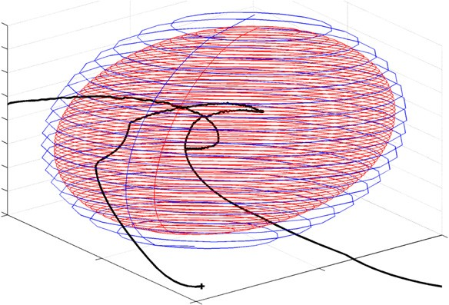
Fig. 9. Example 2—3D inner ellipsoids related to case 1 (external blue ellipsoid) and case 2 (internal red ellipsoid) and stable state space trajectories. (For interpretation of the references to colour in this figure legend, the reader is referred to the web version of this article.)

1480 S. Tarbouriech et al. / Automatica 47 (2011) 1473–1481

Property 4 (Alamo et al. 2005). Suppose that ϵ > 0. Then, for every a ∈ ℜ
a2
−2|a| < sup −α − α + ϵ.
α>0

References
Alamo, T., Cepeda, A., Fiacchini, M., & Camacho, E. F. (2009). Convex invariant sets for discrete-time Lur’e systems. Automatica, 45, 1066–1071.
Alamo, T., Cepeda, A., & Limon, D. (2005). Improved computation of ellipsoidal invariant sets for saturated control systems. In Proceedings of the IEEE conference on decision and control. Sevilla, Spain. December.
Alamo, T., Cepeda, A., Limon, D., & Camacho, E. F. (2006). A new concept of invariance for saturated systems. Automatica, 42, 1515–1521.
Amato, F., Cosentino, C., & Merola, A. (2007). Stabilization of bilinear systems via linear state feedback control. In Proc. 15th medit. conf. contr. aut. MED2007. Athens, Greece.
Boyd, S., El Ghaoui, L., Feron, E., & Balakrishnan, V. (1994). SIAM studies in applied mathematics, Linear matrix inequalities in system and control theory.
Corradini, M. L., Orlando, G., & Parlangeli, G. (2004). A VSC approach for the robust stabilization of nonlinear plants with uncertain nonsmooth actuator nonlinearities—a unified framework. IEEE Transactions on Automatic Control, 49(5), 807–813.
Dai, D., Hu, T., Teel, A. R., & Zaccarian, L. (2009). Piecewise-quadratic Lyapunov functions for systems with deadzones or saturations. Systems & Control Letters, 58, 365–371.
Fiacchini, M. (2010). Convex difference inclusions for systems analysis and control.
Ph.D. thesis. Universidad de Sevilla. Spain. January.
Fliegner, T., Logemann, H., & Ryan, E. P. (2003). Low-gain integral control of continuous-time linear systems subject to input and output nonlinearities. Automatica, 39, 455–462.
Fong, I. -K., & Hsu, C. -C. (2000). State feedback stabilization of single input systems through actuators with saturation and deadzone characteristics. In Proceedings of the IEEE conference on decision and control. Sydney, Australia. December.
Gomes, S. C. P., da Rosa, V. S., & Albertini, B. de. C. (2006). Active control to flexible manipulators. IEEE/ASME Transactions on Mechatronics, 11(1), 75–83.
Gomes da Silva, J.M. Jr., Robaski, L.V., & Reginatto, R. (2002). Anaálise de sistemas de controle lineares discretos sujeitos a n ao linearidades do tipo zona morta e saturaç ao nos atuadores. In Proc. of congresso brasileiro de automática, CBA. Natal, Brazil (pp. 2523–2528).
Gomes da Silva, J. M., Jr., & Tarbouriech, S. (2005). Antiwindup design with guaranteed regions of stability: an LMI-based approach. IEEE Transactions on Automatic Control, 50(1), 106–111.
Hsu, C.-C., & Fong, I.-K. (2003). Robust state feedback control through actuators with generalized sector nonlinearities and saturation. Asian Journal of Control, 5(3), 382–389.
Hu, T., & Lin, Z. (2001). Control system with actuator saturation: analysis and design.
Birkhäuser.
Hu, T., Lin, Z., & Chen, M. (2002). An analysis and design method for linear systems subject to actuator saturation and disturbance. Automatica, 38(2), 351–359.
Hu, T., Thibodeau, T., & Teel, A. R. (2009). Analysis of oscillation and stability for systems with piecewise linear components via saturation functions. In American control conference. St. Louis, MO, USA (pp. 1911–1916).
Kapila, V., & Grigoriadis, K. (Eds.). (2002). Actuator saturation control. Marcel Dekker, Inc..
Khalil, H. K. (2002). Nonlinear systems (3rd ed.) Prentice Hall, Inc..
Lin, Z. (1997). Robust semi-global stabilization of linear systems with imperfect actuators. Systems & Control Letters, 29, 215–221.
Nordin, M., Ma, X., & Gutman, P. O. (2002). Controlling mechanical systems with backlash: a survey. Automatica, 38, 1633–1649.
Olsson, H., & Åström, K. J. (1989). Friction generated limit cycles. IEEE Transactions on Control Systems Technology, 9(4), 629–636.
Ortega, M. G., Aracil, J., Gordillo, F., & Rubio, F. R. (2000). Bifurcation analysis of a feedback system with dead zone and saturation. IEEE Control Systems Magazine, 20(4), 91–101.
Peaucelle, D., Arzelier, D., Bachelier, O., & Bernussou, J. (2000). A new robust d- stability condition for real convex polytopic uncertainty. Systems & Control Letters, 40(1), 21–30.
Pittet, C., Tarbouriech, S., & Burgat, C. (1997). Stability regions of linear systems with saturating controls via circle and Popov criteria. In Proceedings of the IEEE conference on decision and control. San Diego, California, USA. December.
Shoukat Choudhury, M. A. A., Thornhill, N. F., & Shah, S. L. (2005). Modelling valve stiction. Control Engineering Practice, 13, 641–658.
Tarbouriech, S., & Garcia, G. (Eds.). (1997). Lecture notes in control and information sciences: Vol. 217. Control uncertain system with bounded inputs. Springer.
Tarbouriech, S., Garcia, G., & Glattfelder, A. H. (Eds.). (2007). Lecture notes in control and information sciences: Vol. 346. Advanced strategies in control systems with input and output constraints. Springer-Verlag.
Tarbouriech, S., Prieur, C., & Queinnec, I. (2010). Stability analysis for linear systems with input backlash through sufficient LMI conditions. Automatica, 46(11), 1911–1915.
Taware, A., & Tao, G. (2003). Lecture notes in control and information sciences: Vol.
288. Control of sandwich nonlinear systems. Springer.
Thiery, S., Kunze, M., Karimi, A., Curnier, A., & Longchamp, R. (2006). Friction modeling of a high-precision positioning system. In Proceedings of the American control conference. Minneapolis, Minnesota, USA. June 14–16 (pp. 1863–1867).

- Tarbouriech received her Ph.D. degree in Control The- ory in 1991 and her HDR degree (Habilitation à Diriger des Recherches) in 1998 from University Paul Sabatier, Toulouse, France. Currently, she is a full-time researcher (Directeur de Recherche) in LAAS-CNRS, Toulouse. Her main research interests include analysis and control of lin- ear and nonlinear systems with saturation, anti-windup approaches, with applications to aeronautical/spatial do- mains, hybrid systems. She served as Associate Editor for IEEE Transactions on Automatic Control from 20 042 006. She is currently Associate Editor for IET Control Theory and
Applications, for the International Journal of Robust and Nonlinear Control and for IEEE Transactions on Control Systems Technology. She is also co-Editor-in-Chief of the French journal JESA (Journal Européen des Systèmes Automatisés). Since 1999, she has been Associate Editor at the Conference Editorial Board of the IEEE Control Systems Society. She is also a member of the IFAC technical committees on Robust Control and Nonlinear Systems.

I. Queinnec is currently CNRS researcher at LAAS-CNRS, Université de Toulouse. She received her Ph.D. degree and HDR degree in automatic control in 1990 and 2000, re- spectively, from University Paul Sabatier, Toulouse. Her current research interests include constrained control and robust control of processes, with particular interest in ap- plications on aeronautical systems, biochemical and envi- ronmental processes. She serves as member of the IFAC technical committees on ‘‘Biosystems and Bioprocesses’’ and on ‘‘Modelling and Control of Environmental Sys- tems’’, respectively from 2002 and 2005.

- Alamo was born in Spain in 1968. He received his M.Eng. degree in Telecommunications Engineering from the Polytechnic University of Madrid (Spain) in 1993 and his Ph.D. in Telecommunications Engineering from the University of Seville in 1998. From 1993 to 2000 he was assistant professor of the Department of System Engineering and Automatic Control of the University of Seville. Since 2001, he has been an associate professor; and since 2010 he is a full professor in the same department. He was a Researcher in the Ecole Nationale Supérieure des Télécommunications (Telecom Paris) from 1991 to
1993 and he has participated in several European Projects. He is the author or coauthor of more than 120 publications including book chapters, journal papers, conference proceedings and educational books. He has carried out reviews for various conferences and technical journals. His current research interests are in model predictive control, randomized algorithms, robust control, identification, control of constrained systems, invariant sets and convex optimization.

M. Fiacchini received his Laurea degree in Computer Science Engineering in 2004 from the University of Florence and his Ph.D. in Control Engineering from the University of Seville in 2010. He was working as a visiting Ph.D. student at ETH of Zurich (Switzerland). He is currently a postdoctoral researcher at LAAS-CNRS, Toulouse, France. He has participated in Spanish, French and European Projects, and his current research interests are in robust control, hybrid systems, and set theory in control and invariant sets.

E.F. Camacho is a Dr. Electrical engineer from the University of Seville where he is now professor of the Department of System Engineering and Automatic Control. He has written the books: ‘‘Model Predictive Control in the Process industry’’ (1995), ‘‘Advanced Control of Solar Plants’’ (1997) and ‘‘Model Predictive Control’’ (1999), (2004 second edition) published by Springer- Verlag and ‘‘Control e Instrumentación de Procesos Quimicos’’ published by Ed. Sintesis and ‘‘Control of Dead- time Processes’’ (2007) published by Springer Verlag. He chaired the IFAC publication Committee (2002–2005) and
he is currently chairing the IFAC Policy Committee (2005–2011). He chaired the IEEE/CSS International Affairs Committee (2002–2005). He was the president of the European Union Control Association (2005–2007). He was elected member of the IEEE CSS Board of Governors (2008–2011). He is an IFAC fellow. He has carried out review and editorial work for various conferences and technical journals. At present he is one of the editors of the IFAC journal, Control Engineering Practice, one of the editors-at-large of the European Journal of Control and subject editor of the journal Optimal Control: Applications and Methods. He was Publication Chair

S. Tarbouriech et al. / Automatica 47 (2011) 1473–1481 1481

for the IFAC World Congress b’02 and General Chair of the joint 44 IEEE Control and Decision Conference (CDC) and European Control Conference (ECC) held in 2005 and vice-general chair for the joint 50 IEEE Control and Decision Conference (CDC) and European Control Conference (ECC) 2011. He has acted as evaluator of projects at national and European level. He was appointed for Manager of the Advanced Production Technology Program of the Spanish National R&D Program
(1995–1999). He was one of the Spanish representatives on the Program Committee of the Growth Research program and national expert for the Program Committee of the NMP research priority of the European Union. His main research interests are in the areas of model predictive control and solar energy, areas where he has participated and coordinated many research projects and authored and co-authored more than 200 papers in journals and conferences.

