SUPPLEMENTARY MATERIAL

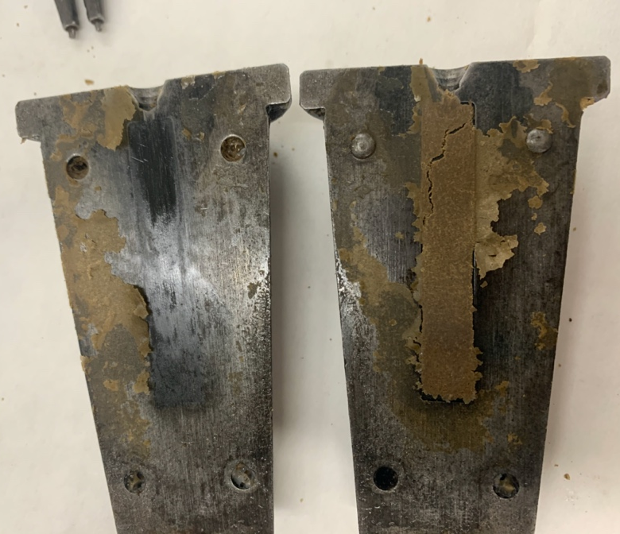
Figure S1. Specimens obtained during injection moulding with excess water in the dough.

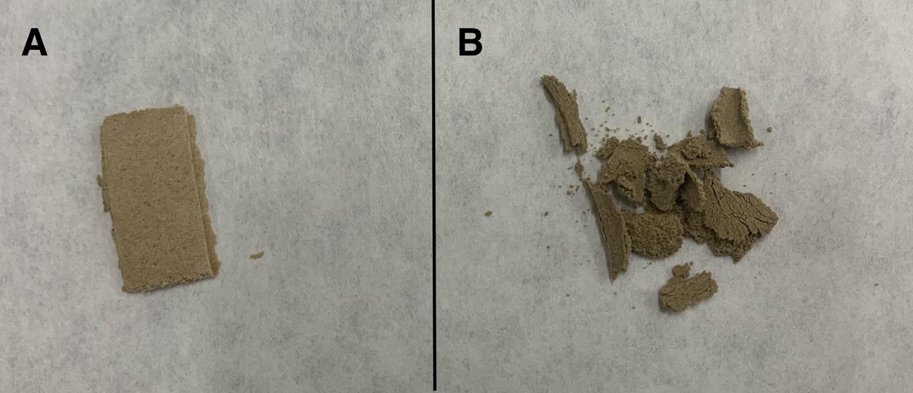
Figure S2. Appearance of the specimens after the freeze drying stage (A) 50 ºC and (B) 110 ºC system.

