

Figure 1. Representation of spiked solutions of purified matrix

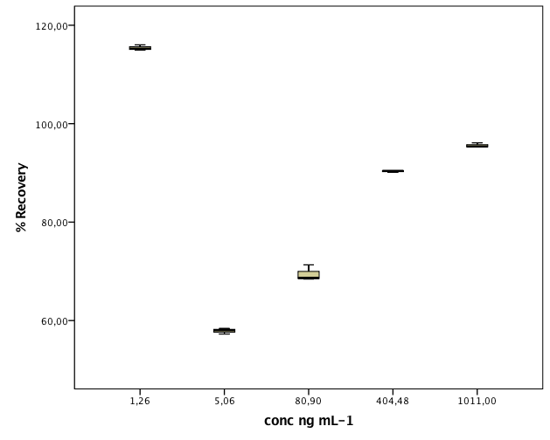

Figure 2. Distribution of the recovery (%) of hydroxytyrosol in blank matrix at five spiked concentration ranged 1.26 to 1011.00 ng mL-1. The limits of AOAC are between 120 and 40% for concentrations in studied range.