

**Fig. 1.** Weight gain comparison between two micromonoliths before calcination

|  |  |
| --- | --- |
|  |  |

**Fig. 2.** XRD patterns for (A) RuAl and S-RuAl (calcined and reduced) and (B) micromonolithic devices (bare, pretreated M and coated M-RuAl). (*) RuO2; (γ) γ-alumina; (Ru) metallic Ru; (o) martensite steel; (+) α-Al2O3; (=) aluminium yttrium oxide



**Fig. 3**. TEM micrographs for reduced powder samples (A) RuAl and (B) S-RuAl

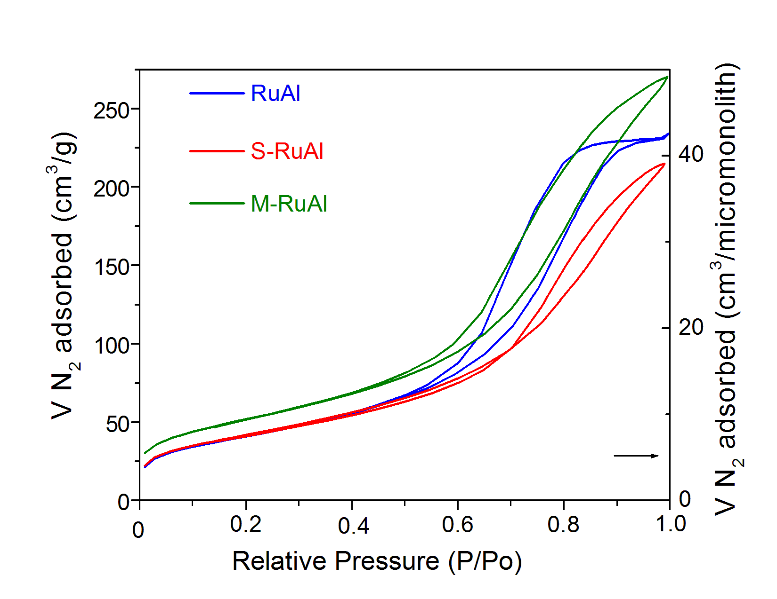

**Fig. 4**. N2 adsorption–desorption isotherms obtained for RuAl, S-RuAl and M-RuAl

|  |  |
| --- | --- |
| **A** |  |
|  | |

|  |  |
| --- | --- |
|  |  |
| **B**  **RuAl**  **α-Al2O3** | **α-Al2O3**  **RuAl** |
| **Fig. 5.** SEM micrographs of M-RuAl sample; (A) top and (B) cross section views | |

|  |  |
| --- | --- |
| RuAl  Resin  α-Al2O3  Fecralloy | Al |
| O | Ru |
| Fe | Cr |
|  |  |
|  |  |

**Fig. 6**. Mapping of cross section of M-RuAl



**Fig. 7.** In-line cross section in-depth compositional EDX analyses for M-RuAl from Fig. 6



**Fig. 8.** TPR profile for RuAl and S-RuAl

|  |
| --- |
|  |
|  |

**Fig. 9** (A) CO (solid lines) and CO2 (dash lines) conversions during S-MET with powders and micromonolithic catalysts. The selective temperature range, where less than 20 ppm CO is emitted with a total H2 consumption lower than 4% is also shown. (B) Selectivity towards CO methanation vs CO conversions. Feed composition: 0.03%CO, 15% CO2, 50%H2 (balance N2); WHSV: 80000 ml.g-1.min-1

**Table 1**

Textural properties of studied samples

|  |  |  |  |
| --- | --- | --- | --- |
| Code | SBET (m2 g-1) | Pore volume (cm3 g-1) | Pore size (nm) |
| RuAl | 149 | 0.36 | 6.0 |
| S-RuAl | 153 | 0.38 | 7.5 |
| M-RuAl | 154* | 0.37 | 7.0 |
| Al2O3 Nyacol** | 192 | 0.37 | 7.8 |

* Calculated from the amount of catalysts deposited

** Nyacol AL20 dried and calcined at 400°C 2h