Fructose dehydration reaction over functionalized nanographitic catalysts in MIBK/H₂O biphasic system.
Gabriel Delgado Martin¹, Charf Eddine Bounoukta², Fatima Ammari², María Isabel Domínguez¹, Antonio Monzón³, Svetlana Ivanova¹, Miguel Ángel Centeno^{1*}

¹ Departamento de Química Inorgánica e Instituto de Ciencia de Materiales de Sevilla – Centro Mixto CSIC/Universidad de Sevilla, Avda. Américo Vespucio, 49, 41092, Sevilla, Spain
² Laboratoire de Génie des Procédés Chimiques- LGPC, Département de Génie des Procédés, Faculté de Technologie, Université FERHAT ABBAS SETIF-1,19000 SETIF, Argelia.
³ Instituto de Nanociencia de Aragón (INA) e Instituto de Ciencia de Materiales de Aragón (ICMA), Universidad de Zaragoza-CSIC, 50018 Zaragoza, Spain

Corresponding autor: centeno@icmse.csic.es

Abstract
A series of functionalized nanographitic carbons is prepared, characterized and tested in fructose dehydration reaction to 5-hydroxymethylfurfural. The functionalization treatment was selected to introduce various Brönsted acid sites and to modify the textural and catalytic properties of the initial carbon material. Within the series, the sulfonated carbons present the most interesting catalytic behavior resulting in important selectivity to the desired product once the reaction variables were properly adjusted.

Keywords: fructose dehydration, 5-hydroxymethylfurfural, nanographitic carbon, functionalization, p-toluenesulfonic acid

Introduction
The growing energy demand and resource depletion and the increasing environmental concern in the very recent days have initiated the intensive quest for methods to convert the renewable biomass into chemicals and fuels as a way to replace the non-renewable fossil raw stocks [1-4].
More and more processes use biomass-derived chemicals, being the carbohydrates, the major raw stock for their production [4, 5]. Among these chemicals, 5-hydroxymethylfurfural (HMF) appears as a fundamental multipurpose platform molecule with high potential that can be transformed into variety of biofuels, liquid alkanes, polymer precursors, solvents and fine chemicals [6]. HMF can be used as precursor for levulinic acid (LA), 2,5-dimethyfuran (DMF), 2,5-bis(hydromethyl)furan (BHF), 2,5-diformylfuran (DFF), furan 2,5-dicarboxylic acid (FDCA) or 2,5-furandimethanol (FDM), among others [2, 7–10].
There are many studies on the conversion of cellulose [3,7, 8, 11] or glucose [1, 2, 6, 8, 12–14] to HMF. Indeed, cellulose is abundant and cheap raw material but also rigid molecule with low solubility in aqueous medium resulting in low HMF yields [3], meanwhile glucose, as its monomer, showed improved solubility and HMF yields strictly dependent on the employed catalysts. Nevertheless, it is fructose and not glucose that forms HMF more [15] and the most effective way to obtain HMF from sugars is fructose dehydration at low temperatures in acidic conditions [12].
Different kinds of solvents have been studied as reaction media for fructose dehydration, such as water, organic solvents, ionic liquids or biphasic systems [16]. The use of water is desirable and environmentally friendly, but unfortunately, under acidic conditions, the degradation of HMF by rehydration befalls [17], making the fructose conversion non-selective. Not only levulinic (LA) and formic acid (FA) are formed by rehydration, [14] but also a high molecular mass products of furan ring condensation reaction, known as humins, [14, 18] causing a severe loss of selectivity (Scheme 1).

Scheme 1.

Unwanted side reactions can be suppressed by using aprotic organic solvents, such as dimethyl sulfoxide (DMSO), dimethylformamide (DMF) or dimethylacetamide (DMA) [19]. The main problem of these solvents is their high-boiling point making difficult the isolation of HMF, unstable at the temperature of solvent distillation [20, 21]. The use of ionic liquids (IL) resolve this problem but their high price limit solvent’ large scale exploitation [16]. Other possibility is the use of biphasic water/organic systems where the solubility of the reactants is assured by the presence of water and HMF selectivity is improved by its extraction in the organic solvent [22], and furthermore their participation in side reaction is partially suppressed [23]. One of the most interesting solvent for biphasic systems is methyl isobutyl ketone (MIBK), chemically stable with relatively low boiling temperature and low water solubility (19,2g/L at 20ºC) [24], and reported as very useful for liquid-liquid extraction.
As for the catalytic systems, homogenous catalysts as mineral acids, organic acids, Lewis acid and acid-ionic liquids are reported [25, 26]. The autocatalytic process with the participation of the formed LA and FA in DMSO is also studied with the latter acting as coordinator of the reaction intermediates [17, 27, 28]. All homogeneous catalysts presented very good activity but suffer of lack of recyclability and caused environmental pollution and reactor corrosion. All these drawbacks limit their use and orientate the research toward the use of heterogeneous catalysts [4, 29]. The use of H-form zeolites and transition metal phosphates resulted in low conversion and selectivity meanwhile the metal-free carbon catalysts present an interesting alternative [30, 31]. The carbon-based materials are of special interest due to their natural abundance in graphitic form, low price and possibility of rapid chemical functionalization. Within the carbon based materials the sulfonated carbons receive a special attention due to their promising activity for fructose/glucose dehydration reaction. Important yields are obtained using DMSO [32-36], ionic liquids (1-butyl 3 methyl imidazolium chloride) [37-39] or water [40, 41] as solvents.
In this context, this work proposes the study of commercial nanographitic material (Asbury, Nano 24) as a possible catalyst for the fructose dehydration reaction in biphasic water/MIBK media. Charcoal`s catalytic properties have been modified by the introduction of different functional groups on its surface by chemical attacks with nitric acid, p-toluenesulfonic acid and a mixture of sulfuric acid/ hydrogen peroxide. In addition, a systematic evaluation of the reaction parameters has been carried out, such as initial fructose concentration, reaction temperature, time and water/MIBK ratio in order to obtain the best activity/selectivity balance.

Experimental

Materials
Nano 24 powder graphite (CN24), from Asbury Mills Ltd., USA, was used in this study. The charcoal was functionalized using nitric acid (HNO₃) 65% (Fischer Chemical), sulfuric acid (H₂SO₄) 95 % (Merck KGaA), hydrogen peroxide (H₂O₂) 30% (Appli Chem & Panreac) and p- toluenesulfonic acid (PTSa) (Sigma-Aldrich). For the reaction, D-fructose (Alfa Aesar) and methyl-isobutyl ketone (MIBK) 99,5% (Sigma-Aldrich) were purchased.

Catalysts functionalization
1 g of CN24 was dispersed in round bottom flask of 250 ml containing the acid solutions: piranha solution (84 ml of H₂SO₄ 98% and H₂O₂ 30%, 70:30 v/v ratio), nitric acid (84 ml HNO₃ 65%) and p-toluenesulfonic acid (15 ml of 0,25 M). The first two functionalizations were carried out at 80ºC for 20 h in a flask equipped with reflux. The resulting solids, abundantly washed with water till neutral pH, were dried overnight at 60ºC and grinded in mortar. The samples are labelled S-CN24 and N-CN24 where S stands for piranha solution treatment and N for that with nitric acid. The piranha solution was used in the same manner for a treatment at room temperature and the resulting sample is denoted as RS-CN24.
PTSa functionalization was carried out at room temperature in a closed round bottom flask for 24 hours. Then the solvent (water) was removed by rotary evaporation and the resulting solid washed to neutral pH, dried at 100ºC overnight, and grinded to obtain the final catalyst, PTSa-CN24.
All charcoal’ functionalizations should provide acid centers and should modify material’ textural properties and surface chemistry changing at least its hydrophilicity/hydrophobicity. p-toluenesulfonic (PTSa) and the piranha mixture (H₂SO₄/H₂O₂) play the role of sulfonating agent and the presence of functional groups such as -OH, -COOH and -SO₃H is expected [42]. On the other hand, the oxidative treatment with concentrated nitric acid generates mostly carboxylic groups. The presence of all these group is expected to increase charcoals mixing with the polar media of reaction and to influence its catalytic properties [43, 44].

Catalyst Characterization
Raman spectroscopy measurements were performed on a Horiba Jobin Yvon dispersive microscopy (HR800) with confocal aperture of 1000 μm, laser spot diameter of 0,72 μm and spatial resolution of 360 nm. The microscope is equipped with a diffraction grating of 600 tours/mm, CCD detector, green laser (λ = 532,14 nm, maximum power 20 mW) and a 100× objective.
The textural properties were analyzed by N₂ adsorption-desorption measurements at liquid nitrogen temperature with a Micrometrics TRISTAR equipment. Prior analysis, the samples were degassed under vacuum during 2 h at 350 °C in order to remove surface impurities and occluded fluids. The Brunauer-Emmett-Teller (BET) method was used to calculate the specific surface area whilst pore-size distributions were determined using the Barett–Joyner–Halenda (BJH) method.
XRD measurements were performed at room temperature on a Panalitycal X’Pert Pro diffractometer (Cu anode) in 10–90° 2θ range with 0,05° step size and 300 s time acquisition.
SEM images were acquired on HITACHI S-4800 microscope equipped with secondary electron backscattered detectors. The micrographs were taken at working distance of 4 mm and 2 kV voltage. The compositional analysis of the samples was performed by energy dispersive X-Ray spectroscopy (EDS), operating at 15 mm working distance and 20 kV voltage.
The pH measurements of solids were carried out with a pH-electrode (Metrohm) over 15 milligrams of sample dispersed in 15 ml of distilled water. pH data was collected with time and the isoelectric point was considered when the pH value remains constant.

Fructose dehydration tests
Fructose dehydration was carried out in 50 ml Schlenck reactor equipped with Young valve at constant temperature and stirring rate (600 rpm). 1 mmol of fructose and 40 mg of catalyst were mixed in the biphasic system containing 2 ml of water (9 wt.% in aqueous phase) and 8 ml of methyl-isobutyl ketone (H₂O/MIBK ratio 1:4 v/v). The reactor was sealed and immersed in preheated oil bath at desired temperature for the preferred time. After each experiment the reaction mixture cooled down in ice bath was filtered with 0.45 µL syringe nylon membrane and analyzed by High-Performance Liquid Chromatography (HPLC) equipped with refractive index detector (Varian 360-LC) and Hi-Plex H column (300 × 7,7 mm) using a 0.01 M H₂SO₄ as mobile phase at 40 ºC and 0,4 ml/min flow.

The fructose conversion, product yield and selectivity was calculated as follows:

$$fructose conversion \left(\%\right)= \frac{moles of fructose reacted}{moles of initial fructose}×100\%$$
$$product yield\left(\%\right)=\frac{moles of formed product}{moles of initial fructose}×100\%$$
$$product selectivity \left(\%\right)=\frac{product yield\left(\%\right)}{fructose conversion \left(\%\right)}×100\%$$
$$humins(\%)=\left(1-\frac{final carbon moles }{initial carbon moles }\right)*100\%$$

Results and discussion

Figure 1 summarizes the XRD patterns of the CN24 catalysts series. All solids show similar diffraction patterns assigned to multilayered nanographitic carbon, with sharp asymmetric diffraction at 2θ = 26,5° corresponding to the (002) plane and corresponding to the 3-D crystalline domain of graphite, broad region at 43-45° 2θ with diffraction related to the (100) and (101) family planes [45-47].

Figure 1.

Upon functionalization, the FWHM (full width at half maximum) value of the (002) plane increases (Table 1), suggesting an amorphization of the carbon structure after the acid treatments and the presence of unorganized polycyclic aromatics carbons [48]. Therefore, the size of carbon crystallites, calculated by Scherrer equation, decrease as shown in Table 1. The hot concentrated nitric acid produces the most important changes in particle size whereas the PTSa treatment barely influence the crystallite size. It appears that more severe the conditions of functionalization (treatment oxidation power and temperature) lower the resulting particles size.

Table 1.

Moreover, the diffraction at 2θ = 55° attributed to (004) plane of graphite rhombohedral structure increases in intensity. Some authors reported similar effect after acid functionalization and assigned the changes to the presence of the sulfonic and/or nitric functionality and/or carbon sulfites over carbon surface [49] although no additional phase is observed in our case. The functionalization affects only the crystallinity of the samples producing a more disordered graphitic carbon with lower crystallite size.
The Raman spectrum (Figure 2) of the original CN24 sample shows an intense peak at 1571 cm⁻¹ corresponding to the as called G-band, attributed to the first order scattering of the E_{2g} phonon of the sp² C-C bond [40]. This band shifts to higher wavelength for the functionalized CN24 samples, due probably to the change of the carbon crystallite size [50, 51]
.
Figure 2.

G-band appears accompanied by a second band at around 1355 cm⁻¹. This band, known as D-band corresponds to carbon breathing mode of A_{1g} symmetry involving phonons near the K zone boundary [50]. The D-band, generally gives the information about the disorder of the structure and increase with the introduction of defects. For our series of samples, an increase of the I(D)/I(G) ratio is observed upon functionalization suggesting an increase of the defect sites population associated either with the introduced Brönsted acid groups or to the collision of the crystallite boundaries caused by the extensive acidity of modifying agents. Indeed, Zhao et al. [52] reported a C-O-C bond cleavage produced upon functionalization with strong acid. It is worth to mention the especially important change produced after treating with piranha mixture at room temperature due probably to the highest effect of hydrogen peroxide produced at this temperature.
Scanning Electron Microscopy was used to investigate the morphology of the samples (Figure 3). The initial CN24 (figure 3A & B) presents agglomerates of different size crystallites with an apparent porosity due to the formation of interparticles irregular cavities. The aggregates are isolated or edge-attached, being more transparent and corrugated in view when a high degree of exfoliation is present [47].

Figure 3.

The functionalization, no matter the nature of the modifying agent, does not change the morphology of the CN24 support, only the apparent porosity resulting in more open interparticular voids. The coupled EDX analysis is used to examine the overall percentage of sulfur, and the O/C ratio (table 2).

Table 2.

The initial sample shows absence of sulfur and low degree of oxidation. Sulfur is detected only for the sulfonated samples, being the highest content that of the RS-CN24 sample. It seems that the use of piranha solution at low temperature result in higher sulfur and oxygen content. The presence of sulfur is due mainly to the presence SO₃H functional groups covalently bonded to the sp² hybridized polycyclic carbon network [53]. The most oxidized sample is that treated with hot nitric acid with O/C ratio of 0,14 presumably by the presence of superficial –COOH groups. The presence of oxygen and/or sulfur-oxygen superficial groups increase the acidity of the samples, confirmed by the decrease of the pH for all treated samples (Table 2). The Brönsted acidity is introduced and the presence of –SO₃H groups confirmed by the appearance of sulfur and oxygen in the samples.
The functionalization influences also the textural properties of the samples (Figure 4 and Table 3). The observed hysteresis in the isotherms of type IV H3 according to IUPAC [54] confirms the presence of mesopores for all samples. The CN24 and PTSa-CN24 samples present similar isotherms, suggesting that either the functionalization does not alter sample’s textural properties or the outgassing temperature prior analysis removes completely PTSa. Indeed, the acidity of the PTSa-CN24 sample after BET measurement has an acidity value of 5,2, closer to that of raw CN24 (6,6), although still more acid.

Figure 4.

For all other samples, the functionalization process reduces N₂ adsorption capacity and the loop of hysteresis becomes broader due to the decreasing of the pore size and total surface. The initial sample present BET specific surface area of 346 m²/g with average pore size of 6,5 nm.

Table 3.

The overall specific surface area decreases for all functionalized samples, being PTSa-CN24 an exception, more probably due to the partial degasification of the surface sulfonated groups, as evidenced by the lower acidity of the PTSa-CN24 sample after BET measurement. The pore size increase for all sulfonated samples due to the increasing contribution of the meso/macropores (figure S1 in supporting information). The introduction of some bulky sites could cause micropores and mesopores enlargement to accommodate those groups inside. On the contrary, the nitric acid treatment provokes a collapse of the CN24 pore systems, the volume diminishes by half as well as the size of the pores resulting in mesoporous solid with poor volume. In addition, the temperature does not influence the textural properties (RS-CN24 vs. S-CN24) suggesting that the specific surface decrease is due more probably to pore blocking.

Catalysts screening
The screening of the catalysts was carried out in standard conditions: temperature of 140ºC, time of 12 h at a MIBK/H₂O (2ml) ratio of 4:1 (v/v). The activity of the samples is compared to that of a blank sample without catalyst. The conversion of fructose rounds 65 % and appears not related to the catalyst presence but to the temperature of reaction (Figure 5A). Practically, for all samples the products of the reaction are HMF, levulinic and formic acids (LA+FA) and glucose (Figure 5B). The cross polymerization of HMF and fructose is the major reaction in blank conditions, leading to an important proportion of humins, recognized qualitatively by the change of reaction mixture color (intensive dark brown) [17, 55] and quantitatively estimated by the loss of analyzed carbon (mole_{in} and mole_{out}). The production of such an important percentage of insoluble humins is due to the use of high fructose concentration in the aqueous phase (9 wt.%). No matter the sample, around 5% of fructose isomerization to glucose is always observed due to the basicity originated by the electron delocalization within the polyaromatic sheets of the carbon.

Figure 5.

The poor HMF selectivity for the initial CN24 sample (19.5%) and high humins formation indicates that fructose tautomers are not dehydrated but polymerized resulting in insoluble polymers. However, when the Brönsted acidity and pore size increase, as in case of all sulfonated samples, the humins production decreases and HMF increases. Nevertheless, still, the production of HMF seems shortfall. The introduction of p-toluenesulfonic sites increases the fructose conversion to 70 % and HMF yield to 30% decreasing significantly the humins formation. Apparently, the same sites participate in the HMF rehydration resulting in around 33% of selectivity to levulinic and formic acids.
N-CN24 sample showed low conversion and selectivity probably due to the inaccessibility of all active sites in the pores of low size. The temperature of functionalization for RS-CN and S-CN does not influence the catalytic behavior indicating that the key parameter to improve the activity is the presence of Brönsted sites.

Time effect
The ajust of all parameters of the reaction was carried out over the most active PTSA-CN24 catalyst. The increase of the time of reaction increases the fructose conversion and HMF yield (Figure 6A). Maximal yield of production of LA and FA is observed at 12 h of reaction and decreases as the time of reaction increases. Glucose production shows a maximum at 6 h suggesting that the reaction of glucose isomerization occurs in the first hours. As for the byproduct distribution (Figure 6B), humins are produced in the first hours of reaction at low fructose conversion and high glucose yield, suggesting that their production is more related to the presence of aldehyde functions and their participation in the cross polymerization reaction. Indeed, the formation of humins from glucose is much more easier than from fructose [56]. The minimum selectivity to humins is obtained at 12 h where the HMF selectivity stabilizes and varies insignificantly with the reaction time. Although the humins production decreases, the HMF rehydration rate increases at this time and the yield of HMF is lower. Thus, at higher time of reaction the HMF yield increases due to the increase of fructose conversion for the same HMF selectivity. So, the selected time of reaction for the study of the influence of the other reaction variables was 24 h.

Figure 6

Temperature effect
Figure 7 shows the conversion of fructose and HMF and humins yield over PTSa-CN24 at different reaction temperatures. The conversion of fructose increases with the temperature, being the difference in activity more important between 120 ºC and 140 ºC. The HMF yield presents a maximum at 140 ºC, where also the humins production is minor. The increase of the temperature produces more humins due to the polymerization of the HMF whereas at lower temperatures the isomerization reaction to glucose decreases HMF selectivity and increases the rate of humins formation. Thus, the temperature of 140ºC seems to be the more adequate to conduct the reaction.

Figure 7

MIBK solvent effect
MIBK presumably suppresses HMF condensation by extraction in the organic phase where the condensation reaction does not occur [27]. The reaction results over PTSa-CN24 at 24 hours, 140°C and different MIBK/H₂O ratios (1:1 2:1, 4:1, 6:1, v/v) are presented in Figure 8. The increase of MIBK ratio affects positively the fructose conversion but does not influence the HMF and humin yields. Zhu et al. [57], reported that low MIBK/H₂O ratios may cause partial insolubility of fructose, thus favoring low fructose conversion.

Figure 8.

Taking into account that from 2:1 to 6:1 MIBK:H₂O ratios the product distribution is very similar, the intermediate ratio of 4:1, with a 43% HMF yield and 90% of fructose conversion, is chosen as an optimal parameter.

Fructose initial concentration effect
For economical purposes, high initial fructose concentration is usually preferred [58]. Its effect on overall conversion and HMF yield at 140°C and 24 h is summarized in Figure 9. The initial concentration of fructose is expressed in wt.%, being the volume of water always constant (2ml). Fructose conversion increases when the initial concentration of 2,2 wt% is doubled to 4,5 wt% and remains constant afterwards. It appears that 4,5 wt% presents the highest HMF yield lowering for higher concentration in favor to humins formation via HMF degradation and hexoses polymerization.

Figure 9.

Table 4 shows a comparison of overall performance of our best catalyst PTSa-CN24 with some reported systems. Our catalytic system clearly shows an excellent fructose conversion ability with HMF yields comparable and even superior to catalysts reported in the literature.

Table 4.

Catalyst recycling
The best catalyst’ life over five catalytic cycles is illustrated in Figure 10. Between every cycle, the catalyst is recovered by centrifugation and, after abundant washing and drying, is used for the next cycle. As a loss of catalyst occurs during the recovery steps, the reaction conditions are readjusted to the recovered quantity to maintain constant catalyst to fructose and water/MIBK ratio. The fructose conversion decreases rapidly till the 2nd cycle, and remains stable in the successive runs ending with 20% loss of activity. Nevertheless, the loss in HMF yield is not as severe with only a 6 % decrease between the 1st and the last cycle. It seems that the loss of conversion does not affect the HMF yield thus converting the catalysts in a very promising candidate for this reaction. A EDX analysis of the sulfur content (Table 3) after recycling indicates 0,1 % of sulfur very similar to the initial content suggesting minor leaching of the active phase.

Figure 10.

Conclusions
A commercial nanographitic carbon is functionalized successfully by different agents with the final goal to increase the number and type of Brönsted sites on catalyst’ surface. The functionalization causes structural amorphization and textural properties changes, being the piranha solution the agent that affects the most the final solid. In general, the sulfonation (piranha solution or p-toluenesulfonic acid treatment) affects in a greater extent the catalytic properties, leading to best activity/selectivity balances, especially for the PTSa-CN24 sample. This sample presents excellent activity and high selectivity for total furans (74% selectivity’s in 12 hours) and most importantly with high carbon balance. The HMF yield can be adjusted by changing some reaction parameters being the more beneficial the decrease of the initial fructose concentration from 9 to 4,5% w/v. In addition, this catalyst is stable under recycling in terms of HMF selectivity offering a promising approach for efficient biomass conversion over carbonaceous acid catalyst.

Acknowledgments
Financial support for this work has been obtained from the Spanish Ministerio de Economía y Competitividad (MINECO) (Projects ENE2017-82451-C3-1-R and ENE2017-82451-C3-3-R) co-financed by FEDER funds from the European Union.

References
[1] C. García-Sancho, I. Fúnez-Núñez, R. Moreno-Tost, J. Santamaría-González, E. Pérez-Inestrosa, J.L.G. Fierro, P. Maireles-Torres, Beneficial effects of calcium chloride on glucose dehydration to 5-hydroxymethylfurfural in the presence of alumina as catalyst, Appl. Catal. B Environ. 206 (2017) 617–625. https://doi.org/10.1016/j.apcatb.2017.01.065.
[2] S. Bali, M.A. Tofanelli, R.D. Ernst, E.M. Eyring, Chromium(III) catalysts in ionic liquids for the conversion of glucose to 5-(hydroxymethyl)furfural (HMF): Insight into metal catalyst:ionic liquid mediated conversion of cellulosic biomass to biofuels and chemicals, Biomass Bioenergy. 42 (2012) 224–227. https://doi.org/10.1016/j.biombioe.2012.03.016.
[3] X. Zhang, D. Zhang, Z. Sun, L. Xue, X. Wang, Z. Jiang, Highly efficient preparation of HMF from cellulose using temperature-responsive heteropolyacid catalysts in cascade reaction, Appl. Catal. B Environ. 196 (2016) 50–56. https://doi.org/10.1016/j.apcatb.2016.05.019.
[4] J. Wang, Z. Zhang, S. Jin, X. Shen, Efficient conversion of carbohydrates into 5-hydroxylmethylfurfan and 5-ethoxymethylfurfural over sufonic acid-functionalized mesoporous carbon catalyst, Fuel. 192 (2017) 102–107. https://doi.org/10.1016/j.fuel.2016.12.027.
[5] Y. Zhang, J. Wang, X. Li, X. Liu, Y. Xia, B. Hu, G. Lu, Y. Wang, Direct conversion of biomass-derived carbohydrates to 5-hydroxymethylfurural over water-tolerant niobium-based catalysts, Fuel. 139 (2015) 301–307. https://doi.org/10.1016/j.fuel.2014.08.047.
[6] W. Li, T. Zhang, H. Xin, M. Su, L. Ma, H. Jameel, H. Chang, G. Pei, p -Hydroxybenzenesulfonic acid–formaldehyde solid acid resin for the conversion of fructose and glucose to 5-hydroxymethylfurfural, RSC Adv. 7 (2017) 27682–27688. https://doi.org/10.1039/C7RA03155F.
[7] W.-H. Peng, Y.-Y. Lee, C. Wu, K. C.-W. Wu, Acid–base bi-functionalized, large-pored mesoporous silica nanoparticles for cooperative catalysis of one-pot cellulose-to-HMF conversion, J. Mater. Chem. 22 (2012) 23181–23185. https://doi.org/10.1039/C2JM35391A.
[8] C. Li, Z. Zhang, Z.K. Zhao, Direct conversion of glucose and cellulose to 5-hydroxymethylfurfural in ionic liquid under microwave irradiation, Tetrahedron Lett. 50 (2009) 5403–5405. https://doi.org/10.1016/j.tetlet.2009.07.053.
[9] A.J. Kumalaputri, G. Bottari, P.M. Erne, H.J. Heeres, K. Barta, Tunable and Selective Conversion of 5-HMF to 2,5-Furandimethanol and 2,5-Dimethylfuran over Copper-Doped Porous Metal Oxides, ChemSusChem. 7 (2014) 2266–2275. https://doi.org/10.1002/cssc.201402095.
[10] Y. Yang, C. Hu, M. M. Abu-Omar, Conversion of carbohydrates and lignocellulosic biomass into 5-hydroxymethylfurfural using AlCl 3 ·6H 2 O catalyst in a biphasic solvent system, Green Chem. 14 (2012) 509–513. https://doi.org/10.1039/C1GC15972K.
[11] F. Shen, T. Guo, C. Bai, M. Qiu, X. Qi, Hydrolysis of cellulose with one-pot synthesized sulfonated carbonaceous solid acid, Fuel Process. Technol. 169 (2018) 244–247. https://doi.org/10.1016/j.fuproc.2017.10.015.
[12] S. Xu, C. Yin, D. Pan, F. Hu, Y. Wu, Y. Miao, L. Gao, G. Xiao, Efficient conversion of glucose into 5-hydroxymethylfurfural using a bifunctional Fe3+ modified Amberlyst-15 catalyst, Sustain. Energy Fuels. 3 (2019) 390–395. https://doi.org/10.1039/C8SE00499D.
[13] C. Megías Sayago, Catalizadores híbridos bifuncionales para la valorización química de biomasa, (2017). https://idus.us.es/xmlui/handle/11441/74827 (accessed October 11, 2019).
[14] F.C. de Melo, R.F. de Souza, P.L.A. Coutinho, M.O. de Souza, F.C. de Melo, R.F. de Souza, P.L.A. Coutinho, M.O. de Souza, Synthesis of 5-Hydroxymethylfurfural from Dehydration of Fructose And Glucose Using Ionic Liquids, J. Braz. Chem. Soc. 25 (2014) 2378–2384. https://doi.org/10.5935/0103-5053.20140256.
[15] A.S. Amarasekara, L.D. Williams, C.C. Ebede, Mechanism of the dehydration of d-fructose to 5-hydroxymethylfurfural in dimethyl sulfoxide at 150°C: an NMR study, Carbohydr. Res. 343 (2008) 3021–3024. https://doi.org/10.1016/j.carres.2008.09.008.
[16] X. Qi, M. Watanabe, T. M. Aida, J. Richard Lee Smith, Catalytic dehydration of fructose into 5-hydroxymethylfurfural by ion-exchange resin in mixed-aqueous system by microwave heating, Green Chem. 10 (2008) 799–805. https://doi.org/10.1039/B801641K.
[17] A. Ranoux, K. Djanashvili, I.W.C.E. Arends, U. Hanefeld, 5-Hydroxymethylfurfural Synthesis from Hexoses Is Autocatalytic, ACS Catal. 3 (2013) 760–763. https://doi.org/10.1021/cs400099a.
[18] H.E. van Dam, A.P.G. Kieboom, H. van Bekkum, The Conversion of Fructose and Glucose in Acidic Media: Formation of Hydroxymethylfurfural, Starch - Stärke. 38 (1986) 95–101. https://doi.org/10.1002/star.19860380308.
[19] A.H. Jadhav, H. Kim, I.T. Hwang, Efficient selective dehydration of fructose and sucrose into 5-hydroxymethylfurfural (HMF) using dicationic room temperature ionic liquids as a catalyst, Catal. Commun. 21 (2012) 96–103. https://doi.org/10.1016/j.catcom.2012.02.007.
[20] T. Okano, K. Qiao, Q. Bao, D. Tomida, H. Hagiwara, C. Yokoyama, Dehydration of fructose to 5-hydroxymethylfurfural (HMF) in an aqueous acetonitrile biphasic system in the presence of acidic ionic liquids, Appl. Catal. Gen. 451 (2013) 1–5. https://doi.org/10.1016/j.apcata.2012.11.004.
[21] S. Hu, Z. Zhang, Y. Zhou, B. Han, H. Fan, W. Li, J. Song, Y. Xie, Conversion of fructose to 5-hydroxymethylfurfural using ionic liquids prepared from renewable materials, Green Chem. 10 (2008) 1280–1283. https://doi.org/10.1039/B810392E.
[22] F. Tao, H. Song, L. Chou, Dehydration of fructose into 5-hydroxymethylfurfural in acidic ionic liquids, RSC Adv. 1 (2011) 672–676. https://doi.org/10.1039/C1RA00088H.
[23] Y. Román-Leshkov, J.A. Dumesic, Solvent Effects on Fructose Dehydration to 5-Hydroxymethylfurfural in Biphasic Systems Saturated with Inorganic Salts, Top. Catal. 52 (2009) 297–303. https://doi.org/10.1007/s11244-008-9166-0.
[24] W. Wang, K. Yang, J.M. Sierra, X. Zhang, S. Yuan, Z. Hu, Potential impact of methyl isobutyl ketone (MIBK) on phenols degradation in an UASB reactor and its degradation properties, J. Hazard. Mater. 333 (2017) 73–79. https://doi.org/10.1016/j.jhazmat.2017.03.033.
[25] T. Wang, J.A. Glasper, B.H. Shanks, Kinetics of glucose dehydration catalyzed by homogeneous Lewis acidic metal salts in water, Appl. Catal. Gen. 498 (2015) 214–221. https://doi.org/10.1016/j.apcata.2015.03.037.
[26] T.D. Swift, C. Bagia, V. Choudhary, G. Peklaris, V. Nikolakis, D.G. Vlachos, Kinetics of Homogeneous Brønsted Acid Catalyzed Fructose Dehydration and 5-Hydroxymethyl Furfural Rehydration: A Combined Experimental and Computational Study, ACS Catal. 4 (2014) 259–267. https://doi.org/10.1021/cs4009495.
[27] G. Portillo Perez, A. Mukherjee, M.-J. Dumont, Insights into HMF catalysis, J. Ind. Eng. Chem. 70 (2019) 1–34. https://doi.org/10.1016/j.jiec.2018.10.002.
[28] H. Ma, F. Wang, Y. Yu, L. Wang, X. Li, Autocatalytic Production of 5-Hydroxymethylfurfural from Fructose-Based Carbohydrates in a Biphasic System and Its Purification, Ind. Eng. Chem. Res. 54 (2015) 2657–2666. https://doi.org/10.1021/ie504791x.
[29] Y. Zhu, W. Li, Y. Lu, T. Zhang, H. Jameel, H. Chang, L. Ma, Production of furfural from xylose and corn stover catalyzed by a novel porous carbon solid acid in γ-valerolactone, RSC Adv. 7 (2017) 29916–29924. https://doi.org/10.1039/C7RA03995F.
[30] J. Wang, W. Xu, J. Ren, X. Liu, G. Lu, Y. Wang, Efficient catalytic conversion of fructose into hydroxymethylfurfural by a novel carbon-based solid acid, Green Chem. 13 (2011) 2678–2681. https://doi.org/10.1039/C1GC15306D.
[31] M. Shaikh, A. Sahu, A.K. Kumar, M. Sahu, S. K. Singh, K.V. S. Ranganath, Metal-free carbon as a catalyst for oxidative coupling: solvent-enhanced poly-coupling with regioselectivity, Green Chem. 19 (2017) 4533–4537. https://doi.org/10.1039/C7GC02227A.
[32] J. Zhao, C. Zhou, C. He, Y. Dai, X. Jia, Y. Yang, Efficient dehydration of fructose to 5-hydroxymethylfurfural over sulfonated carbon sphere solid acid catalysts, Catalysis Today. 264 (2016) 123–130. https://doi.org/10.1016/j.cattod.2015.07.005.
[33] Q. Hou, W. Li, M. Ju, L. Liu, Y. Chen, Q. Yang, One-pot synthesis of sulfonated graphene oxide for efficient conversion of fructose into HMF, RSC Adv. 6 (2016) 104016–104024. https://doi.org/10.1039/C6RA23420H.
[34] R.S. Thombal, V.H. Jadhav, Biomass derived β-cyclodextrin-SO 3 H carbonaceous solid acid catalyst for catalytic conversion of carbohydrates to 5-hydroxymethylfurfural, Applied Catalysis A: General. 499 (2015) 213–216. https://doi.org/10.1016/j.apcata.2015.04.021.
[35] M. Li, Q. Zhang, B. Luo, C. Chen, S. Wang, D. Min, Lignin-based carbon solid acid catalyst prepared for selectively converting fructose to 5-hydroxymethylfurfural, Industrial Crops and Products. (2019) 111920, https://doi.org/10.1016/j.indcrop.2019.111920
[36] J. Wang, Y. Zhang, Y. Wang, L. Zhu, H. Cui, W. Yi, Catalytic fructose dehydration to 5-hydroxymethylfurfural over sulfonated carbons with hierarchically ordered pores, J Fuel Chem Technol, 2016, 44(11), 1341−1348
[37] X. Qi, N. Liu, Y. Lian, Carbonaceous microspheres prepared by hydrothermal carbonization of glucose for direct use in catalytic dehydration of fructose, RSC Adv. 5 (2015) 17526–17531. https://doi.org/10.1039/C4RA15296D.
[38] G. Portillo Perez, M.-J. Dumont, Production of HMF in high yield using a low cost and recyclable carbonaceous catalyst, Chemical Engineering Journal. 382 (2020) 122766. https://doi.org/10.1016/j.cej.2019.122766.
[39] M. Li, Q. Zhang, B. Luo, C. Chen, S. Wang, D. Min, Lignin-based carbon solid acid catalyst prepared for selectively converting fructose to 5-hydroxymethylfurfural, Industrial Crops and Products. (2019) 111920. https://doi.org/10.1016/j.indcrop.2019.111920.
[40] X. Xiong, I.K.M. Yu, S.S. Chen, D.C.W. Tsang, L. Cao, H. Song, E.E. Kwon, Y.S. Ok, S. Zhang, C.S. Poon, Sulfonated biochar as acid catalyst for sugar hydrolysis and dehydration, Catalysis Today. 314 (2018) 52–61. https://doi.org/10.1016/j.cattod.2018.02.034.
[41] Y. Nishimura, M. Suda, M. Kuroha, H. Kobayashi, K. Nakajima, A. Fukuoka, Synthesis of 5-hydroxymethylfurfural from highly concentrated aqueous fructose solutions using activated carbon, Carbohydrate Research. 486 (2019) 107826. https://doi.org/10.1016/j.carres.2019.107826.
[42] A.C. Zaman, Polyol derived sulfonated solvothermal carbon for efficient dye removal from aqueous solutions, J. Mol. Liq. 249 (2018) 892–903. https://doi.org/10.1016/j.molliq.2017.11.117.
[43] I.D. Rosca, F. Watari, M. Uo, T. Akasaka, Oxidation of multiwalled carbon nanotubes by nitric acid, Carbon. 43 (2005) 3124–3131. https://doi.org/10.1016/j.carbon.2005.06.019.
[44] M. Shaikh, S.K. Singh, S. Khilari, M. Sahu, K.V.S. Ranganath, Graphene oxide as a sustainable metal and solvent free catalyst for dehydration of fructose to 5-HMF: A new and green protocol, Catal. Commun. 106 (2018) 64–67. https://doi.org/10.1016/j.catcom.2017.12.018.
[45] A. Yasmin, I.M. Daniel, Mechanical and thermal properties of graphite platelet/epoxy composites, Polymer. 45 (2004) 8211–8219. https://doi.org/10.1016/j.polymer.2004.09.054.
[46] M.S.A. Farabi, M.L. Ibrahim, U. Rashid, Y.H. Taufiq-Yap, Esterification of palm fatty acid distillate using sulfonated carbon-based catalyst derived from palm kernel shell and bamboo, Energy Conversion and Management. 181 (2019) 562–570. https://doi.org/10.1016/j.enconman.2018.12.033.
[47] V. Kumar, D.-J. Lee, J.-Y. Lee, Studies of RTV silicone rubber nanocomposites based on graphitic nanofillers, Polymer Testing. 56 (2016) 369–378. https://doi.org/10.1016/j.polymertesting.2016.11.004.
[48] Z.Q. Li, C.J. Lu, Z.P. Xia, Y. Zhou, Z. Luo, X-ray diffraction patterns of graphite and turbostratic carbon, Carbon. 45 (2007) 1686–1695. https://doi.org/10.1016/j.carbon.2007.03.038.
[49] S.K. Sangar, C.S. Lan, S.M. Razali, M.S.A. Farabi, Y.H. Taufiq-Yap, Methyl ester production from palm fatty acid distillate (PFAD) using sulfonated cow dung-derived carbon-based solid acid catalyst, Energy Conversion and Management. 196 (2019) 1306–1315. https://doi.org/10.1016/j.enconman.2019.06.073.
[50] A.C. Ferrari, J. Robertson, Interpretation of Raman spectra of disordered and amorphous carbon, Phys. Rev. B. 61 (2000) 14095–14107. https://doi.org/10.1103/PhysRevB.61.14095.
[51] S.S. Nanda, M.J. Kim, K.S. Yeom, S.S.A. An, H. Ju, D.K. Yi, Raman spectrum of graphene with its versatile future perspectives, TrAC Trends in Analytical Chemistry. 80 (2016) 125–131. https://doi.org/10.1016/j.trac.2016.02.024.
[52] J. Zhao, L. Yang, F. Li, R. Yu, C. Jin, Structural evolution in the graphitization process of activated carbon by high-pressure sintering, Carbon. 47 (2009) 744–751. https://doi.org/10.1016/j.carbon.2008.11.006.
[53] K. Nakajima, M. Hara, S. Hayashi, Environmentally Benign Production of Chemicals and Energy Using a Carbon-Based Strong Solid Acid, J American Ceramic Society. 0 (2007) 071019062949001-??? https://doi.org/10.1111/j.1551-2916.2007.02082.x.
[54] F. Rouquerol, J. Rouquerol, K. Sing, Assessment of Mesoporosity, in: Adsorption by Powders and Porous Solids, Elsevier, 1999: pp. 191–217. https://doi.org/10.1016/B978-012598920-6/50008-7.
[55] F. Wang, A.-W. Shi, X.-X. Qin, C.-L. Liu, W.-S. Dong, Dehydration of fructose to 5-hydroxymethylfurfural by rare earth metal trifluoromethanesulfonates in organic solvents, Carbohydr. Res. 346 (2011) 982–985. https://doi.org/10.1016/j.carres.2011.03.009.
[56] Sushil K. R. Patil, Jacob Heltzel, Carl R. F. Lund, Comparison of Structural Features of Humins Formed Catalytically from Glucose, Fructose and 5-hydroxymethylfurfuraldehyde, Energy Fuels 2012, 26, 8, 5281-5293, https://doi.org/10.1021/ef3007454
[57] L. Zhu, J. Wang, P. Zhao, F. Song, X. Sun, L. Wang, H. Cui, W. Yi, Preparation of the Nb-P/SBA-15 catalyst and its performance in the dehydration of fructose to 5-hydroxymethylfurfural, Journal of Fuel Chemistry and Technology. 45 (2017) 651–659. https://doi.org/10.1016/S1872-5813(17)30034-8.
[58] B. Agarwal, K. Kailasam, R.S. Sangwan, S. Elumalai, Traversing the history of solid catalysts for heterogeneous synthesis of 5-hydroxymethylfurfural from carbohydrate sugars: A review, Renewable and Sustainable Energy Reviews. 82 (2018) 2408–2425. https://doi.org/10.1016/j.rser.2017.08.088.
[59] C. Moreau, R. Durand, S. Razigade, J. Duhamet, P. Faugeras, P. Rivalier, P. Ros, G. Avignon, Dehydration of fructose to 5-hydroxymethylfurfural over H-mordenites, Applied Catalysis A: General. 145 (1996) 211–224. https://doi.org/10.1016/0926-860X(96)00136-6.
[60] C. Sonsiam, A. Kaewchada, S. pumrod, A. Jaree, Synthesis of 5-hydroxymethylfurfural (5-HMF) from fructose over cation exchange resin in a continuous flow reactor, Chemical Engineering and Processing - Process Intensification. 138 (2019) 65–72. https://doi.org/10.1016/j.cep.2019.03.001.
[61] V.V. Ordomsky, J. van der Schaaf, J.C. Schouten, T.A. Nijhuis, The effect of solvent addition on fructose dehydration to 5-hydroxymethylfurfural in biphasic system over zeolites, Journal of Catalysis. 287 (2012) 68–75. https://doi.org/10.1016/j.jcat.2011.12.002.
[62] S.F. Mayer, H. Falcón, R. Dipaola, P. Ribota, L. Moyano, S. Morales-delaRosa, R. Mariscal, J.M. Campos-Martín, J.A. Alonso, J.L.G. Fierro, Dehydration of fructose to HMF in presence of (H3O)xSbxTe(2-x)O6 (x = 1, 1.1, 1.25) in H2O-MIBK, Molecular Catalysis. (2019) 110276. https://doi.org/10.1016/j.mcat.2018.12.025.

CAPTIONS

Scheme 1. Side reactions for fructose dehydration to HMF

Figure 1. XR Diffraction of the studied series
Figure 2. Raman spectra of the catalysts.
Figure 3. SEM images of the prepared catalyst series A and B) CN24, C) N-CN24, D) RS-CN24, E) S-CN24, F) PTSa-CN24.
Figure 4. N₂ physisorption isotherms of the prepared catalysts
Figure 5. Catalyst screening A) fructose conversion and HMF yield, B) product distribution, (t=24h, T= 140ºC, 4:1 (MIBK:H₂O v/v),V_{H2O}=2 ml, 180 mg Fructose, 40 mg catalyst) * Byproducts includes soluble and insoluble polymers.
Figure 6. Influence of reaction time over A) Fructose conversion and HMF, LA+FA and Glucose yields and B) product selectivity over PTSa-CN24 catalyst, (T= 140ºC, 4:1 (MIBK: H₂O V/V), V_{H2O}=2 ml, 180 mg Fructose, 40 mg PTSa-CN24)
Figure 7. Temperature effect over PTSa-CN24 catalyst, (t= 24 hours, 4:1 (MIBK: H₂O V/V), V_{H2O}=2ml, 180 mg Fructose, 40 mg PTSa-CN24)
Figure 8. MIBK effect over PTSa-CN24 catalyst, (t= 12h, T= 140ºC, V_{H2O}=2 ml, 180 mg Fructose, 40 mg PTSa-CN24)
Figure 9. Fructose concentration effect over PTSa-CN24 based catalyst, (t=24h, T= 140ºC, 4:1 (MIBK: H₂O V/V), V_{H2O}=2ml)
Figure 10. Regeneration of PTSa-CN24 effect on fructose dehydration. (24h, 140ºC, 4:1 (MIBK:H₂O), 40 mg PTSa-CN24)

TABLES

Table 1. FWHM value, average catalysts particle size by Scherrer´s equation and I(D)/I(G) ratio calculated over Raman spectra.

Catalyst | FWHM 002 DRX | Crystallite size (Å) | I(D)/I(G)
CN24 | 0,713 | 133 | 0,42
N-CN24 | 1,029 | 88 | 0,53
RS-CN24 | 0,956 | 95 | 0,82
S-CN24 | 0,966 | 94 | 0,52
PTSa-CN24 | 0,801 | 116 | 0,59

Table 2. EDX analysis of the studied samples and catalysts acidity; in parenthesis measured after recycling test.
Catalyst | O/C ratio | Sulfur  Content (at.%) | pH
CN24 | 0,062 | 0 | 6,6
N-CN24 | 0,14 | 0 | 4,5
RS-CN24 | 0,12 | 0,98 | 4,7
S-CN24 | 0,10 | 0,01 | 4,0
PTSa-CN24 | 0,061 | 0,14 (0,1) | 4,5

Table 3. Specific surface area, cumulative pore volume and average pore size of the samples
Catalyst | BET Surface  Area (m²/g) | BJH pore volume (cm³/g) | Pore diameter (nm)
CN24 | 346 | 0,44 | 6,5
N-CN24 | 122 | 0,21 | 5,9
RS-CN24 | 172 | 0,37 | 7,9
S-CN24 | 174 | 0,39 | 8,0
PTSa-CN24 | 334 | 0,49 | 6,9

Table 4. HMF yield and fructose conversion over different heterogeneous catalysts in biphasic MIBK/H₂O system.
Catalyst | Fructose concentration  (w/v %) | Reaction  temperature  (°C) | Fructose  conversion  (%) | HMF  yield  (%) | Ref.
Zeolite | 1,7 | 165 | 76 | 69 | [59]
IER | 10,0 | 90 | 44 | 31 | [60]
Nb/SBA-15 | 3,3 | 130 | 45 | 31 | [57]
Nb-P/SBA-15 | 3,3 | 130 | 53 | 48 | [57]
H-MOR/SiO₂ | 6,7 | 165 | 85 | 53 | [61]
(H₃O)_{1.25}Sb_{1.25}Te_{0.75}O₆ | 1,5 | 150 | 98 | 59 | [62]
PTSa-CN24 | 9,0 | 140 | 89 | 43 | This work
PTSa-CN24 | 4,5 | 140 | 90 | 52 | This work

FIGURES

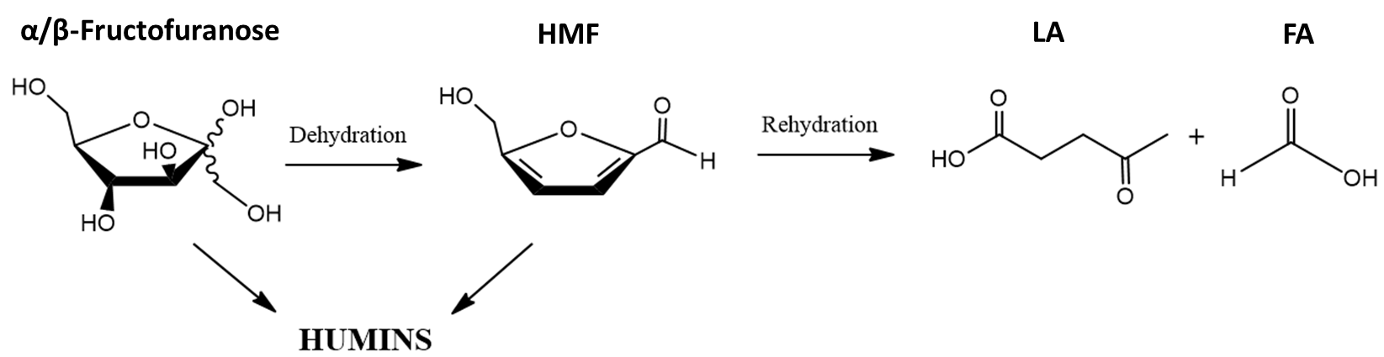
Scheme 1.

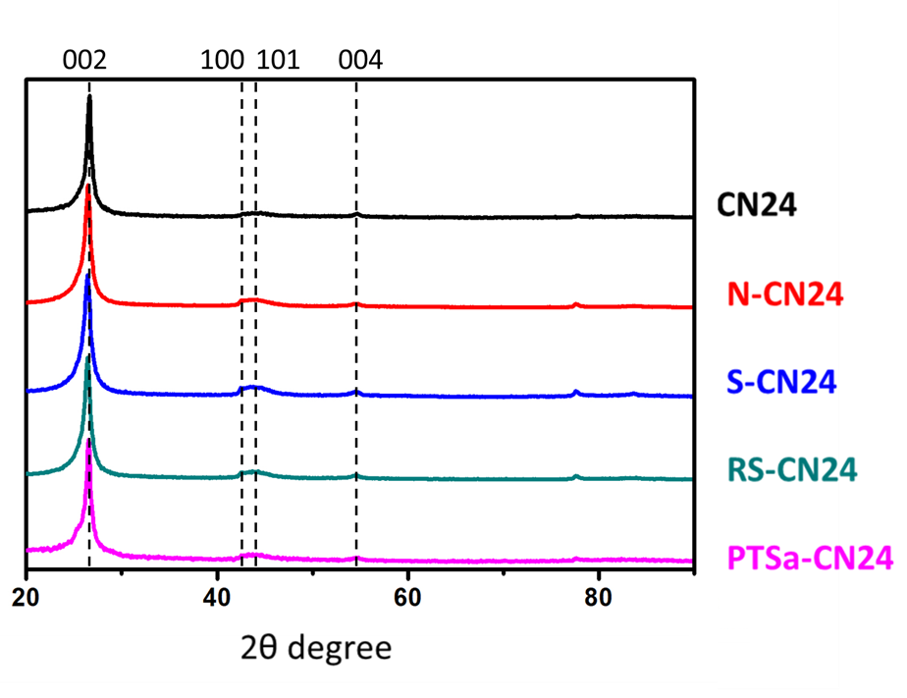
Figure 1.

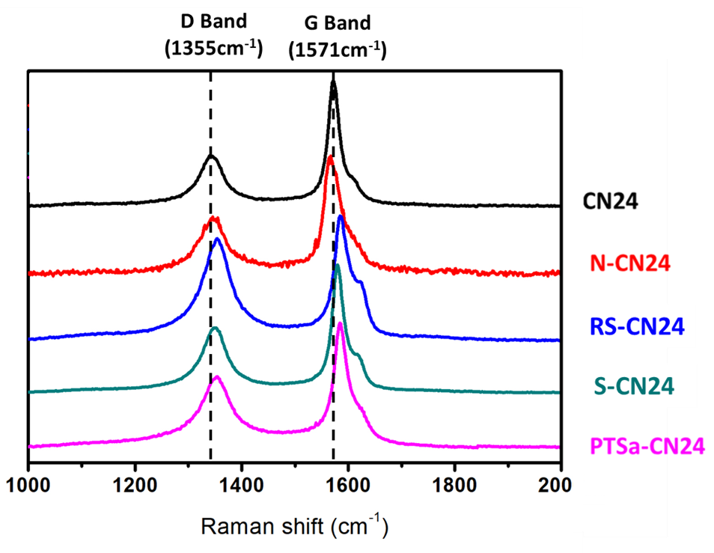
Figure 2.

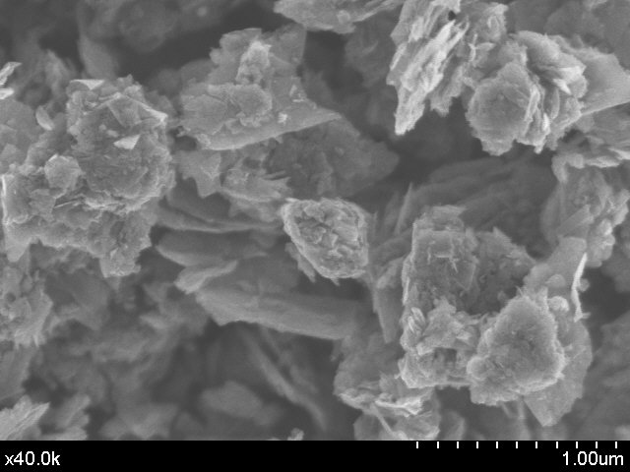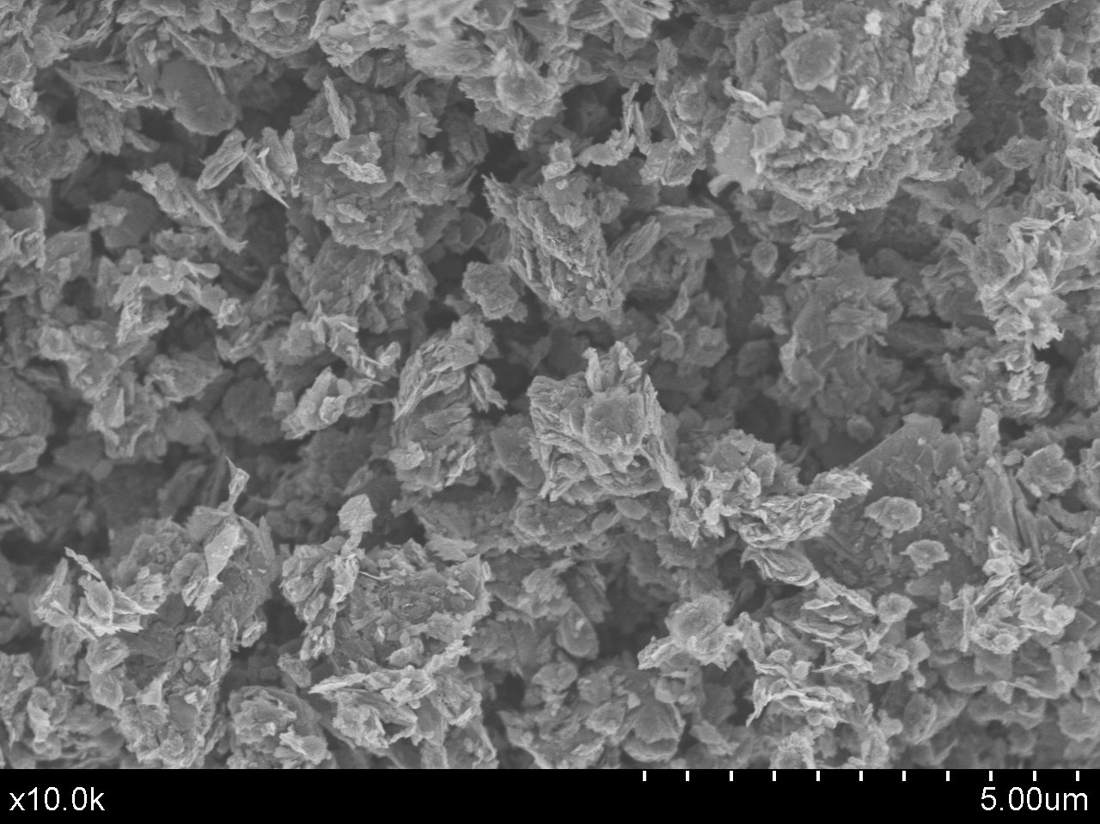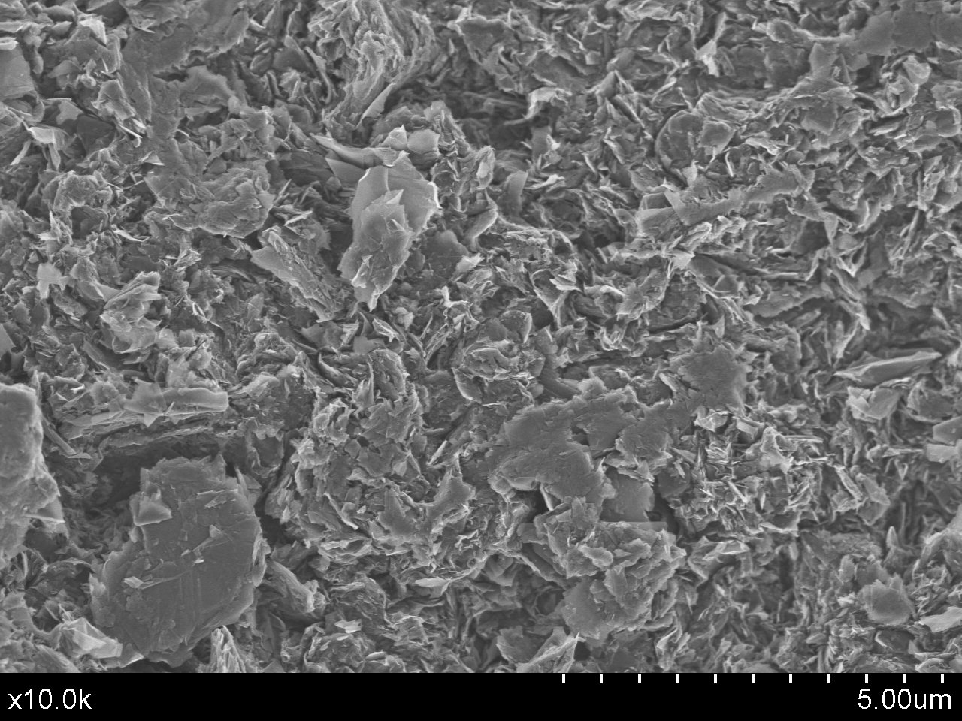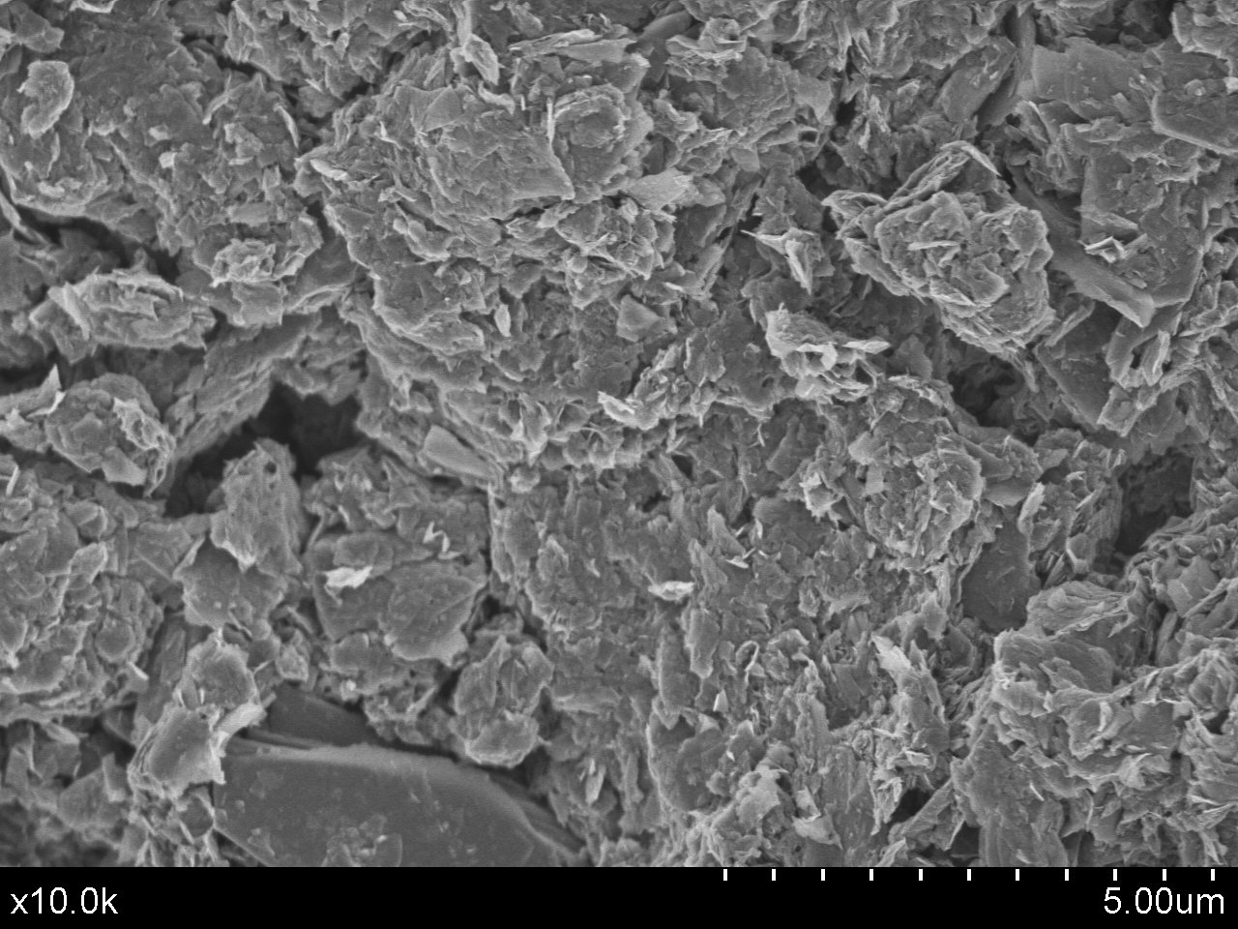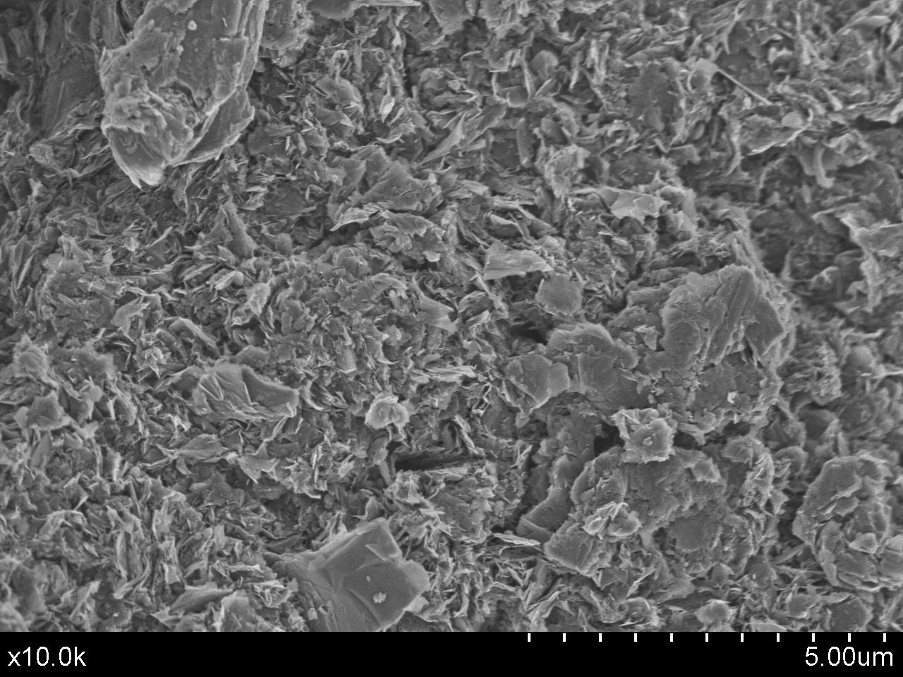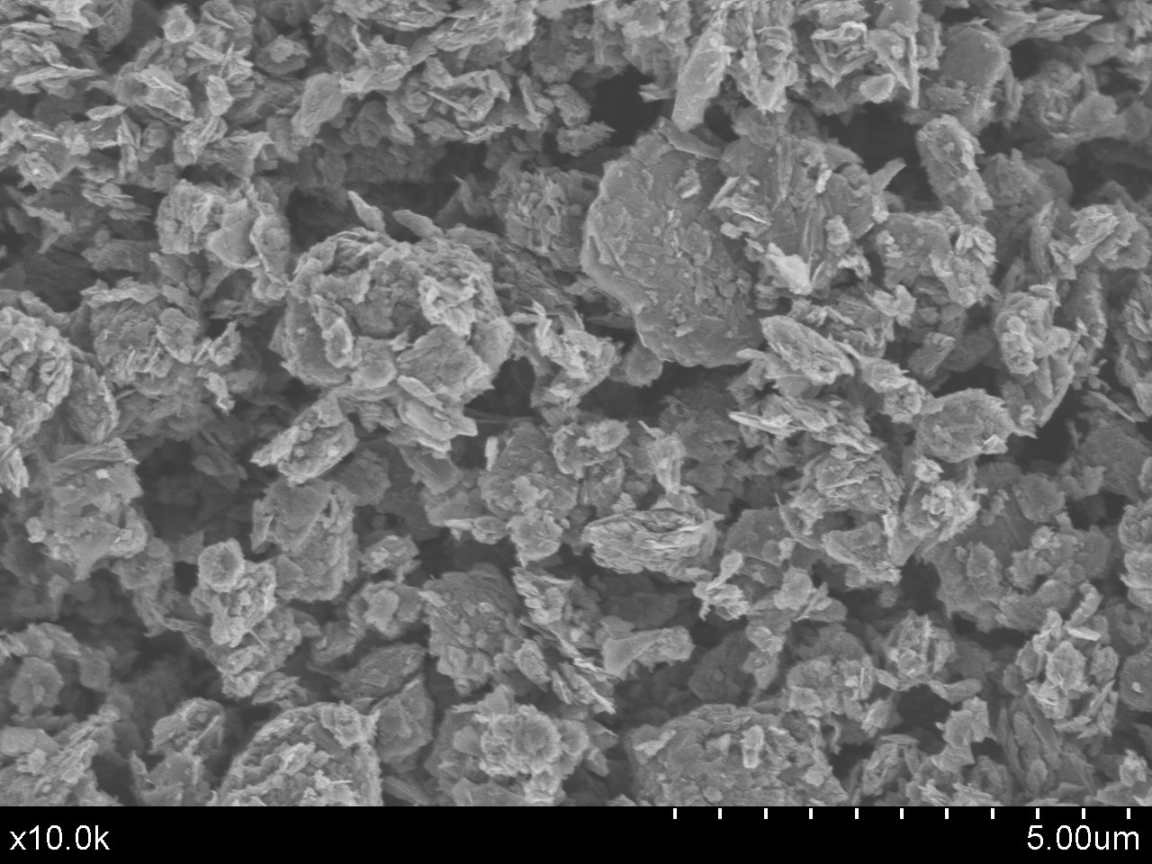
A
B
C
D
E
F
Figure 3.

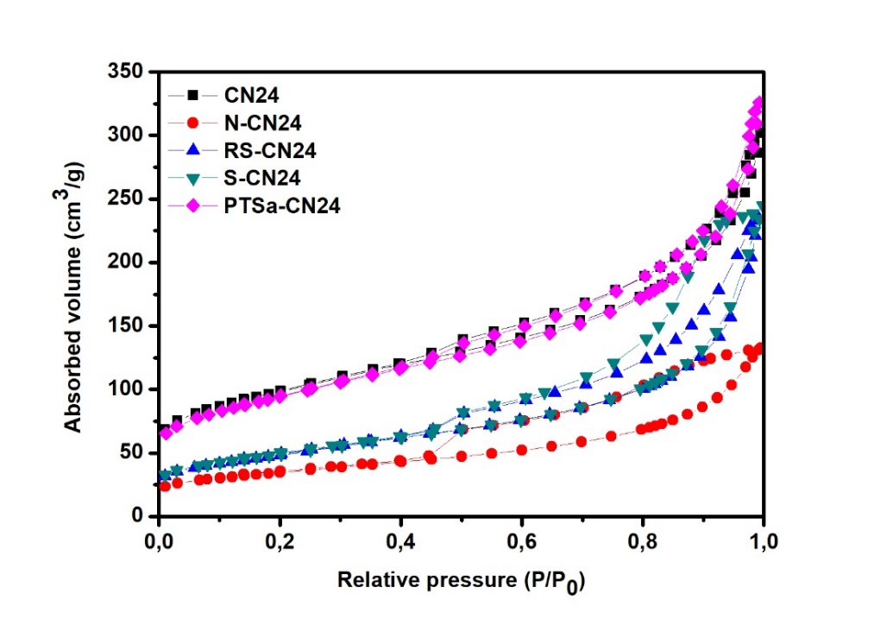
Figure 4.

A
B
Figure 5.

A
B

Figure 6.

Figure 7.

Figure 8.

Figure 9.

Figure 10.

Supporting information

Fructose dehydration reaction over functionalized nanographitic catalysts in MIBK/H₂O biphasic system.
Gabriel Delgado Martin¹, Charf Eddine Bounoukta², Fatima Ammari², María Isabel Domínguez¹, Antonio Monzón³, Svetlana Ivanova¹, Miguel Ángel Centeno^{1*}

Figure S1. Pore size distribution of the studied samples

